UNITED STATES
SECURITIES AND EXCHANGE COMMISSION
Washington, DC 20549

FORM 8-K

CURRENT REPORT PURSUANT
TO SECTION 13 OR 15(D) OF THE
SECURITIES EXCHANGE ACT OF 1934

June 16, 2026
Date of report (Date of earliest event reported)

Valmont Industries, Inc.
(Exact Name of Registrant as Specified in Its Charter)

Delaware
(State or Other Jurisdiction of Incorporation)

1-31429 | 47-0351813
(Commission File Number) | (IRS Employer Identification No.)

15000 Valmont Plaza
Omaha, NE | 68154
(Address of Principal Executive Offices) | (Zip Code)

(402) 963-1000
(Registrant’s Telephone Number, Including Area Code)

(Former Name or Former Address, if Changed Since Last Report)

Securities registered pursuant to Section 12(b) of the Act:

Title of each class |  | Trading symbol(s) |  | Name of each exchange on which registered
Common Stock, $1.00 par value |  | VMI |  | New York Stock Exchange

Check the appropriate box below if the Form 8-K filing is intended to simultaneously satisfy the filing obligation of the registrant under any of the following provisions (see General Instruction A.2. below):

 | ☐ | Written communications pursuant to Rule 425 under the Securities Act (17 CFR 230.425)

 | ☐ | Soliciting material pursuant to Rule 14a-12 under the Exchange Act (17 CFR 240.14a-12)

 | ☐ | Pre-commencement communications pursuant to Rule 14d-2(b) under the Exchange Act (17 CFR 240.14d-2(b))

 | ☐ | Pre-commencement communications pursuant to Rule 13e-4(c) under the Exchange Act (17 CFR 240.13e-4(c))

Indicate by check mark whether the registrant is an emerging growth company as defined in Rule 405 of the Securities Act of 1933 (§230.405 of this chapter) or Rule 12b-2 of the Securities Exchange Act of 1934 (§240.12b-2 of this chapter).

Emerging growth company ☐

If an emerging growth company, indicate by check mark if the registrant has elected not to use the extended transition period for complying with any new or revised financial accounting standards provided pursuant to Section 13(a) of the Exchange Act. ☐

Item 7.01 Regulation FD Disclosure.

Valmont Industries, Inc. (the “Company”) will host an Investor Day on Tuesday, June 16, 2026, beginning at 8:30 a.m. Eastern Time in New York City. As previously announced a live webcast of the presentation will be available online at investors.valmont.com by clicking on the events link for the event. Presentation slides to be used by the Company during the webcast are furnished with this Form 8-K as Exhibit 99.1 and are incorporated herein by reference.

The information in Item 7.01 is being furnished and shall not be deemed “filed” for the purpose of Section 18 of the Securities Exchange Act of 1934, as amended (the “Exchange Act”), or otherwise subject to the liabilities of that section. The information in Item 7.01 shall not be deemed incorporated by reference in any filing under the Securities Act of 1933, as amended, or the Exchange Act, except as shall be expressly set forth by specific reference in such a filing.

Item 9.01. Financial Statements and Exhibits.

(d) Exhibits.

Exhibit No. |  | Description
99.1 |  | Presentation Slides June 16, 2026
104 |  | Cover Page Interactive File (the cover page XBRL tags are embedded in the Inline XBRL document)

SIGNATURES

Pursuant to the requirements of the Securities Exchange Act of 1934, the registrant has duly caused this report to be signed on its behalf by the undersigned hereunto duly authorized.

 | Valmont Industries, Inc.
Date: June 16, 2026
 | By: | /s/ William E. Johnson
 |  | Name: | William E. Johnson
 |  | Title: | Chief Accounting Officer

Exhibit 99.1

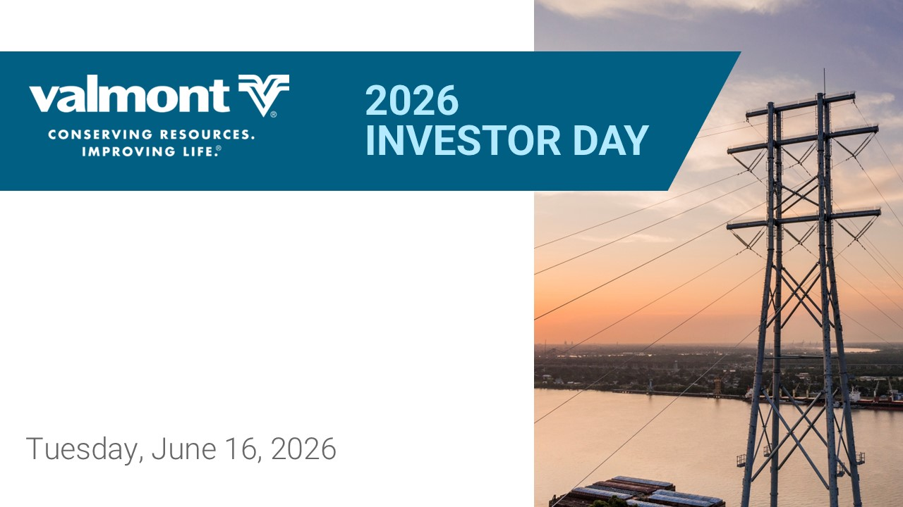
Tuesday, June 16, 2026 -2:)7836(%=

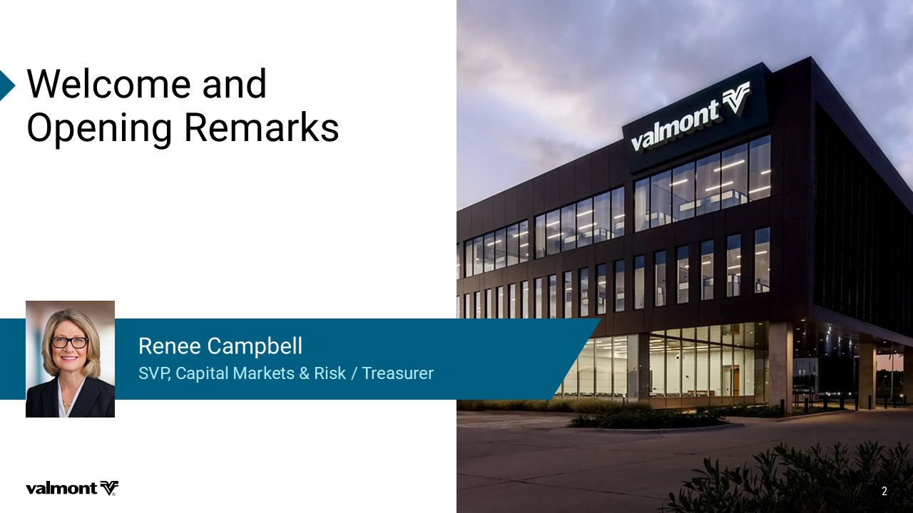
;IPGSQIERH 3TIRMRK6IQEVOW 7:4'ETMXEP1EVOIXW6MWO8VIEWYVIV 6IRII'EQTFIPP

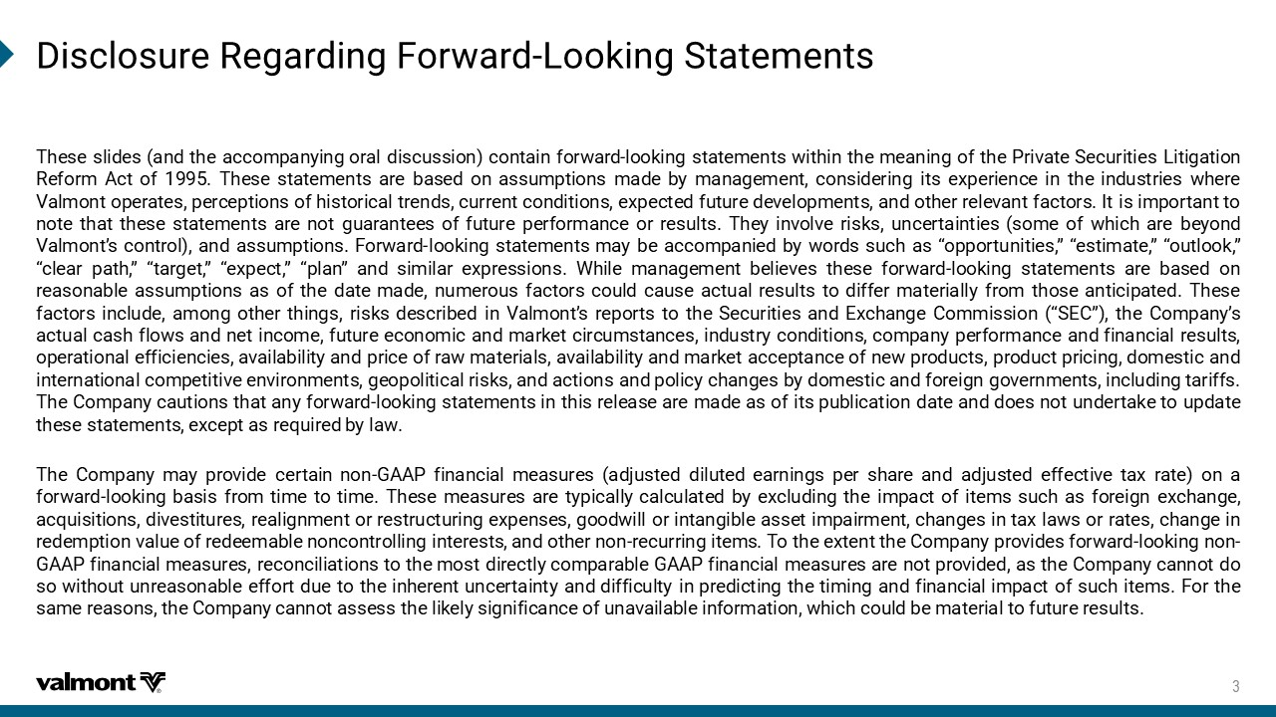
(MWGPSWYVI6IKEVHMRK*SV[EVH 0SSOMRK7XEXIQIRXW 9MJXJ XQNIJX FSI YMJ FHHTRUFS^NSL TWFQ INXHZXXNTS HTSYFNS KTW\FWI QTTPNSL XYFYJRJSYX \NYMNS YMJ RJFSNSL TK YMJ 5WN[FYJ 8JHZWNYNJX 1NYNLFYNTS 7JKTWR &HY TK 9MJXJ XYFYJRJSYX FWJ GFXJI TS FXXZRUYNTSX RFIJ G^ RFSFLJRJSY HTSXNIJWNSL NYX J]UJWNJSHJ NS YMJ NSIZXYWNJX \MJWJ ;FQRTSY TUJWFYJX UJWHJUYNTSX TK MNXYTWNHFQ YWJSIX HZWWJSY HTSINYNTSX J]UJHYJI KZYZWJ IJ[JQTURJSYX FSI TYMJW WJQJ[FSY KFHYTWX .Y NX NRUTWYFSY YT STYJ YMFY YMJXJ XYFYJRJSYX FWJ STY LZFWFSYJJX TK KZYZWJ UJWKTWRFSHJ TW WJXZQYX 9MJ^ NS[TQ[J WNXPX ZSHJWYFNSYNJX XTRJ TK \MNHM FWJ GJ^TSI ;FQRTSYѣX HTSYWTQ FSI FXXZRUYNTSX +TW\FWI QTTPNSL XYFYJRJSYX RF^ GJ FHHTRUFSNJI G^ \TWIX XZHM FX ѦTUUTWYZSNYNJXѧ ѦJXYNRFYJѧ ѦTZYQTTPѧ ѦHQJFW UFYMѧ ѦYFWLJYѧ ѦJ]UJHYѧ ѦUQFSѧ FSI XNRNQFW J]UWJXXNTSX <MNQJ RFSFLJRJSY GJQNJ[JX YMJXJ KTW\FWI QTTPNSL XYFYJRJSYX FWJ GFXJI TS WJFXTSFGQJ FXXZRUYNTSX FX TK YMJ IFYJ RFIJ SZRJWTZX KFHYTWX HTZQI HFZXJ FHYZFQ WJXZQYX YT INKKJW RFYJWNFQQ^ KWTR YMTXJ FSYNHNUFYJI 9MJXJ KFHYTWX NSHQZIJ FRTSL TYMJW YMNSLX WNXPX IJXHWNGJI NS ;FQRTSYѣX WJUTWYX YT YMJ 8JHZWNYNJX FSI *]HMFSLJ (TRRNXXNTS Ѧ8*(ѧ YMJ (TRUFS^ѣX FHYZFQ HFXM KQT\X FSI SJY NSHTRJ KZYZWJ JHTSTRNH FSI RFWPJY HNWHZRXYFSHJX NSIZXYW^ HTSINYNTSX HTRUFS^ UJWKTWRFSHJ FSI KNSFSHNFQ WJXZQYX TUJWFYNTSFQ JKKNHNJSHNJX F[FNQFGNQNY^ FSI UWNHJ TK WF\ RFYJWNFQX F[FNQFGNQNY^ FSI RFWPJY FHHJUYFSHJ TK SJ\ UWTIZHYX UWTIZHY UWNHNSL ITRJXYNH FSI NSYJWSFYNTSFQ HTRUJYNYN[J JS[NWTSRJSYX LJTUTQNYNHFQ WNXPX FSI FHYNTSX FSI UTQNH^ HMFSLJX G^ ITRJXYNH FSI KTWJNLS LT[JWSRJSYX NSHQZINSL YFWNKKX 9MJ (TRUFS^ HFZYNTSX YMFY FS^ KTW\FWI QTTPNSL XYFYJRJSYX NS YMNX WJQJFXJ FWJ RFIJ FX TK NYX UZGQNHFYNTS IFYJ FSI ITJX STY ZSIJWYFPJ YT ZUIFYJ YMJXJ XYFYJRJSYX J]HJUY FX WJVZNWJI G^ QF\ 9MJ (TRUFS^ RF^ UWT[NIJ HJWYFNS STS ,&&5 KNSFSHNFQ RJFXZWJX FIOZXYJI INQZYJI JFWSNSLX UJW XMFWJ FSI FIOZXYJI JKKJHYN[J YF] WFYJ TS F KTW\FWI QTTPNSL GFXNX KWTR YNRJ YT YNRJ 9MJXJ RJFXZWJX FWJ Y^UNHFQQ^ HFQHZQFYJI G^ J]HQZINSL YMJ NRUFHY TK NYJRX XZHM FX KTWJNLS J]HMFSLJ FHVZNXNYNTSX IN[JXYNYZWJX WJFQNLSRJSY TW WJXYWZHYZWNSL J]UJSXJX LTTI\NQQ TW NSYFSLNGQJ FXXJY NRUFNWRJSY HMFSLJX NS YF] QF\X TW WFYJX HMFSLJ NS WJIJRUYNTS [FQZJ TK WJIJJRFGQJ STSHTSYWTQQNSL NSYJWJXYX FSI TYMJW STS WJHZWWNSL NYJRX 9T YMJ J]YJSY YMJ (TRUFS^ UWT[NIJX KTW\FWI QTTPNSL STS ,&&5 KNSFSHNFQ RJFXZWJX WJHTSHNQNFYNTSX YT YMJ RTXY INWJHYQ^ HTRUFWFGQJ ,&&5 KNSFSHNFQ RJFXZWJX FWJ STY UWT[NIJI FX YMJ (TRUFS^ HFSSTY IT XT \NYMTZY ZSWJFXTSFGQJ JKKTWY IZJ YT YMJ NSMJWJSY ZSHJWYFNSY^ FSI INKKNHZQY^ NS UWJINHYNSL YMJ YNRNSL FSI KNSFSHNFQ NRUFHY TK XZHM NYJRX +TW YMJ XFRJ WJFXTSX YMJ (TRUFS^ HFSSTY FXXJXX YMJ QNPJQ^ XNLSNKNHFSHJ TK ZSF[FNQFGQJ NSKTWRFYNTS \MNHM HTZQI GJ RFYJWNFQ YT KZYZWJ WJXZQYX

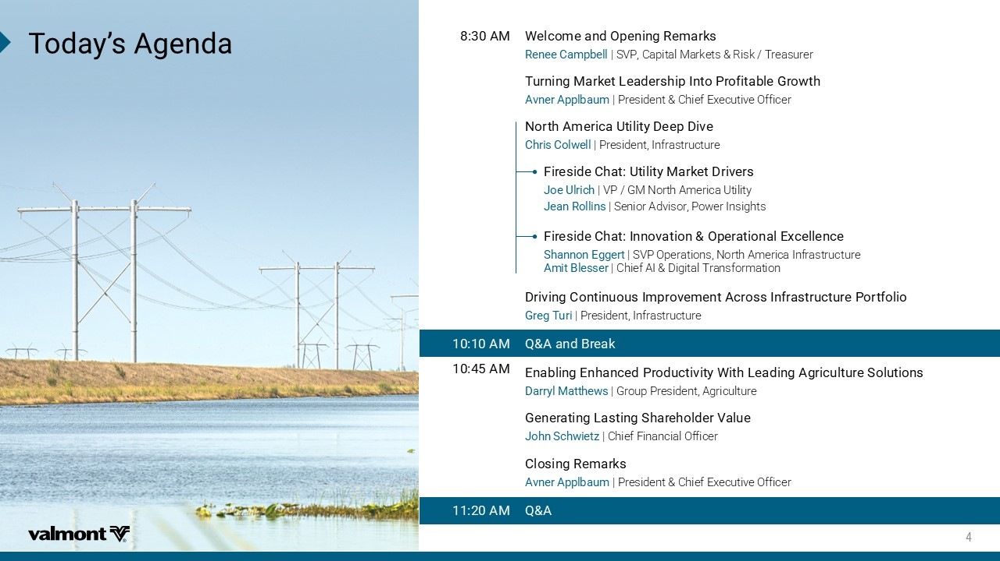
8SHE]ƆW%KIRHE ;IPGSQIERH3TIRMRK6IQEVOW 6IRII'EQTFIPP | SVP, Capital Markets & Risk / Treasurer %1 8YVRMRK1EVOIX0IEHIVWLMT-RXS4VSJMXEFPI+VS[XL %ZRIV %TTPFEYQ | President & Chief Executive Officer 2SVXL%QIVMGE9XMPMX](IIT(MZI 'LVMW'SP[IPP | President, Infrastructure *MVIWMHI'LEX9XMPMX]1EVOIX(VMZIVW .SI9PVMGL | VP / GM North America Utility .IER6SPPMRW | Senior Advisor, Power Insights *MVIWMHI'LEX-RRSZEXMSR3TIVEXMSREP)\GIPPIRGI 7LERRSR)KKIVX | SVP Operations, North America Infrastructure %QMX&PIWWIV | Chief AI & Digital Transformation (VMZMRK'SRXMRYSYW-QTVSZIQIRX%GVSWW-RJVEWXVYGXYVI4SVXJSPMS +VIK8YVM | President, Infrastructure 5%ERH&VIEO %1 )REFPMRK)RLERGIH4VSHYGXMZMX];MXL0IEHMRK%KVMGYPXYVI7SPYXMSRW (EVV]P1EXXLI[W | Group President, Agriculture %1 +IRIVEXMRK0EWXMRK7LEVILSPHIV:EPYI .SLR7GL[MIX^ | Chief Financial Officer 'PSWMRK6IQEVOW %ZRIV %TTPFEYQ | President & Chief Executive Officer 5% %1



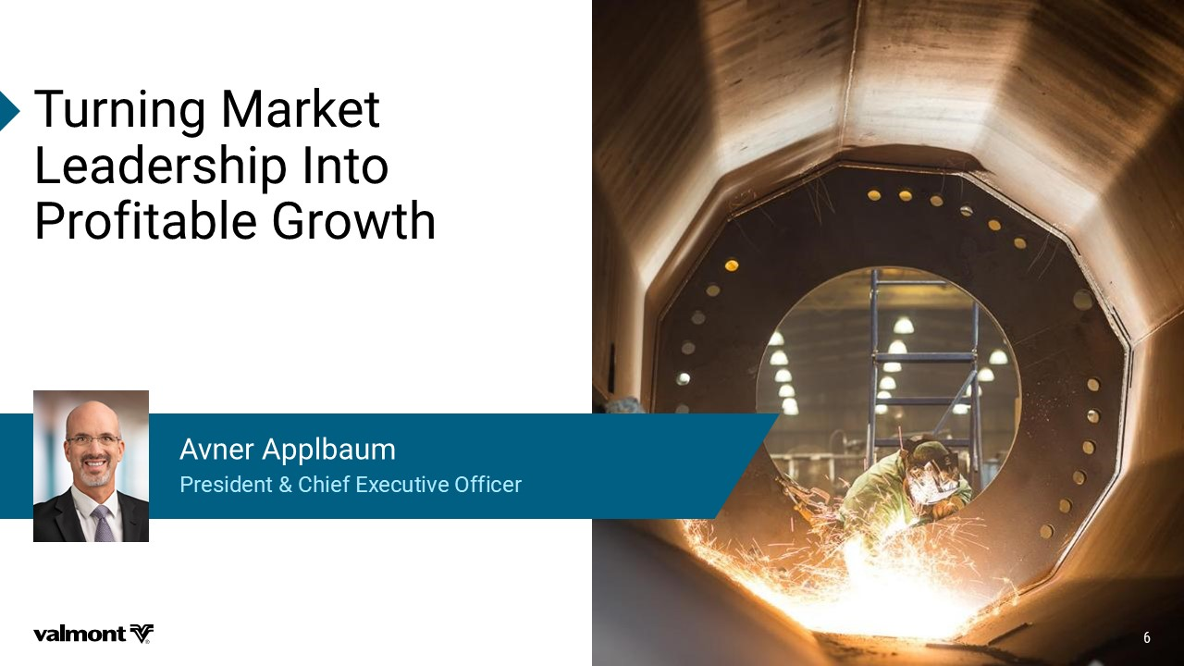
8YVRMRK1EVOIX 0IEHIVWLMT-RXS 4VSJMXEFPI+VS[XL 4VIWMHIRX'LMIJ)\IGYXMZI3JJMGIV %ZRIV %TTPFEYQ

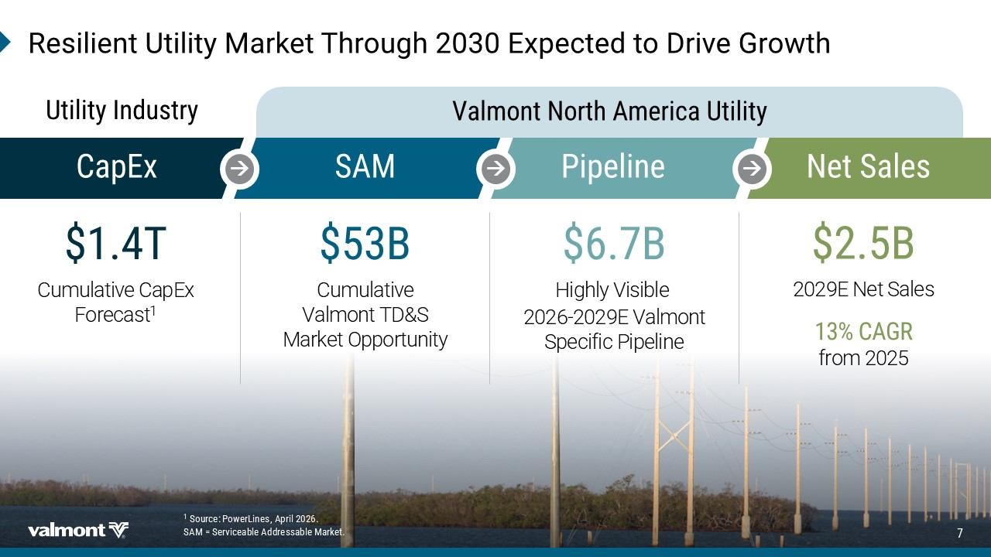
'ET)\ 4MTIPMRI 6IWMPMIRX9XMPMX]1EVOIX8LVSYKL)\TIGXIHXS(VMZI+VS[XL 7%1 Highly Visible 2026 - 2029E Valmont Specific Pipeline & & Cumulative Valmont TD&S Market Opportunity 8 Cumulative CapEx Forecast 1 7SYVGI 4S[IV0MRIW %TVMP 7%1!7IVZMGIEFPI%HHVIWWEFPI1EVOIX & 2029E Net Sales '%+6 from 2025 2IX7EPIW :EPQSRX2SVXL%QIVMGE9XMPMX] 9XMPMX]-RHYWXV]

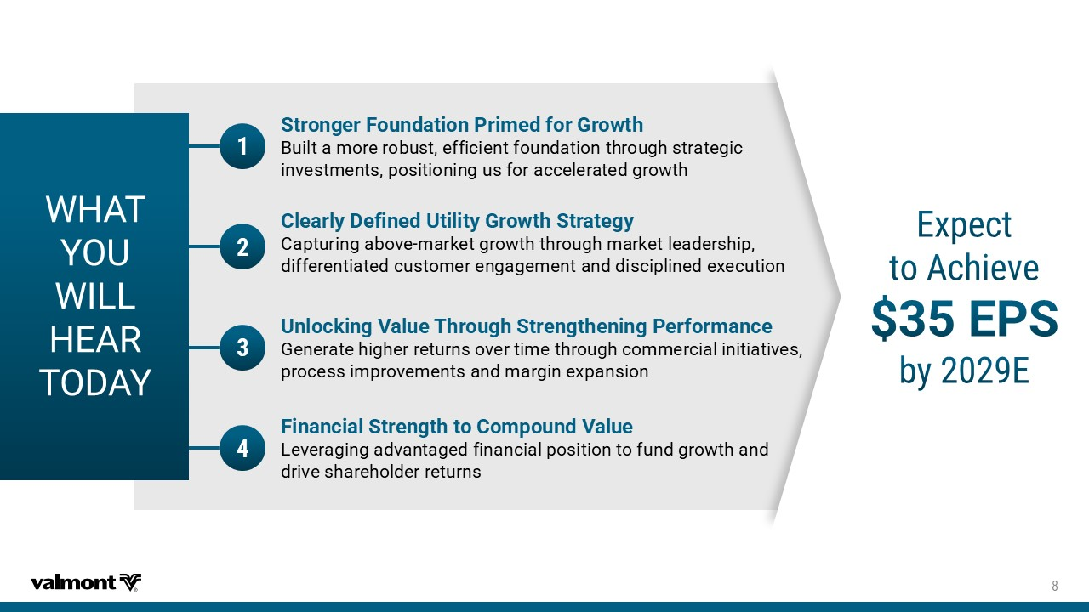
;,%8 =39 ;-00 ,)%6 83(%= 7XVSRKIV*SYRHEXMSR4VMQIHJSV+VS[XL 'ZNQYFRTWJWTGZXYJKKNHNJSYKTZSIFYNTSYMWTZLMXYWFYJLNH NS[JXYRJSYXUTXNYNTSNSLZXKTWFHHJQJWFYJILWT\YM 9RPSGOMRK:EPYI8LVSYKL7XVIRKXLIRMRK4IVJSVQERGI ,JSJWFYJMNLMJWWJYZWSXT[JWYNRJYMWTZLMHTRRJWHNFQNSNYNFYN[JX UWTHJXXNRUWT[JRJSYXFSIRFWLNSJ]UFSXNTS *MRERGMEP7XVIRKXLXS'SQTSYRH:EPYI 1J[JWFLNSLFI[FSYFLJIKNSFSHNFQUTXNYNTSYTKZSILWT\YMFSI IWN[JXMFWJMTQIJWWJYZWSX 'PIEVP](IJMRIH9XMPMX]+VS[XL7XVEXIK] (FUYZWNSLFGT[J RFWPJYLWT\YMYMWTZLMRFWPJYQJFIJWXMNU INKKJWJSYNFYJIHZXYTRJWJSLFLJRJSYFSIINXHNUQNSJIJ]JHZYNTS

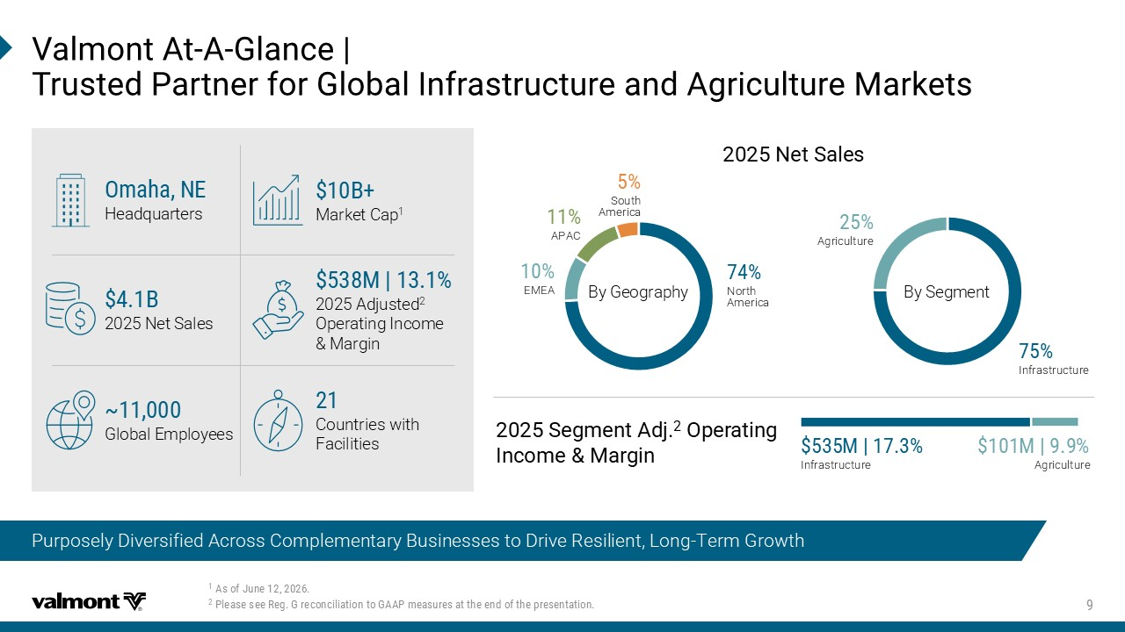
Purposely Diversified Across Complementary Businesses to Drive Resilient, Long - Term Growth %WSJ.YRI 4PIEWIWII6IK+VIGSRGMPMEXMSRXS+%%4QIEWYVIWEXXLIIRHSJXLITVIWIRXEXMSR :EPQSRX%X % +PERGI` 8VYWXIH4EVXRIVJSV+PSFEP-RJVEWXVYGXYVIERH%KVMGYPXYVI1EVOIXW 3QELE2) Headquarters 1` 2025 Adjusted 2 Operating Income & Margin Countries with Facilities b Global Employees By Geography By Segment EMEA APAC South America North America Agriculture Infrastructure 7IKQIRX%HN 3TIVEXMRK -RGSQI1EVKMR 1` Infrastructure 1` Agriculture & 2025 Net Sales 2IX7EPIW & Market Cap 1

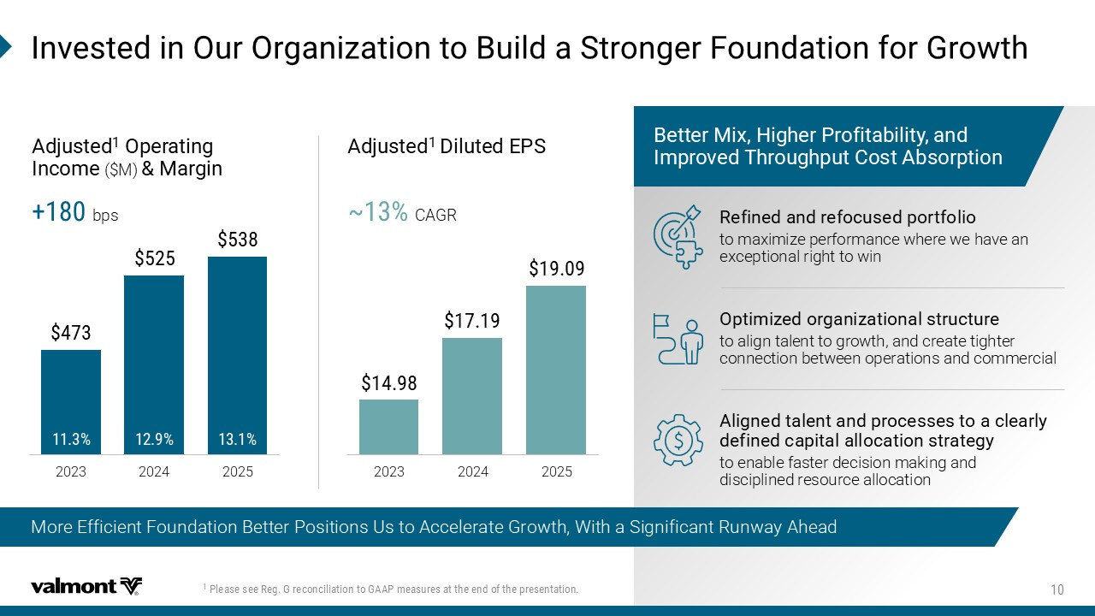
More Efficient Foundation Better Positions Us to Accelerate Growth, With a Significant Runway Ahead 4PIEWIWII6IK+VIGSRGMPMEXMSRXS+%%4QIEWYVIWEXXLIIRHSJXLITVIWIRXEXMSR -RZIWXIHMR3YV3VKERM^EXMSRXS&YMPHE7XVSRKIV*SYRHEXMSRJSV+VS[XL &IXXIV1M\,MKLIV4VSJMXEFMPMX]ERH -QTVSZIH8LVSYKLTYX'SWX%FWSVTXMSR 6IJMRIHERHVIJSGYWIHTSVXJSPMS to maximize performance where we have an exceptional right to win 3TXMQM^IHSVKERM^EXMSREPWXVYGXYVI to align talent to growth, and create tighter connection between operations and commercial %PMKRIHXEPIRXERHTVSGIWWIWXSEGPIEVP] HIJMRIHGETMXEPEPPSGEXMSRWXVEXIK] to enable faster decision making and disciplined resource allocation 2023 2024 2025 2023 2024 2025 %HNYWXIH 3TIVEXMRK -RGSQI ($M) 1EVKMR %HNYWXIH (MPYXIH)47 b CAGR bps

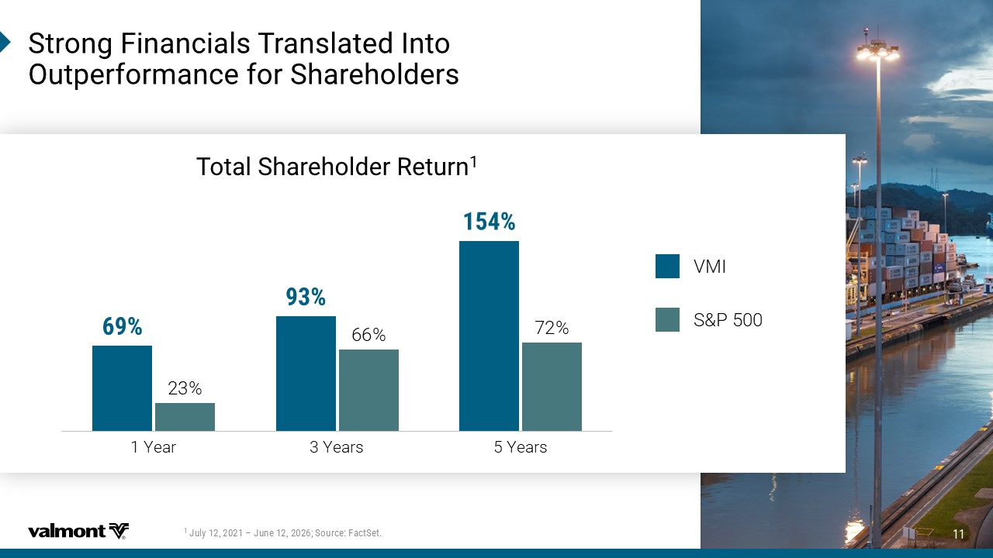
7XVSRK*MRERGMEPW8VERWPEXIH-RXS 3YXTIVJSVQERGIJSV7LEVILSPHIVW .YP] Ɓ .YRI7SYVGI*EGX7IX 8SXEP7LEVILSPHIV6IXYVR 23% 66% 72% 1 Year 3 Years 5 Years VMI S&P 500

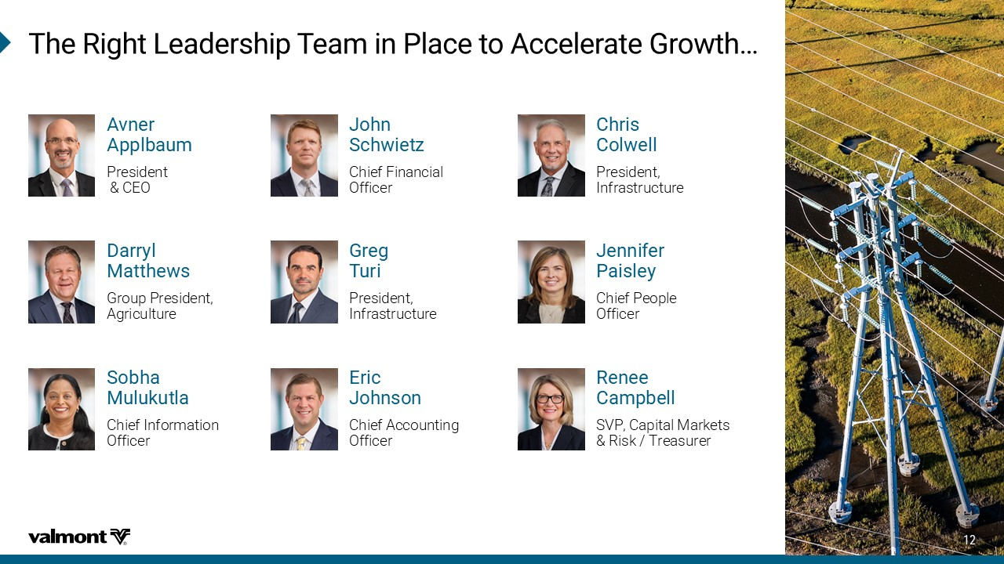
6IRII 'EQTFIPP SVP, Capital Markets & Risk / Treasurer )VMG .SLRWSR Chief Accounting Officer 7SFLE 1YPYOYXPE Chief Information Officer .IRRMJIV 4EMWPI] Chief People Officer 8LI6MKLX0IEHIVWLMT8IEQMR4PEGIXS%GGIPIVEXI+VS[XLƐ %ZRIV %TTPFEYQ President & CEO +VIK 8YVM President, Infrastructure 'LVMW 'SP[IPP President, Infrastructure (EVV]P 1EXXLI[W Group President, Agriculture .SLR 7GL[MIX^ Chief Financial Officer

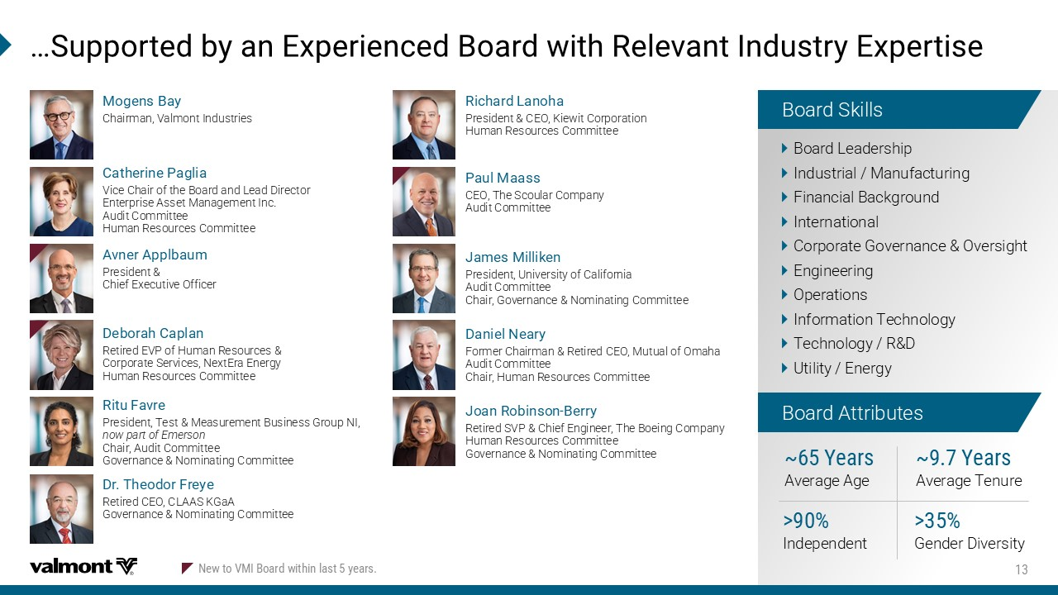
Ɛ7YTTSVXIHF]ER)\TIVMIRGIH&SEVH[MXL6IPIZERX-RHYWXV])\TIVXMWI 'EXLIVMRI4EKPME Vice Chair of the Board and Lead Director Enterprise Asset Management Inc. Audit Committee Human Resources Committee 6MGLEVH 0ERSLE President & CEO, Kiewit Corporation Human Resources Committee .EQIW1MPPMOIR President, University of California Audit Committee Chair, Governance & Nominating Committee (ERMIP2IEV] Former Chairman & Retired CEO, Mutual of Omaha Audit Committee Chair, Human Resources Committee .SER6SFMRWSR &IVV] Retired SVP & Chief Engineer, The Boeing Company Human Resources Committee Governance & Nominating Committee 6MXY*EZVI President, Test & Measurement Business Group NI, now part of Emerson Chair, Audit Committee Governance & Nominating Committee Board Skills Board Attributes Board Leadership Industrial / Manufacturing Financial Background International Corporate Governance & Oversight Engineering Operations Information Technology Technology / R&D Utility / Energy b=IEVW Average Tenure " Gender Diversity b=IEVW Average Age " Independent 1SKIRW&E] Chairman, Valmont Industries (V8LISHSV*VI]I Retired CEO, CLAAS KGaA Governance & Nominating Committee 4EYP1EEWW CEO, The Scoular Company Audit Committee (IFSVEL'ETPER Retired EVP of Human Resources & Corporate Services, NextEra Energy Human Resources Committee %ZRIV %TTPFEYQ President & Chief Executive Officer 2I[XS:1-&SEVH[MXLMRPEWX]IEVW

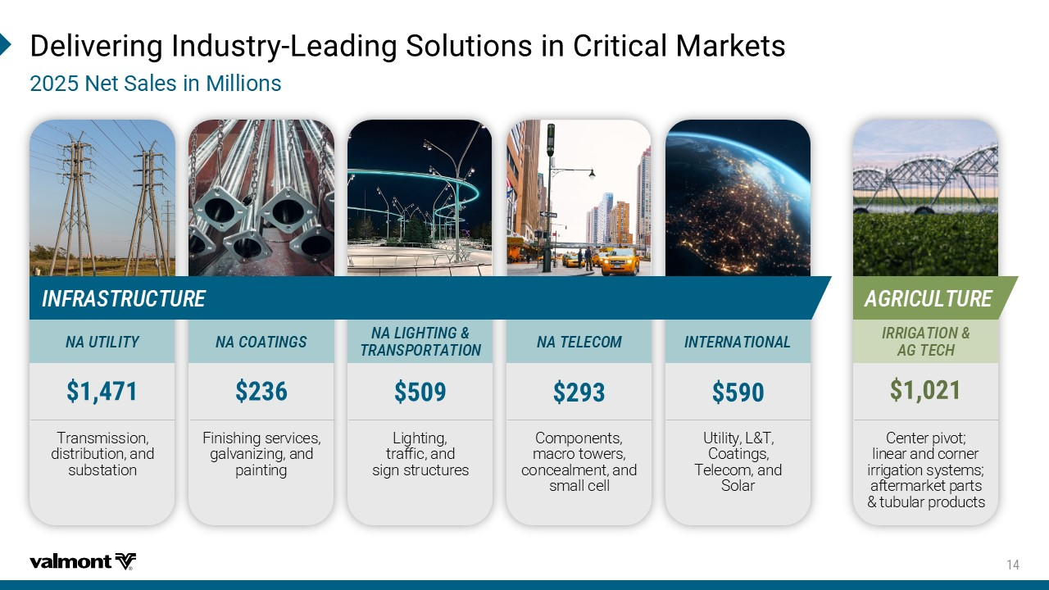
(IPMZIVMRK-RHYWXV] 0IEHMRK7SPYXMSRWMR'VMXMGEP1EVOIXW 2IX7EPIWMR1MPPMSRW Lighting, traffic, and sign structures Finishing services, galvanizing, and painting Center pivot; linear and corner irrigation systems; aftermarket parts & tubular products Components, macro towers, concealment, and small cell Utility, L&T, Coatings, Telecom, and Solar Transmission, distribution, and substation %+6-'90896) -2*6%7869'896) 2%0-+,8-2+ 86%274368%8-32 2%'3%8-2+7 2%8)0)'31 -28)62%8-32%0 2%98-0-8= -66-+%8-32 %+8)',

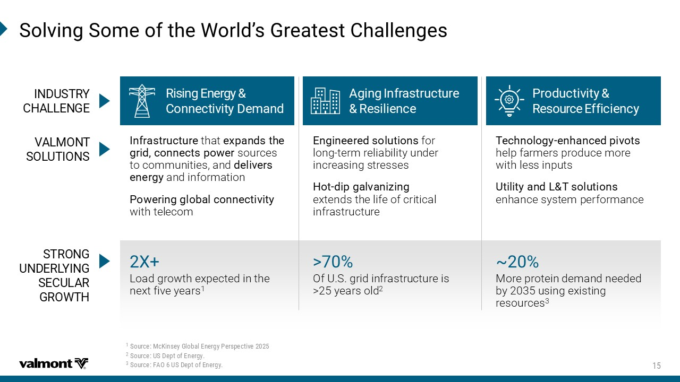
7SPZMRK7SQISJXLI;SVPHƆW+VIEXIWX'LEPPIRKIW 7SYVGI1G/MRWI]+PSFEP)RIVK]4IVWTIGXMZI 7SYVGI97(ITXSJ)RIVK] 7SYVGI*%397(ITXSJ)RIVK] 6MWMRK )RIVK] 'SRRIGXMZMX] (IQERH %KMRK -RJVEWXVYGXYVI 6IWMPMIRGI 4VSHYGXMZMX] 6IWSYVGI )JJMGMIRG] :%01328 73098-327 < Load growth expected in the next five years 1 b More protein demand needed by 2035 using existing resources 3 " Of U.S. grid infrastructure is >25 years old 2 -RJ VEWXVYGXYVI that I\TERHWXLI KVMHGSRRIGXWTS[IV sources to communities, and HIPMZIVW IRIVK] and information 4S[IVMRKKPSFEPGSRRIGXMZMX] with telecom )RKMRIIVIHWSPYXMSRW for long - term reliability under increasing stresses ,SX HMTKEPZERM^MRK extends the life of critical infrastructure 8IGLRSPSK] IRLERGIHTMZSXW help farmers produce more with less inputs 9XMPMX]ERH08WSPYXMSRW enhance system performance -2(9786= ',%00)2+) 78632+ 92()60=-2+ 7)'90%6 +63;8,


4SWMXMSRIHXS;MR8LVSYKL)\TIVXMWIERH6IPMEFMPMX] Our Differentiated Capabilities Are Difficult to Replicate and Are Critical to Win in the Markets We Serve ]IEVW of utility structures engineering expertise Differentiated and innovative IRKMRIIVMRK and HIWMKR GETEFMPMXMIW Comprehensive, TVIQMYQ TSVXJSPMS of products and services (IIT MRHYWXV]XIGLRMGEP I\TIVXMWI and long - standing customer relationships – partnering with XSTYXMPMX]GSQTERMIW Unmatched Agriculture sales and service channel supported by a KPSFEPRIX[SVO of "HIEPIV PSGEXMSRW *SYRHIV of QIGLERM^IHMVVMKEXMSR High - value, integrated manufacturing capabilities across scaled, KPSFEP JSSXTVMRX 7GEPI drives cost efficiency and ensures reliable delivery of large, complex projects 4VSZIR XVEGO VIGSVH of reliability, on - time execution, and quality 'SQQIVGMEP0IEHIVWLMTMR (YVEFPI1EVOIXW -RHYWXV] 0IEHMRK )RKMRIIVMRK 6IWMPMIRX3TIVEXMSREP *SYRHEXMSR

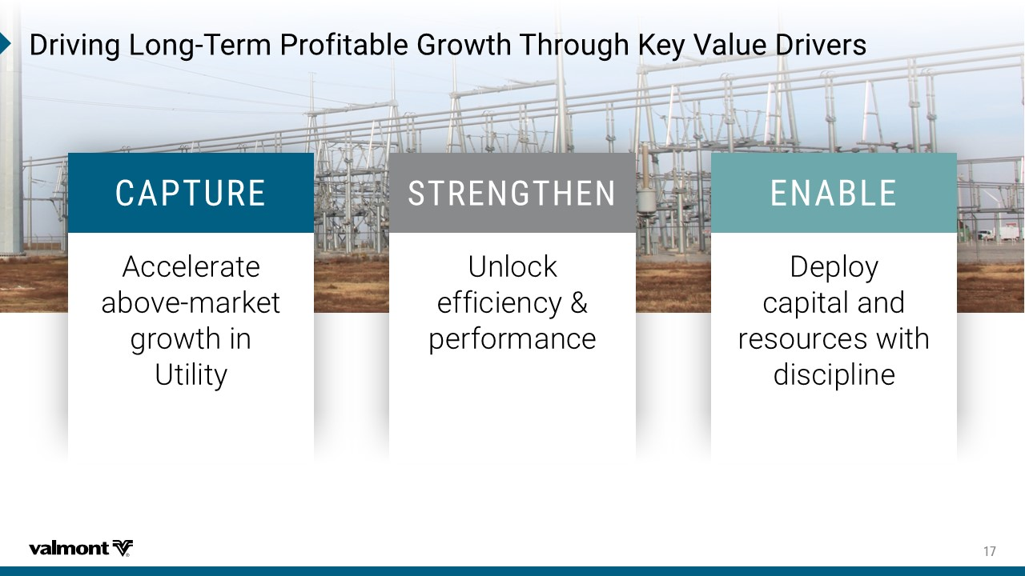
(VMZMRK0SRK 8IVQ4VSJMXEFPI+VS[XL8LVSYKL/I]:EPYI(VMZIVW Accelerate above - market growth in Utility Deploy capital and resources with discipline Unlock efficiency & performance '%4896) 786)2+8,)2 )2%&0)

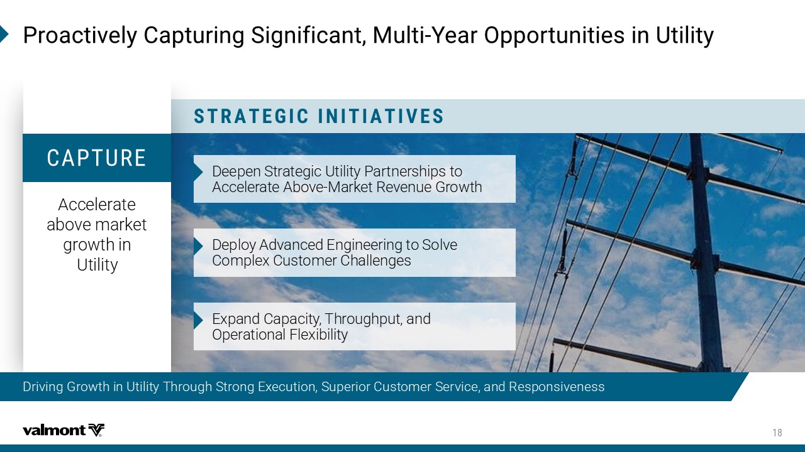
Driving Growth in Utility Through Strong Execution, Superior Customer Service, and Responsiveness 4VSEGXMZIP]'ETXYVMRK7MKRMJMGERX1YPXM =IEV3TTSVXYRMXMIWMR9XMPMX] 786%8)+-'-2-8-%8-:)7 Accelerate above market growth in Utility )JJUJS8YWFYJLNH:YNQNY^5FWYSJWXMNUXYT &HHJQJWFYJ&GT[J 2FWPJY7J[JSZJ,WT\YM )JUQT^&I[FSHJI*SLNSJJWNSLYT8TQ[J (TRUQJ](ZXYTRJW(MFQQJSLJX *]UFSI(FUFHNY^9MWTZLMUZYFSI 4UJWFYNTSFQ+QJ]NGNQNY^ '%4896)

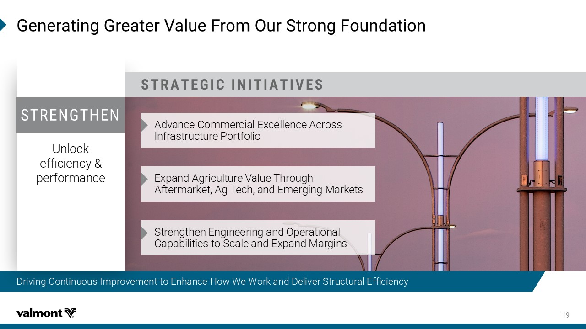
Driving Continuous Improvement to Enhance How We Work and Deliver Structural Efficiency +IRIVEXMRK+VIEXIV:EPYI*VSQ3YV7XVSRK*SYRHEXMSR 786%8)+-'-2-8-%8-:)7 &I[FSHJ(TRRJWHNFQ*]HJQQJSHJ&HWTXX .SKWFXYWZHYZWJ5TWYKTQNT *]UFSI&LWNHZQYZWJ;FQZJ9MWTZLM &KYJWRFWPJY&L9JHMFSI*RJWLNSL2FWPJYX Strengthen Engineering and Operational Capabilities to Scale and Expand Margins Unlock efficiency & performance 786)2+8,)2

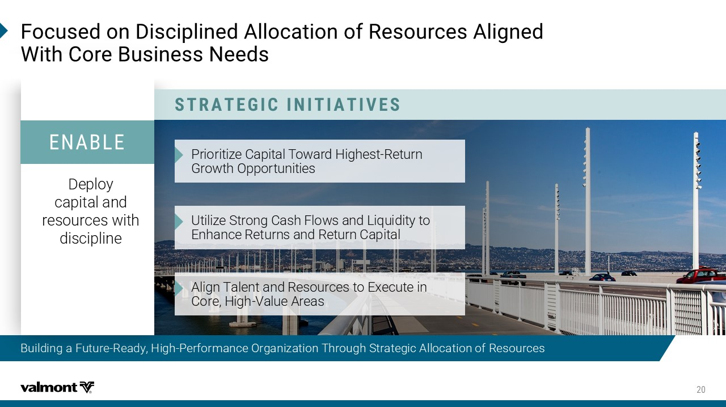
Building a Future - Ready, High - Performance Organization Through Strategic Allocation of Resources *SGYWIHSR(MWGMTPMRIH%PPSGEXMSRSJ6IWSYVGIW%PMKRIH ;MXL'SVI&YWMRIWW2IIHW 786%8)+-'-2-8-%8-:)7 5WNTWNYN_J(FUNYFQ9T\FWI-NLMJXY 7JYZWS ,WT\YM4UUTWYZSNYNJX :YNQN_J8YWTSL(FXM+QT\XFSI1NVZNINY^YT *SMFSHJ7JYZWSXFSI7JYZWS(FUNYFQ Align Talent and Resources to Execute in Core, High - Value Areas Deploy capital and resources with discipline )2%&0)

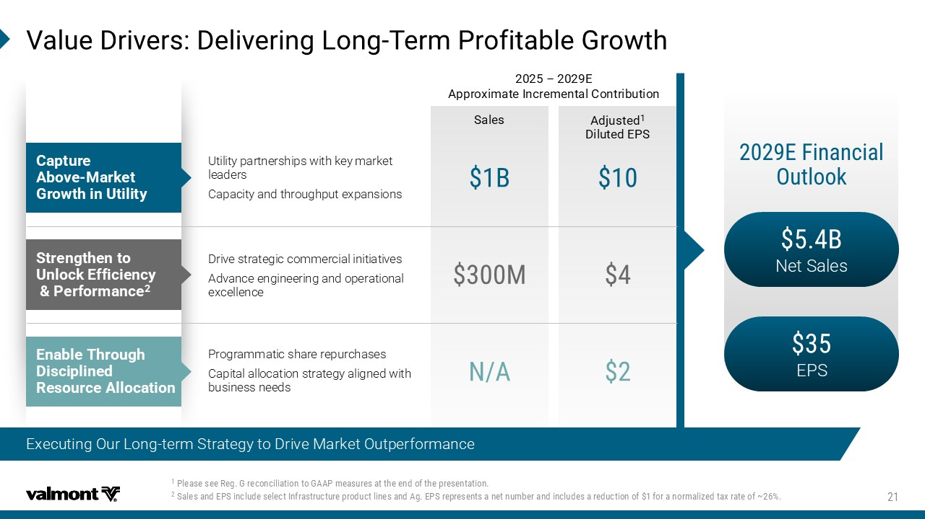
D 7EPIW %HNYWXIH (MPYXIH)47 4PIEWIWII6IK+VIGSRGMPMEXMSRXS+%%4QIEWYVIWEXXLIIRHSJXLITVIWIRXEXMSR 7EPIWERH)47MRGPYHIWIPIGX-RJVEWXVYGXYVITVSHYGXPMRIWERH%K)47VITVIWIRXWERIXRYQFIVERHMRGPYHIWEVIHYGXMSRSJ JS VERSVQEPM^IHXE\VEXISJb :EPYI(VMZIVW(IPMZIVMRK0SRK 8IVQ4VSJMXEFPI+VS[XL & Net Sales EPS )*MRERGMEP 3YXPSSO 'ETXYVI %FSZI 1EVOIX +VS[XLMR9XMPMX] Utility partnerships with key market leaders Capacity and throughput expansions & 7XVIRKXLIRXS 9RPSGO )JJMGMIRG] 4IVJSVQERGI 1 Programmatic share repurchases Capital allocation strategy aligned with business needs 2% )REFPI 8LVSYKL (MWGMTPMRIH 6IWSYVGI%PPSGEXMSR Ƃ ) %TTVS\MQEXI-RGVIQIRXEP'SRXVMFYXMSR Drive strategic commercial initiatives Advance engineering and operational excellence Executing Our Long - term Strategy to Drive Market Outperformance

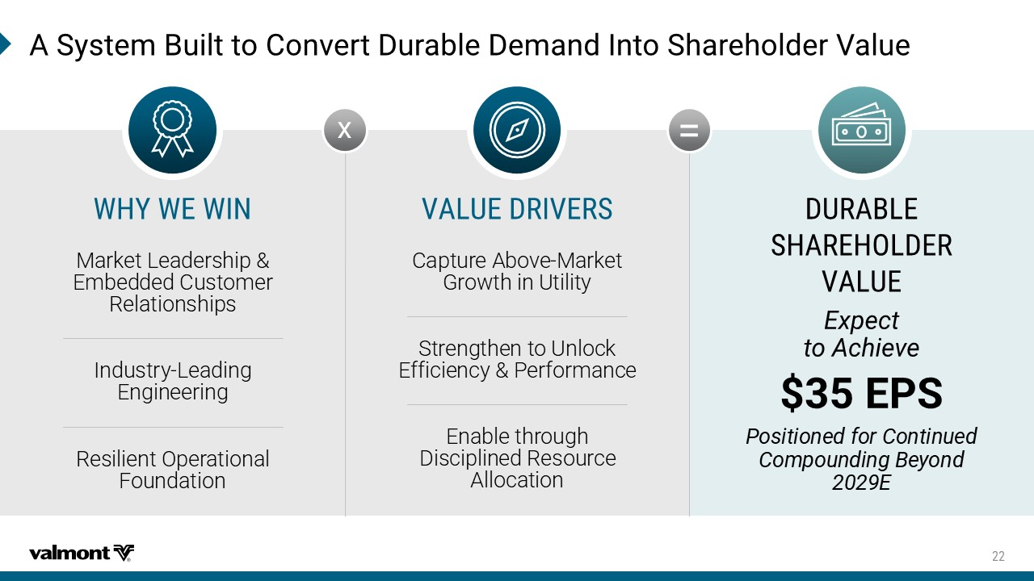
%7]WXIQ&YMPXXS'SRZIVX(YVEFPI(IQERH-RXS7LEVILSPHIV:EPYI (96%&0) 7,%6),30()6 :%09) )\TIGX XS%GLMIZI )47 4SWMXMSRIHJSV'SRXMRYIH 'SQTSYRHMRK&I]SRH ) ;,=;);-2 2FWPJY1JFIJWXMNU *RGJIIJI(ZXYTRJW 7JQFYNTSXMNUX .SIZXYW^ 1JFINSL *SLNSJJWNSL 7JXNQNJSY4UJWFYNTSFQ +TZSIFYNTS :%09)(6-:)67 (FUYZWJ&GT[J 2FWPJY ,WT\YMNS:YNQNY^ 8YWJSLYMJSYT:SQTHP *KKNHNJSH^5JWKTWRFSHJ *SFGQJYMWTZLM )NXHNUQNSJI7JXTZWHJ &QQTHFYNTS = x


2SVXL%QIVMGE 9XMPMX](IIT(MZI 4VIWMHIRX-RJVEWXVYGXYVI 'LVMW'SP[IPP

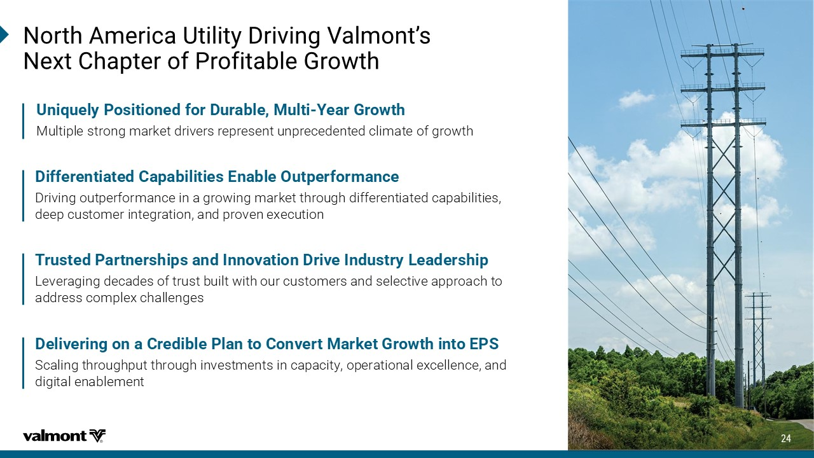
2SVXL%QIVMGE9XMPMX](VMZMRK:EPQSRXƆW 2I\X'LETXIVSJ4VSJMXEFPI+VS[XL (MJJIVIRXMEXIH'ETEFMPMXMIW)REFPI3YXTIVJSVQERGI Driving outperformance in a growing market through differentiated capabilities, deep customer integration, and proven execution 9RMUYIP]4SWMXMSRIHJSV(YVEFPI1YPXM =IEV+VS[XL Multiple strong market drivers represent unprecedented climate of growth 8VYWXIH4EVXRIVWLMTWERH-RRSZEXMSR(VMZI-RHYWXV]0IEHIVWLMT Leveraging decades of trust built with our customers and selective approach to address complex challenges (IPMZIVMRKSRE'VIHMFPI4PERXS'SRZIVX1EVOIX+VS[XLMRXS)47 Scaling throughput through investments in capacity, operational excellence, and digital enablement

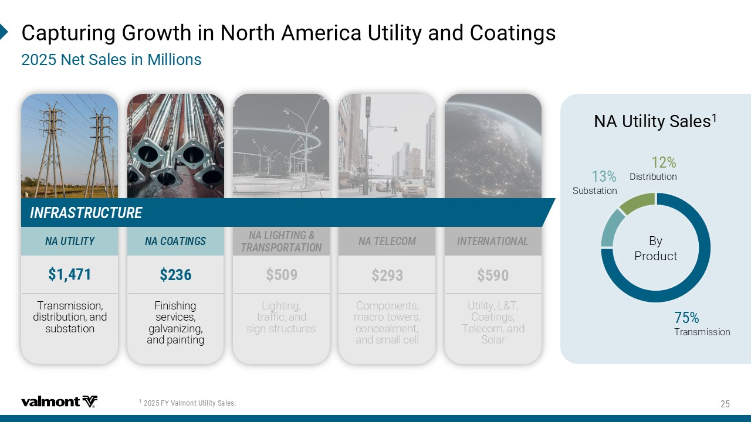
'ETXYVMRK+VS[XLMR2SVXL%QIVMGE9XMPMX]ERH'SEXMRKW 2IX7EPIWMR1MPPMSRW *=:EPQSRX9XMPMX]7EPIW By Product Substation Transmission Distribution 2%9XMPMX]7EPIW Lighting, traffic, and sign structures Finishing services, galvanizing, and painting Components, macro towers, concealment, and small cell Utility, L&T, Coatings, Telecom, and Solar Transmission, distribution, and substation 2%0-+,8-2+ 86%274368%8-32 2%'3%8-2+7 2%8)0)'31 -28)62%8-32%0 2%98-0-8= -2*6%7869'896)

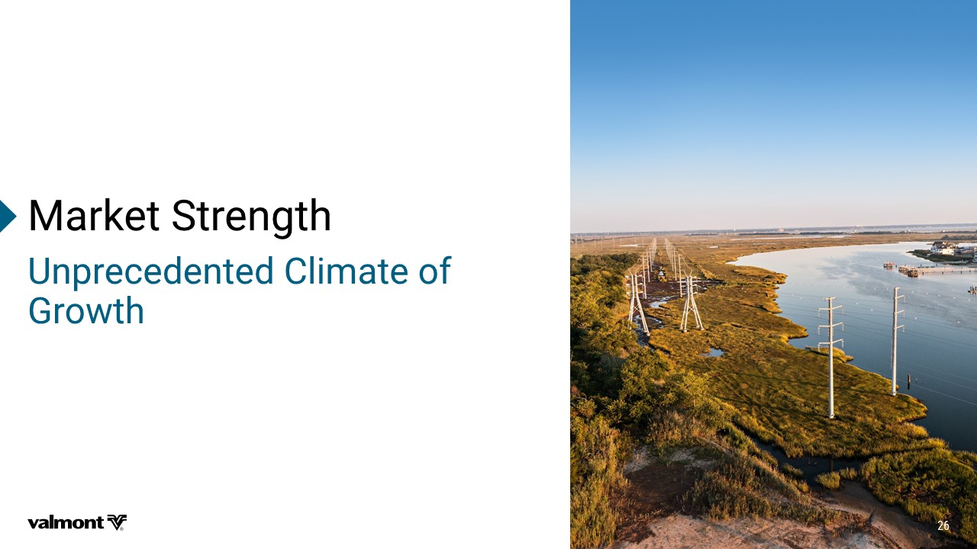
1EVOIX7XVIRKXL 9RTVIGIHIRXIH'PMQEXISJ +VS[XL

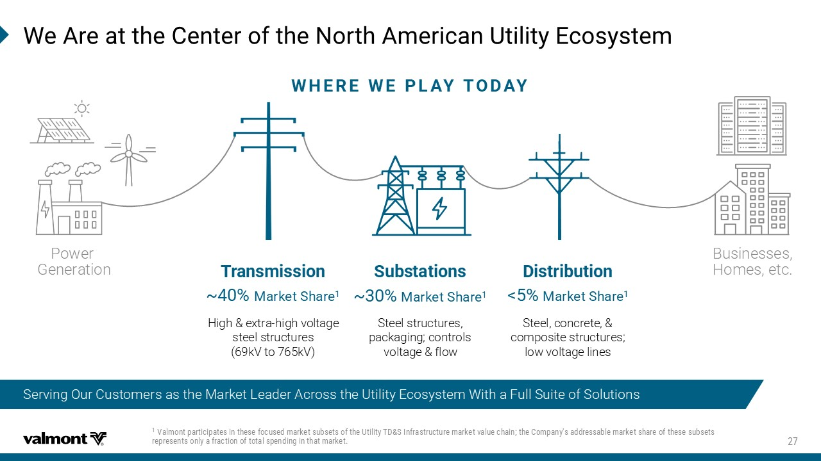
Serving Our Customers as the Market Leader Across the Utility Ecosystem With a Full Suite of Solutions ;I%VIEXXLI'IRXIVSJXLI2SVXL%QIVMGER9XMPMX])GSW]WXIQ ;,)6);)40%=83(%= Power Generation Businesses, Homes, etc. (MWXVMFYXMSR 1EVOIX7LEVI 7YFWXEXMSRW b 1EVOIX7LEVI 8VERWQMWWMSR b 1EVOIX7LEVI Steel, concrete, & composite structures; low voltage lines Steel structures, packaging; controls voltage & flow High & extra - high voltage steel structures (69kV to 765kV) :EPQSRXTEVXMGMTEXIWMRXLIWIJSGYWIHQEVOIXWYFWIXWSJXLI9XMPMX]8(7-RJVEWXVYGXYVIQEVOIXZEPYIGLEMRXLI'SQTER]WEHH VI WWEFPIQEVOIXWLEVISJXLIWIWYFWIXW VITVIWIRXWSRP]EJVEGXMSRSJXSXEPWTIRHMRKMRXLEXQEVOIX

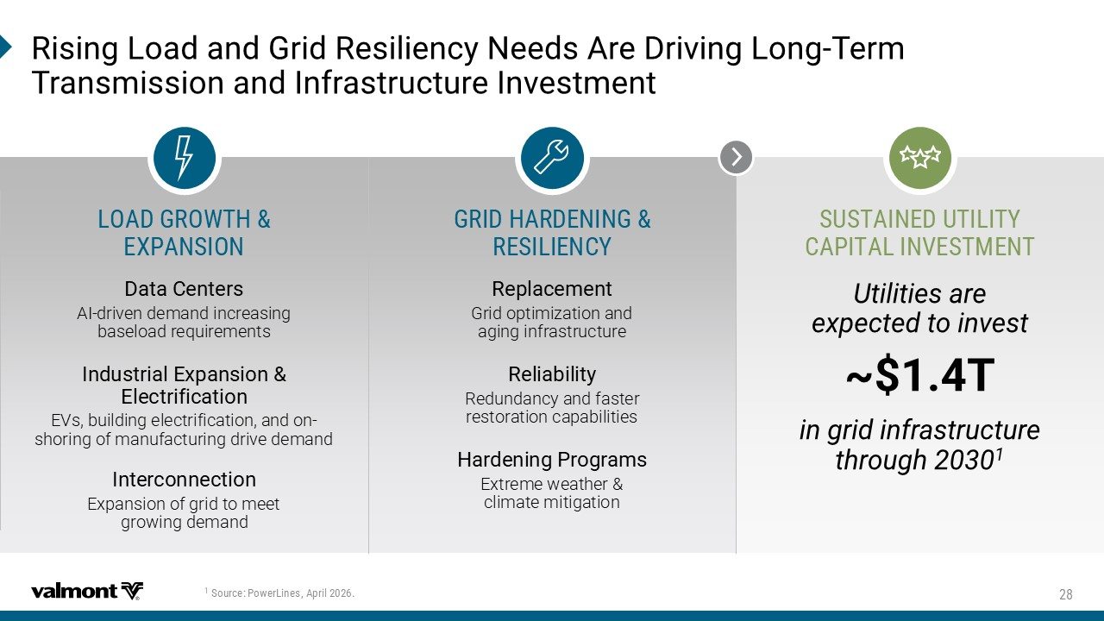
03%(+63;8, )<4%27-32 7978%-2)(98-0-8= '%4-8%0-2:)781)28 +6-(,%6()2-2+ 6)7-0-)2'= 6MWMRK0SEHERH+VMH6IWMPMIRG]2IIHW%VI(VMZMRK0SRK 8IVQ 8VERWQMWWMSRERH-RJVEWXVYGXYVI-RZIWXQIRX (EXE'IRXIVW AI - driven demand increasing baseload requirements -RHYWXVMEP)\TERWMSR )PIGXVMJMGEXMSR EVs, building electrification, and on - shoring of manufacturing drive demand -RXIVGSRRIGXMSR Expansion of grid to meet growing demand 6ITPEGIQIRX Grid optimization and aging infrastructure 6IPMEFMPMX] Redundancy and faster restoration capabilities ,EVHIRMRK4VSKVEQW Extreme weather & climate mitigation 7SYVGI 4S[IV0MRIW %TVMP 9XMPMXMIWEVI I\TIGXIHXSMRZIWX b8 MRKVMHMRJVEWXVYGXYVI XLVSYKL


*MVIWMHI'LEX :YNQNY^2FWPJY)WN[JWX .SI9PVMGL VP / GM, North America Utility .IER6SPPMRW Senior Advisor, Power Insights

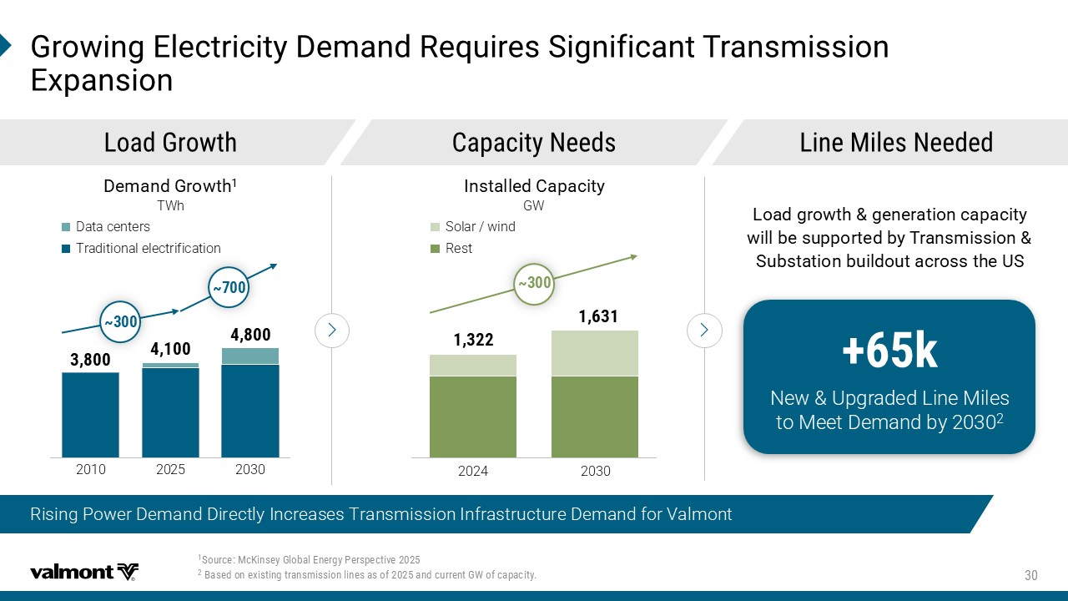
Rising Power Demand Directly Increases Transmission Infrastructure Demand for Valmont 7SYVGI1G/MRWI]+PSFEP)RIVK]4IVWTIGXMZI &EWIHSRI\MWXMRKXVERWQMWWMSRPMRIWEWSJERHGYVVIRX+;SJGETEGMX] +VS[MRK)PIGXVMGMX](IQERH6IUYMVIW7MKRMJMGERX8VERWQMWWMSR )\TERWMSR ​ 2024 ​ 2030 ​ ​ ​ 2010 ​ 20 25 ​ 2030 ​ ​ (IQERH+VS[XL TWh 0SEH+VS[XL 'ETEGMX]2IIHW 0MRI1MPIW2IIHIH -RWXEPPIH'ETEGMX] GW Data centers Traditional electrification Solar / wind Rest b b b O 3J\:ULWFIJI1NSJ2NQJX YT2JJY)JRFSIG^ 0SEHKVS[XLKIRIVEXMSRGETEGMX] [MPPFIWYTTSVXIHF]8VERWQMWWMSR 7YFWXEXMSRFYMPHSYXEGVSWWXLI97

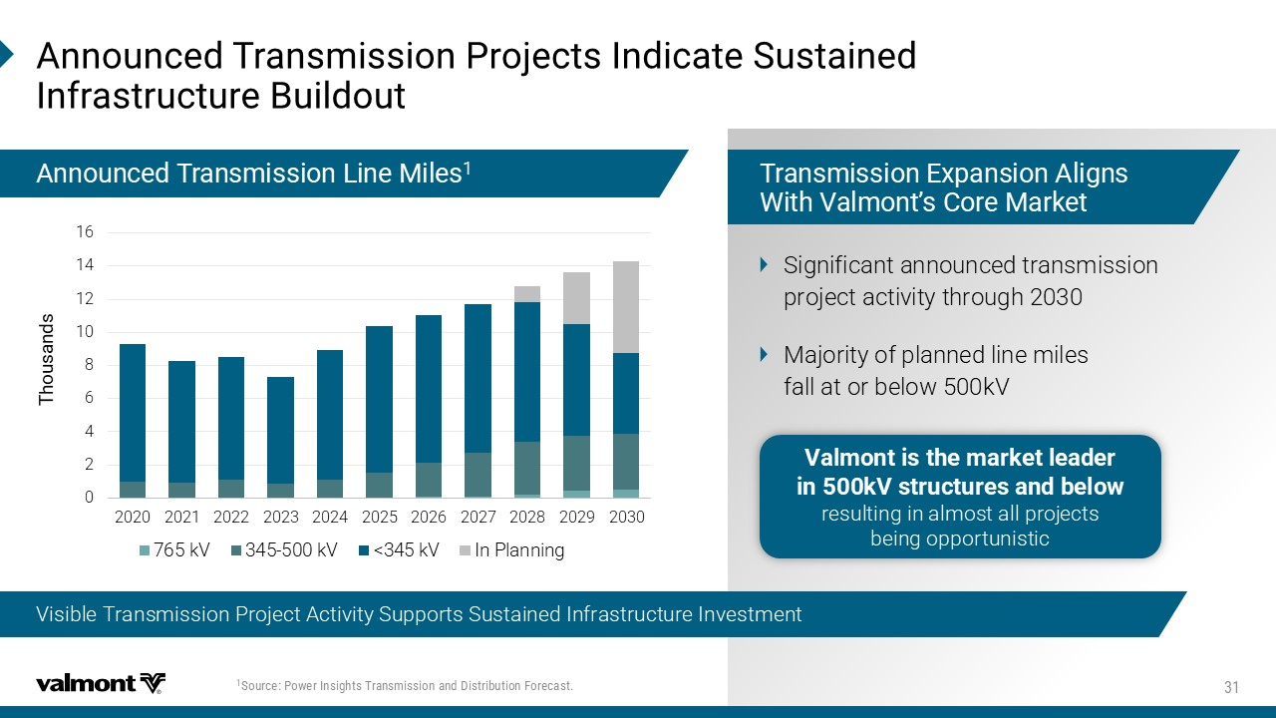
Visible Transmission Project Activity Supports Sustained Infrastructure Investment 7SYVGI4S[IV-RWMKLXW8VERWQMWWMSRERH(MWXVMFYXMSR*SVIGEWX %RRSYRGIH8VERWQMWWMSR4VSNIGXW-RHMGEXI7YWXEMRIH -RJVEWXVYGXYVI&YMPHSYX 0 2 4 6 8 10 12 14 16 2020 2021 2022 2023 2024 2025 2026 2027 2028 2029 2030 Thousands 765 kV 345-500 kV <345 kV In Planning 8VERWQMWWMSR)\TERWMSR%PMKRW ;MXL:EPQSRXƆW'SVI1EVOIX Significant announced transmission project activity through 2030 Majority of planned line miles fall at or below 500kV %RRSYRGIH8VERWQMWWMSR0MRI1MPIW Valmont is the market leader in 500kV structures and below WJXZQYNSLNSFQRTXYFQQUWTOJHYX GJNSLTUUTWYZSNXYNH

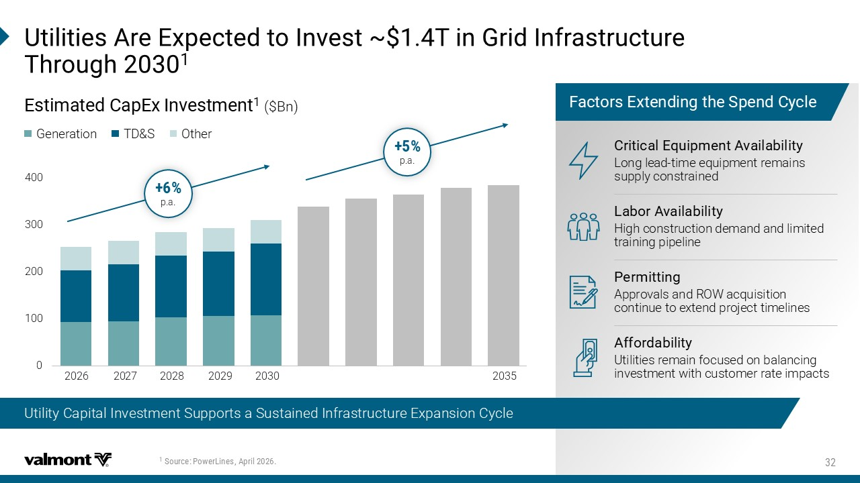
Utility Capital Investment Supports a Sustained Infrastructure Expansion Cycle 7SYVGI 4S[IV0MRIW %TVMP 9XMPMXMIW%VI)\TIGXIHXS-RZIWXb8MR+VMH-RJVEWXVYGXYVI 8LVSYKL 0 100 200 300 400 Thousands ​ 20 27 ​ 20 28 ​ 2029 ​ 20 30 ​ 2035 ​ 2026 *EGXSVW)\XIRHMRKXLI7TIRH']GPI )WXMQEXIH 'ET)\ -RZIWXQIRX ($Bn) Generation TD&S Other p.a. p.a. 'VMXMGEP)UYMTQIRX%ZEMPEFMPMX] Long lead - time equipment remains supply constrained 0EFSV%ZEMPEFMPMX] High construction demand and limited training pipeline 4IVQMXXMRK Approvals and ROW acquisition continue to extend project timelines %JJSVHEFMPMX] Utilities remain focused on balancing investment with customer rate impacts

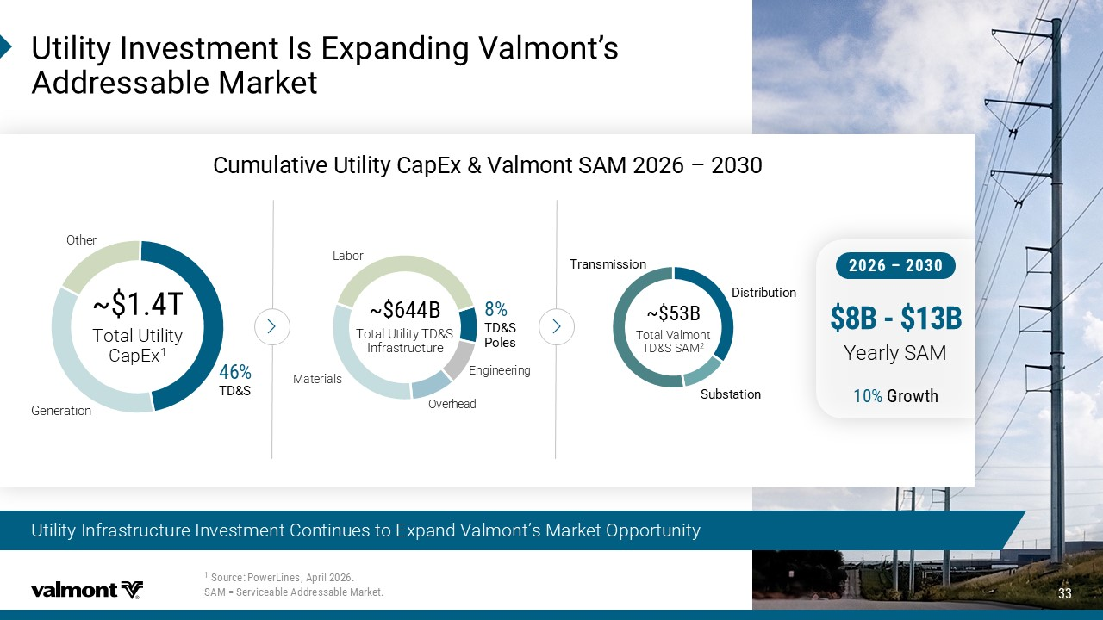
Utility Infrastructure Investment Continues to Expand Valmont’s Market Opportunity 9XMPMX]-RZIWXQIRX-W)\TERHMRK:EPQSRXƆW %HHVIWWEFPI1EVOIX 'YQYPEXMZI9XMPMX] 'ET)\ :EPQSRX7%1 Ƃ b8 Total Utility CapEx 1 Generation Other 8(7 8(7 4SPIW Overhead Materials Labor Engineering b & Total Utility TD&S Infrastructure (MWXVMFYXMSR 7YFWXEXMSR 8VERWQMWWMSR b & Total Valmont TD&S SAM 2 Ɓ & & Yearly SAM +VS[XL 7SYVGI 4S[IV0MRIW %TVMP 7%1!7IVZMGIEFPI%HHVIWWEFPI1EVOIX

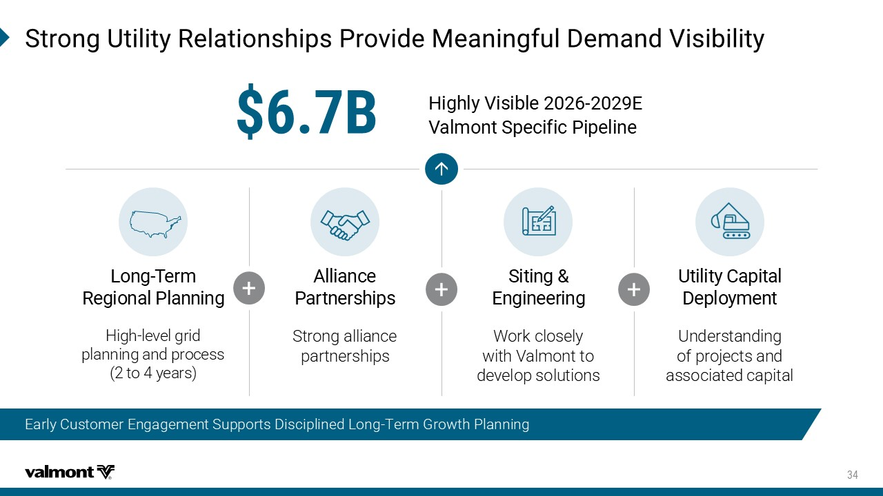
Early Customer Engagement Supports Disciplined Long - Term Growth Planning 7XVSRK9XMPMX]6IPEXMSRWLMTW4VSZMHI1IERMRKJYP(IQERH:MWMFMPMX] & -NLMQ^;NXNGQJ * ;FQRTSY8UJHNKNH5NUJQNSJ 9XMPMX]'ETMXEP (ITPS]QIRX Understanding of projects and associated capital 7MXMRK )RKMRIIVMRK Work closely with Valmont to develop solutions %PPMERGI 4EVXRIVWLMTW Strong alliance partnerships 0SRK 8IVQ 6IKMSREP4PERRMRK High - level grid planning and process (2 to 4 years) + + +

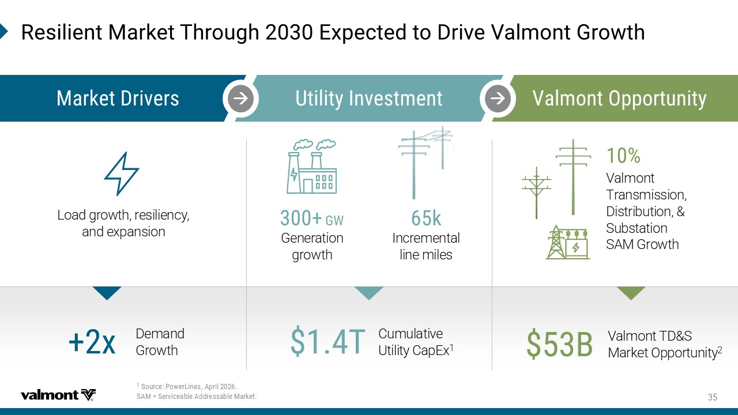
6IWMPMIRX1EVOIX8LVSYKL)\TIGXIHXS(VMZI:EPQSRX+VS[XL Load growth, resiliency, and expansion +; O 1EVOIX(VMZIVW 9XMPMX]-RZIWXQIRX :EPQSRX3TTSVXYRMX] Generation growth Incremental line miles Valmont Transmission, Distribution, & Substation SAM Growth Valmont TD&S Market Opportunity 2 & Cumulative Utility CapEx 1 8 Demand Growth \ 7SYVGI 4S[IV0MRIW %TVMP 7%1!7IVZMGIEFPI%HHVIWWEFPI1EVOIX

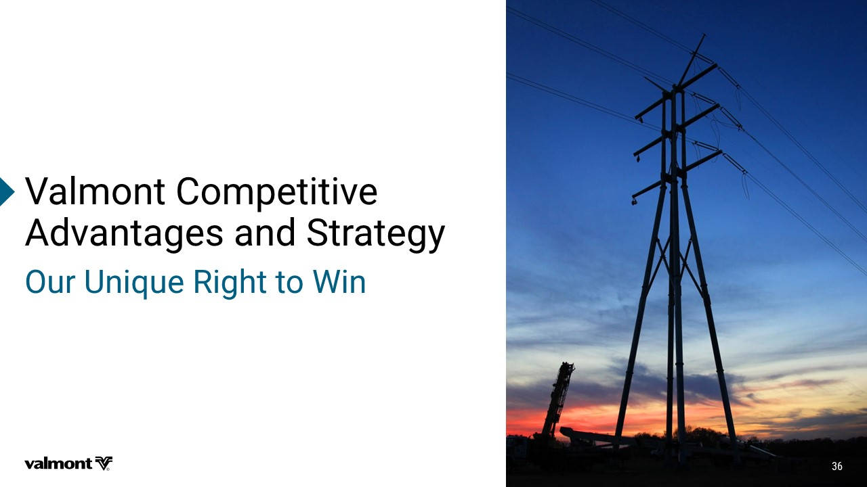
:EPQSRX'SQTIXMXMZI %HZERXEKIWERH7XVEXIK] 3YV9RMUYI6MKLXXS;MR

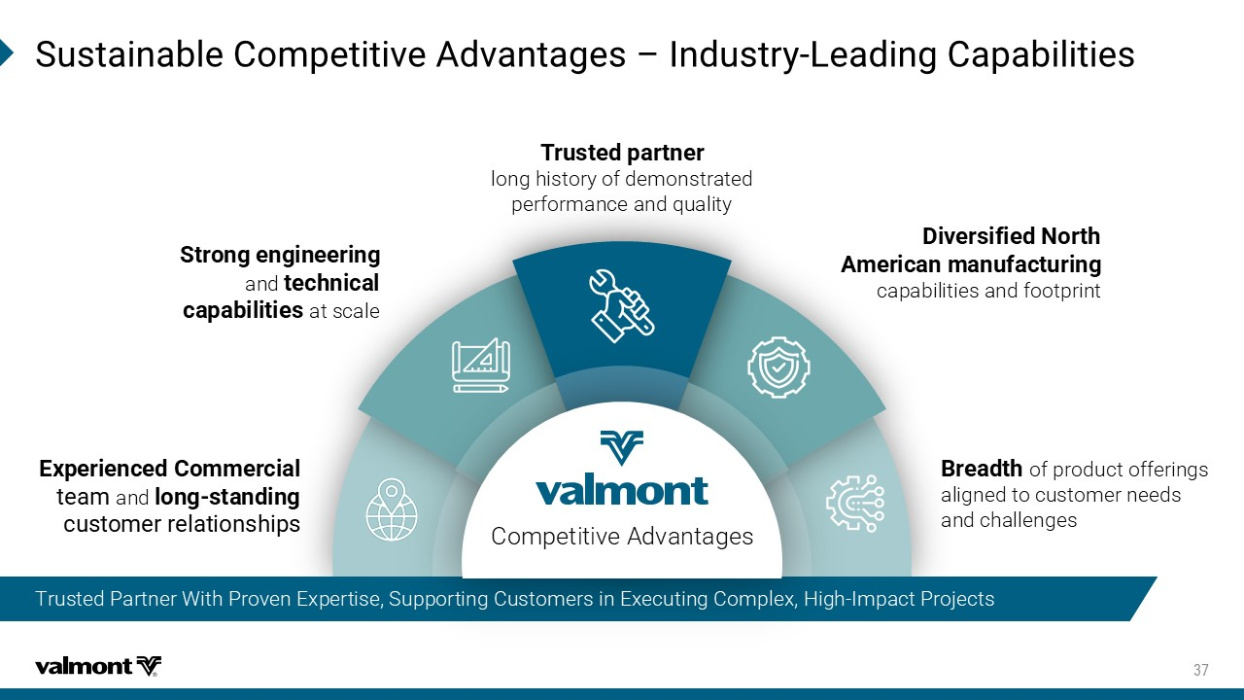
7YWXEMREFPI'SQTIXMXMZI%HZERXEKIW Ƃ -RHYWXV] 0IEHMRK'ETEFMPMXMIW 8VYWXIHTEVXRIV long history of demonstrated performance and quality (MZIVWMJMIH2SVXL %QIVMGERQERYJEGXYVMRK capabilities and footprint &VIEHXL of product offerings aligned to customer needs and challenges )\TIVMIRGIH'SQQIVGMEP XIEQ and PSRK WXERHMRK GYWXSQIVVIPEXMSRWLMTW Competitive Advantages 7XVSRKIRKMRIIVMRK and XIGLRMGEP GETEFMPMXMIW at scale Trusted Partner With Proven Expertise, Supporting Customers in Executing Complex, High - Impact Projects

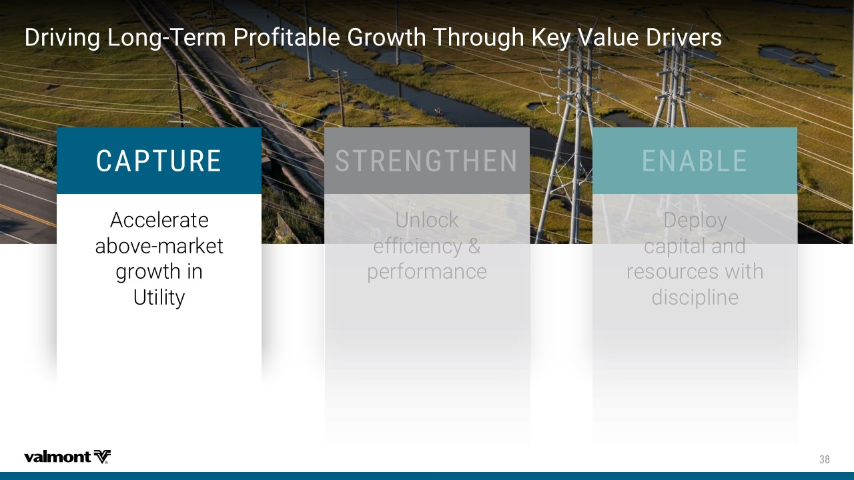
(VMZMRK0SRK 8IVQ4VSJMXEFPI+VS[XL8LVSYKL/I]:EPYI(VMZIVW '%4896) Accelerate above - market growth in Utility

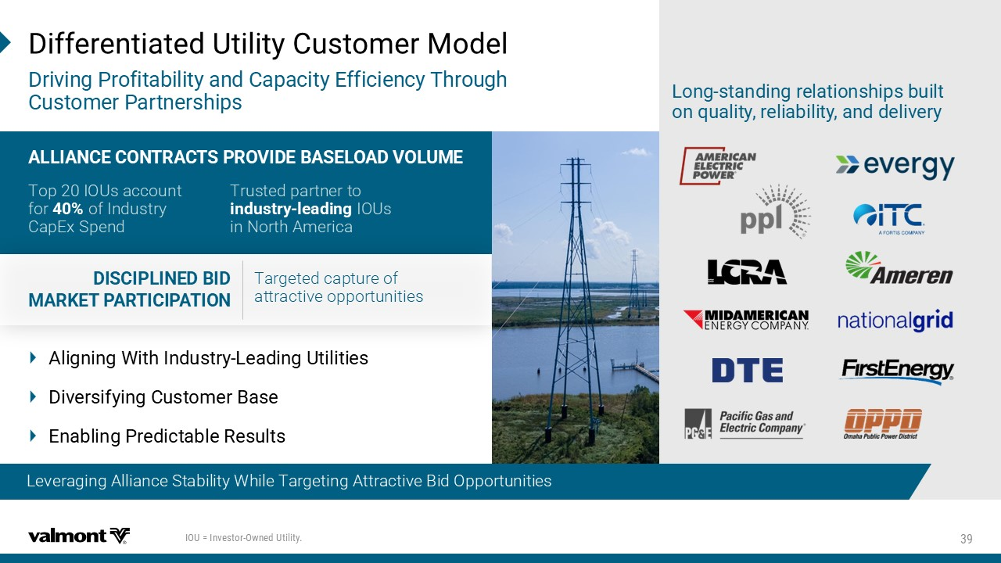
Leveraging Alliance Stability While Selectively Capturing Bid Opportunities (MJJIVIRXMEXIH9XMPMX]'YWXSQIV1SHIP (VMZMRK4VSJMXEFMPMX]ERH'ETEGMX])JJMGMIRG]8LVSYKL 'YWXSQIV4EVXRIVWLMTW 0SRK WXERHMRKVIPEXMSRWLMTWFYMPX SRUYEPMX]VIPMEFMPMX]ERHHIPMZIV] Leveraging Alliance Stability While Targeting Attractive Bid Opportunities (-7'-40-2)(&-( 1%6/)84%68-'-4%8-32 Targeted capture of attractive opportunities %00-%2')'3286%'87463:-()&%7)03%(:3091) Top 20 IOUs account for of Industry CapEx Spend Trusted partner to MRHYWXV] PIEHMRK IOUs in North America Aligning With Industry - Leading Utilities )N[JWXNK^NSL(ZXYTRJW'FXJ *SFGQNSL5WJINHYFGQJ7JXZQYX -39!-RZIWXSV 3[RIH9XMPMX]

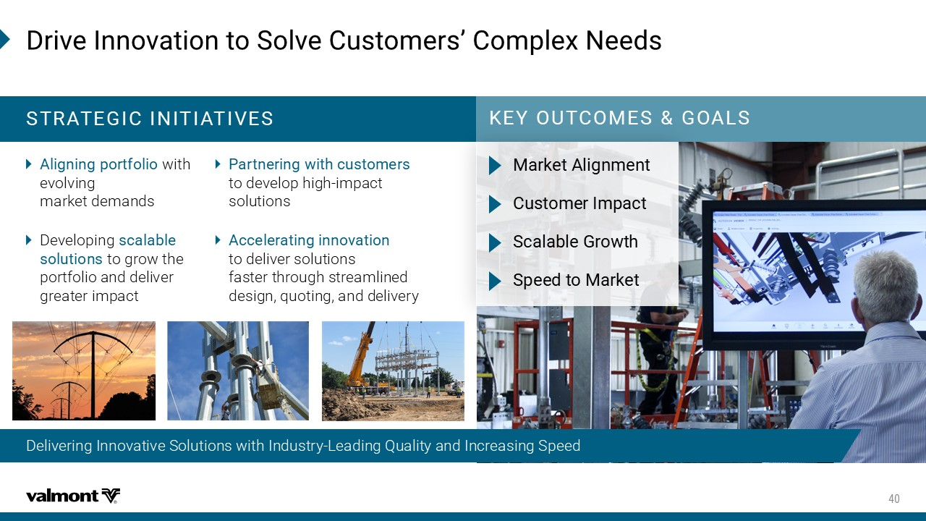
Delivering Innovative Solutions with Industry - Leading Quality and Increasing Speed (VMZI-RRSZEXMSRXS7SPZI'YWXSQIVWƆ'SQTPI\2IIHW /)=398'31)7+3%07 786%8)+-'-2-8-%8-:)7 %PMKRMRKTSVXJSPMS with evolving market demands Developing WGEPEFPI WSPYXMSRW to grow the portfolio and deliver greater impact 4EVXRIVMRK[MXLGYWXSQIVW to develop high - impact solutions %GGIPIVEXMRKMRRSZEXMSR to deliver solutions faster through streamlined design, quoting, and delivery 1EVOIX%PMKRQIRX 'YWXSQIV-QTEGX 7GEPEFPI+VS[XL 7TIIHXS1EVOIX

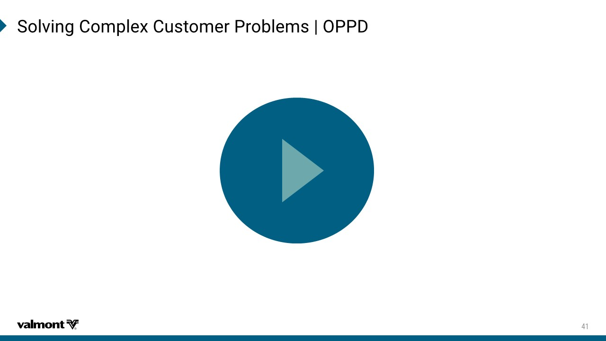
7SPZMRK'SQTPI\'YWXSQIV4VSFPIQW`344(

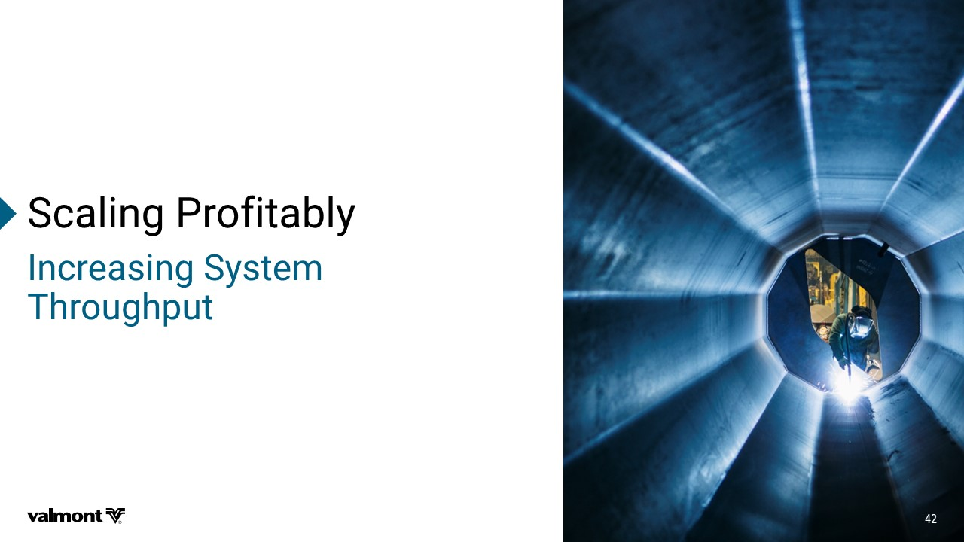
7GEPMRK4VSJMXEFP] -RGVIEWMRK7]WXIQ 8LVSYKLTYX

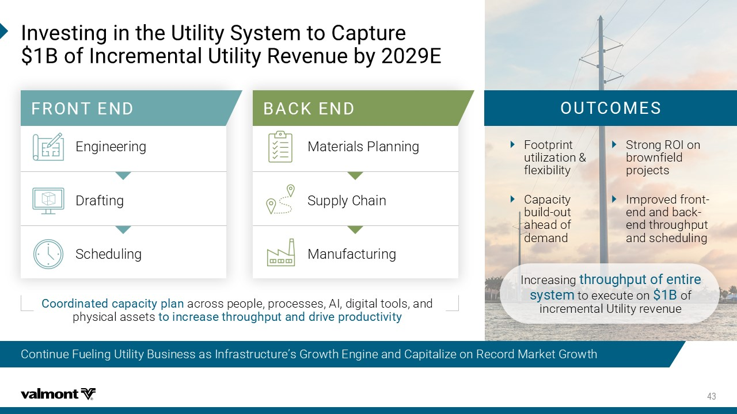
Continue Fueling Utility Business as Infrastructure’s Growth Engine and Capitalize on Record Market Growth -RZIWXMRKMRXLI9XMPMX]7]WXIQXS'ETXYVI &SJ-RGVIQIRXEP9XMPMX]6IZIRYIF]) *6328)2( &%'/)2( Engineering Materials Planning Drafting Supply Chain Scheduling Manufacturing 398'31)7 Footprint utilization & flexibility Capacity build - out ahead of demand Strong ROI on brownfield projects Improved front - end and back - end throughput and scheduling 'SSVHMREXIHGETEGMX]TPER across people, processes, AI, digital tools, and physical assets XSMRGVIEWIXLVSYKLTYXERHHVMZITVSHYGXMZMX] Increasing XLVSYKLTYX SJIRXMVI W]WXIQ to execute on & of incremental Utility revenue

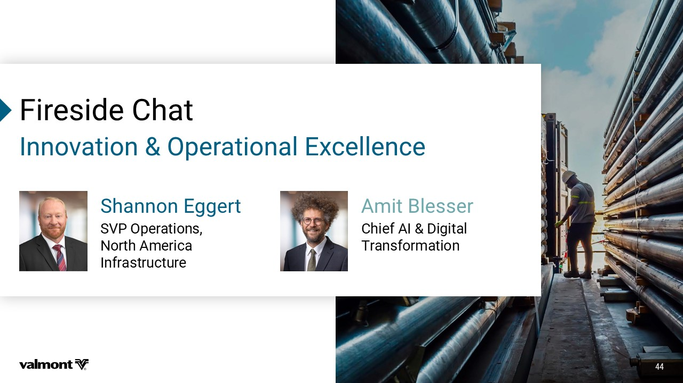
*MVIWMHI'LEX .SST[FYNTS4UJWFYNTSFQ*]HJQQJSHJ 7LERRSR)KKIVX SVP Operations, North America Infrastructure %QMX&PIWWIV Chief AI & Digital Transformation

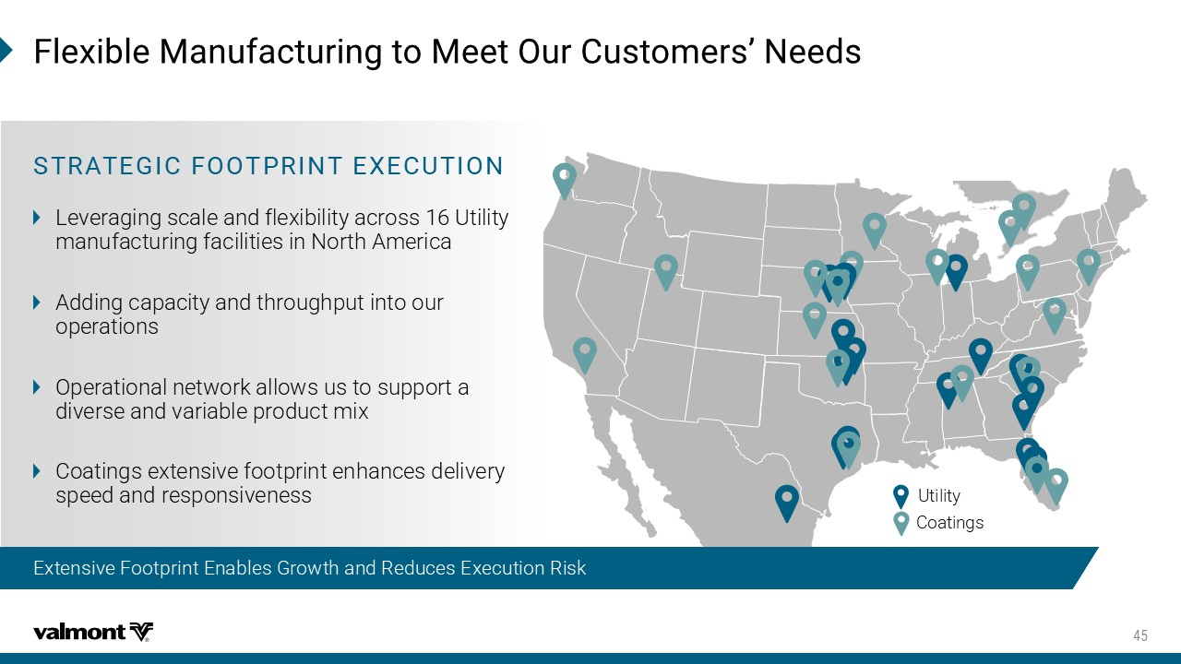
Utility Coatings *PI\MFPI1ERYJEGXYVMRKXS1IIX3YV'YWXSQIVWƆ2IIHW Extensive Footprint Enables Growth and Reduces Execution Risk 786%8)+-'*33846-28)<)'98-32 Leveraging scale and flexibility across 16 Utility manufacturing facilities in North America Adding capacity and throughput into our operations Operational network allows us to support a diverse and variable product mix Coatings extensive footprint enhances delivery speed and responsiveness

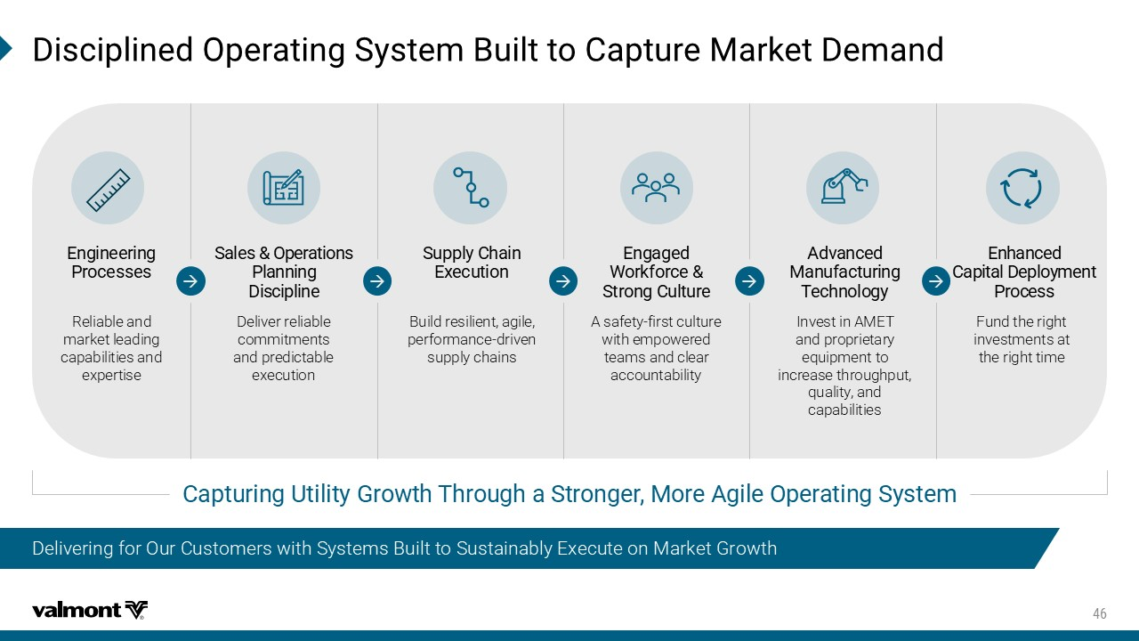
Delivering for Our Customers with Systems Built to Sustainably Execute on Market Growth (MWGMTPMRIH3TIVEXMRK7]WXIQ&YMPXXS'ETXYVI1EVOIX(IQERH 'ETXYVMRK9XMPMX]+VS[XL8LVSYKLE7XVSRKIV1SVI%KMPI3TIVEXMRK7]WXIQ 7EPIW3TIVEXMSRW 4PERRMRK (MWGMTPMRI 7YTTP]'LEMR )\IGYXMSR )RKEKIH ;SVOJSVGI 7XVSRK'YPXYVI %HZERGIH 1ERYJEGXYVMRK 8IGLRSPSK] Deliver reliable commitments and predictable execution Build resilient, agile, performance - driven supply chains A safety - first culture with empowered teams and clear accountability Invest in AMET and proprietary equipment to increase throughput, quality, and capabilities )RLERGIH 'ETMXEP(ITPS]QIRX 4VSGIWW Fund the right investments at the right time )RKMRIIVMRK 4VSGIWWIW Reliable and market leading capabilities and expertise

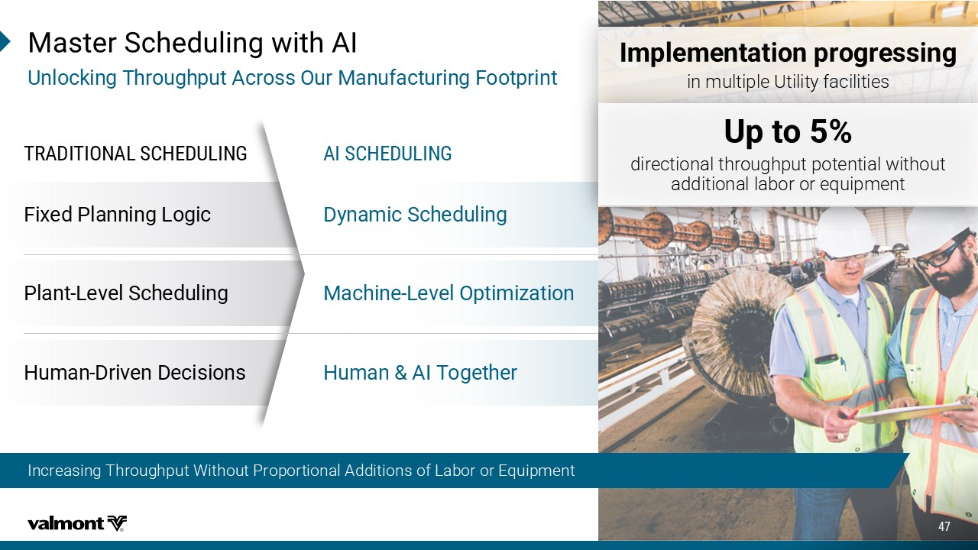
Fixed Planning Logic Plant - Level Scheduling Human - Driven Decisions 86%(-8-32%07',)(90-2+ Dynamic Scheduling Machine - Level Optimization Human & AI Together %-7',)(90-2+ Increasing Throughput Without Proportional Additions of Labor or Equipment 1EWXIV7GLIHYPMRK[MXL%- 9RPSGOMRK8LVSYKLTYX%GVSWW3YV1ERYJEGXYVMRK*SSXTVMRX Implementation progressing NSRZQYNUQJ:YNQNY^KFHNQNYNJX Up to 5% INWJHYNTSFQYMWTZLMUZYUTYJSYNFQ\NYMTZY FIINYNTSFQQFGTWTWJVZNURJSY

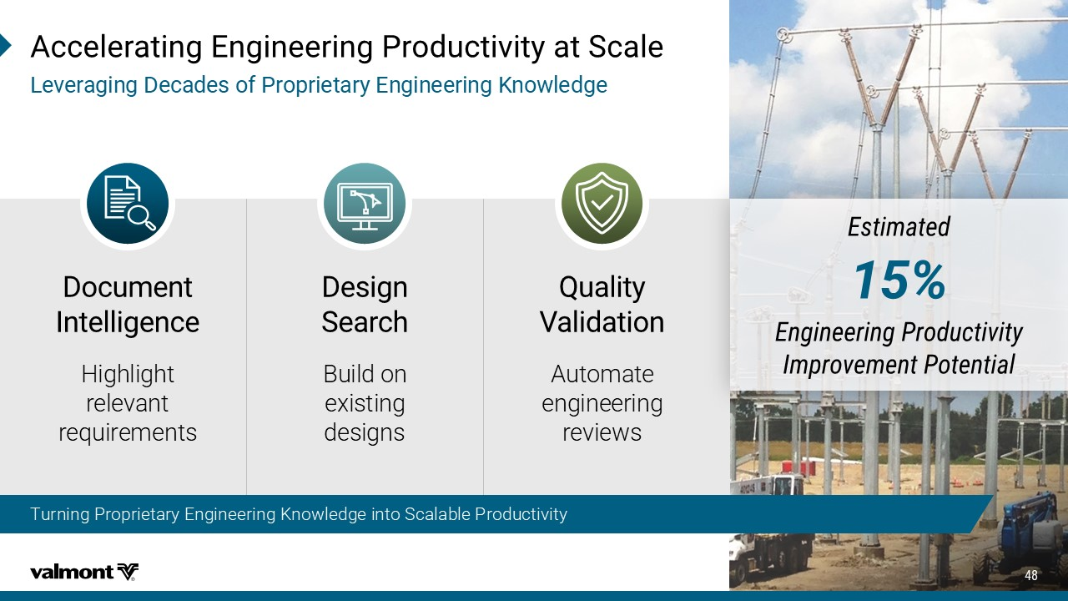
)WXMQEXIH )RKMRIIVMRK4VSHYGXMZMX] -QTVSZIQIRX4SXIRXMEP %GGIPIVEXMRK)RKMRIIVMRK4VSHYGXMZMX]EX7GEPI 0IZIVEKMRK(IGEHIWSJ4VSTVMIXEV])RKMRIIVMRK/RS[PIHKI (SGYQIRX -RXIPPMKIRGI (IWMKR 7IEVGL 5YEPMX] :EPMHEXMSR Highlight relevant requirements Build on existing designs Automate engineering reviews Turning Proprietary Engineering Knowledge into Scalable Productivity

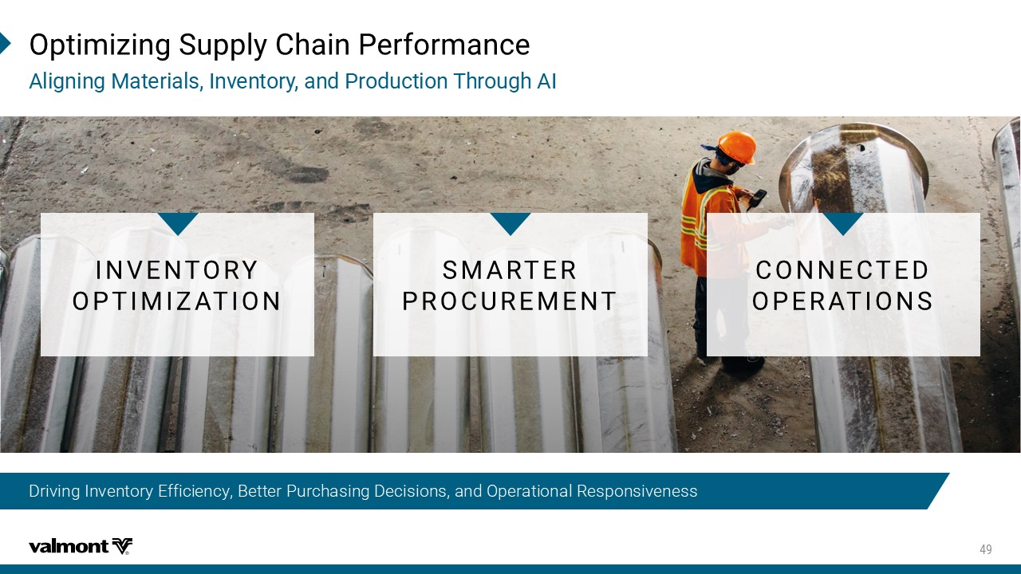
Driving Inventory Efficiency, Better Purchasing Decisions, and Operational Responsiveness 3TXMQM^MRK7YTTP]'LEMR4IVJSVQERGI %PMKRMRK1EXIVMEPW-RZIRXSV]ERH4VSHYGXMSR8LVSYKL%- -2:)2836= 348-1->%8-32 71%68)6 463'96)1)28 '322)'8)( 34)6%8-327

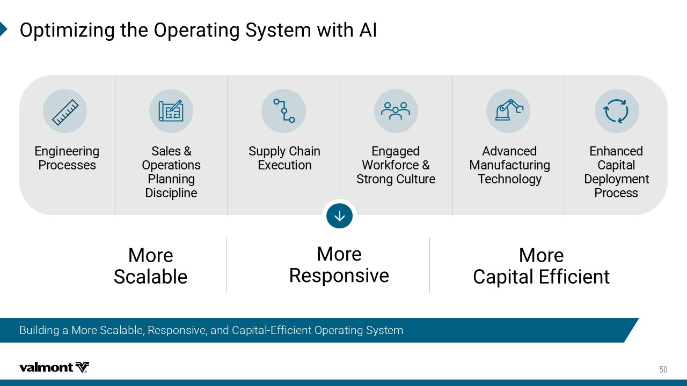
Building a More Scalable, Responsive, and Capital - Efficient Operating System 3TXMQM^MRKXLI3TIVEXMRK7]WXIQ[MXL%- 1SVI 7GEPEFPI 1SVI 6IWTSRWMZI 1SVI 'ETMXEP)JJMGMIRX 7EPIW 3TIVEXMSRW 4PERRMRK (MWGMTPMRI 7YTTP]'LEMR )\IGYXMSR )RKEKIH ;SVOJSVGI 7XVSRK'YPXYVI %HZERGIH 1ERYJEGXYVMRK 8IGLRSPSK] )RLERGIH 'ETMXEP (ITPS]QIRX 4VSGIWW )RKMRIIVMRK 4VSGIWWIW

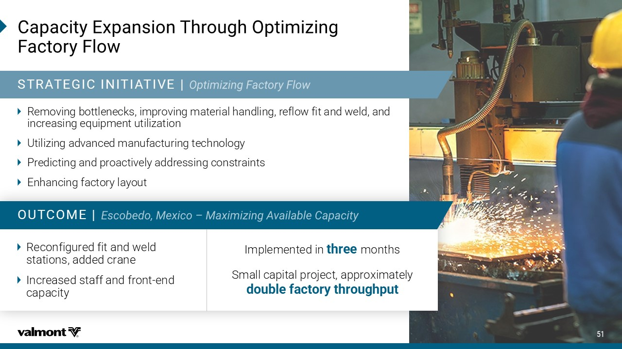
'ETEGMX])\TERWMSR8LVSYKL3TXMQM^MRK *EGXSV]*PS[ 786%8)+-'-2-8-%8-:)` Removing bottlenecks, improving material handling, reflow fit and weld, and increasing equipment utilization Utilizing advanced manufacturing technology Predicting and proactively addressing constraints Enhancing factory layout Implemented in three months Small capital project, approximately double factory throughput Reconfigured fit and weld stations, added crane Increased staff and front - end capacity 398'31)`

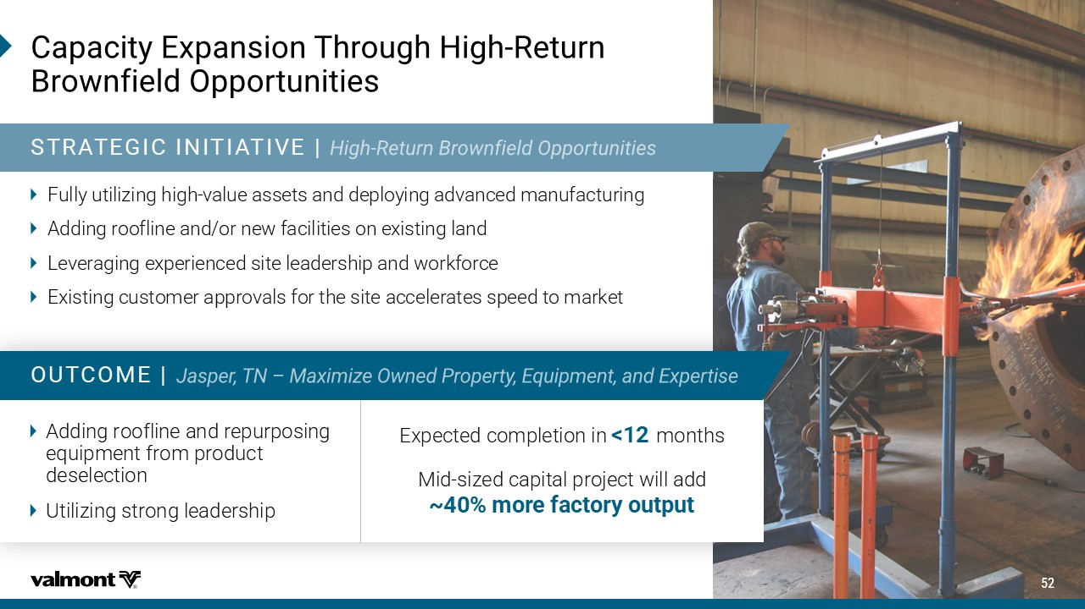
'ETEGMX])\TERWMSR8LVSYKL,MKL 6IXYVR &VS[RJMIPH3TTSVXYRMXMIW 786%8)+-'-2-8-%8-:)` Fully utilizing high - value assets and deploying advanced manufacturing Adding roofline and/or new facilities on existing land Leveraging experienced site leadership and workforce Existing customer approvals for the site accelerates speed to market Expected completion in <12 months Mid - sized capital project will add ~40% more factory output Adding roofline and repurposing equipment from product deselection Utilizing strong leadership 398'31)`

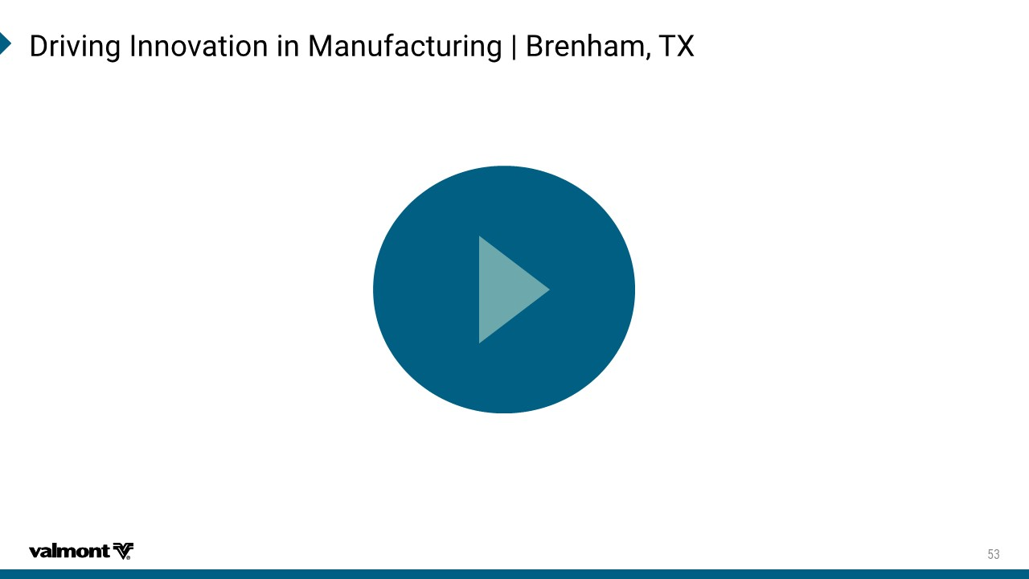
(VMZMRK-RRSZEXMSRMR1ERYJEGXYVMRK`&VIRLEQ8<

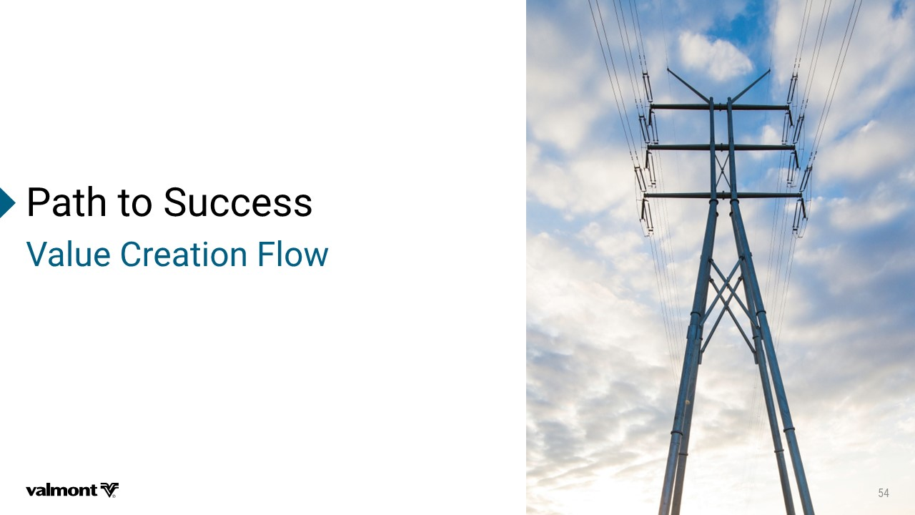
4EXLXS7YGGIWW :EPYI'VIEXMSR*PS[

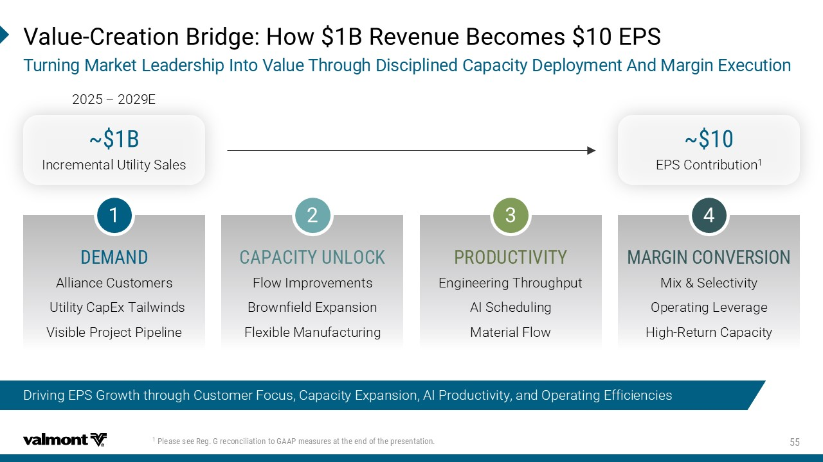
4PIEWIWII6IK+VIGSRGMPMEXMSRXS+%%4QIEWYVIWEXXLIIRHSJXLITVIWIRXEXMSR :EPYI 'VIEXMSR&VMHKI,S[&6IZIRYI&IGSQIW)47 8YVRMRK1EVOIX0IEHIVWLMT-RXS:EPYI8LVSYKL(MWGMTPMRIH'ETEGMX](ITPS]QIRX%RH1EVKMR)\IGYXMSR b& Incremental Utility Sales b EPS Contribution 1 ()1%2( '%4%'-8=9203'/ 463(9'8-:-8= 1%6+-2'32:)67-32 Alliance Customers Flow Improvements Engineering Throughput Mix & Selectivity Utility CapEx Tailwinds Brownfield Expansion AI Scheduling Operating Leverage Visible Project Pipeline Flexible Manufacturing Material Flow High - Return Capacity 2025 – 2029E Driving EPS Growth through Customer Focus, Capacity Expansion, AI Productivity, and Operating Efficiencies

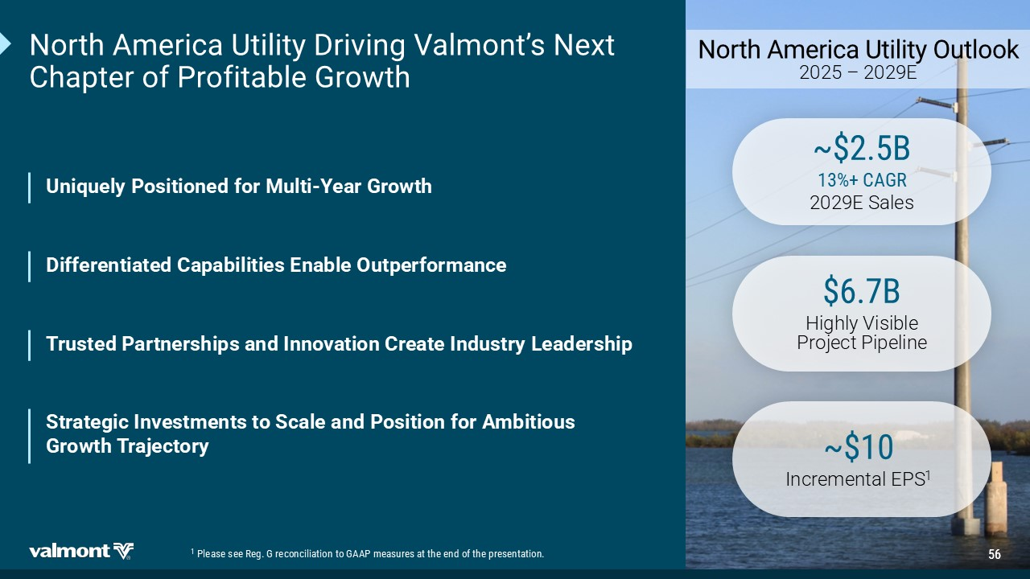
2SVXL%QIVMGE9XMPMX](VMZMRK:EPQSRXƆW2I\X 'LETXIVSJ4VSJMXEFPI+VS[XL 9RMUYIP]4SWMXMSRIHJSV1YPXM =IEV+VS[XL 2SVXL%QIVMGE9XMPMX]3YXPSSO 2025 – 2029E b& '%+6 2029E Sales & Highly Visible Project Pipeline b Incremental EPS 1 (MJJIVIRXMEXIH'ETEFMPMXMIW)REFPI3YXTIVJSVQERGI 8VYWXIH4EVXRIVWLMTWERH-RRSZEXMSR'VIEXI-RHYWXV]0IEHIVWLMT 7XVEXIKMG-RZIWXQIRXWXS7GEPIERH4SWMXMSRJSV%QFMXMSYW +VS[XL8VENIGXSV] 4PIEWIWII6IK+VIGSRGMPMEXMSRXS+%%4QIEWYVIWEXXLIIRHSJXLITVIWIRXEXMSR

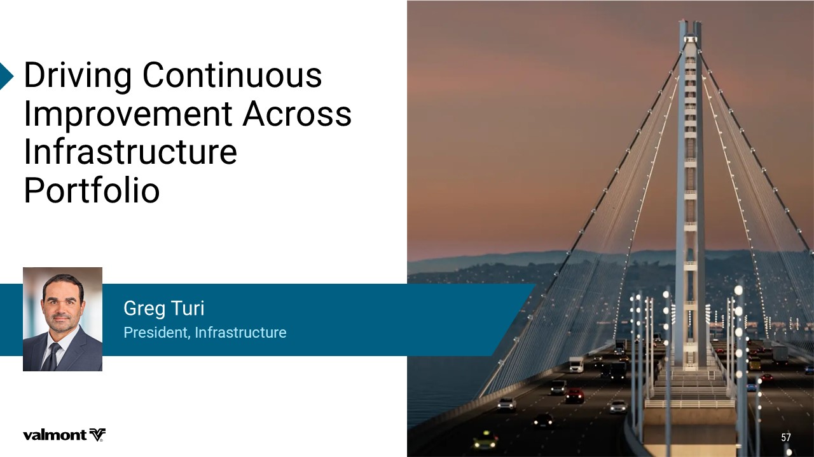
(VMZMRK'SRXMRYSYW -QTVSZIQIRX%GVSWW -RJVEWXVYGXYVI 4SVXJSPMS 4VIWMHIRX-RJVEWXVYGXYVI +VIK8YVM

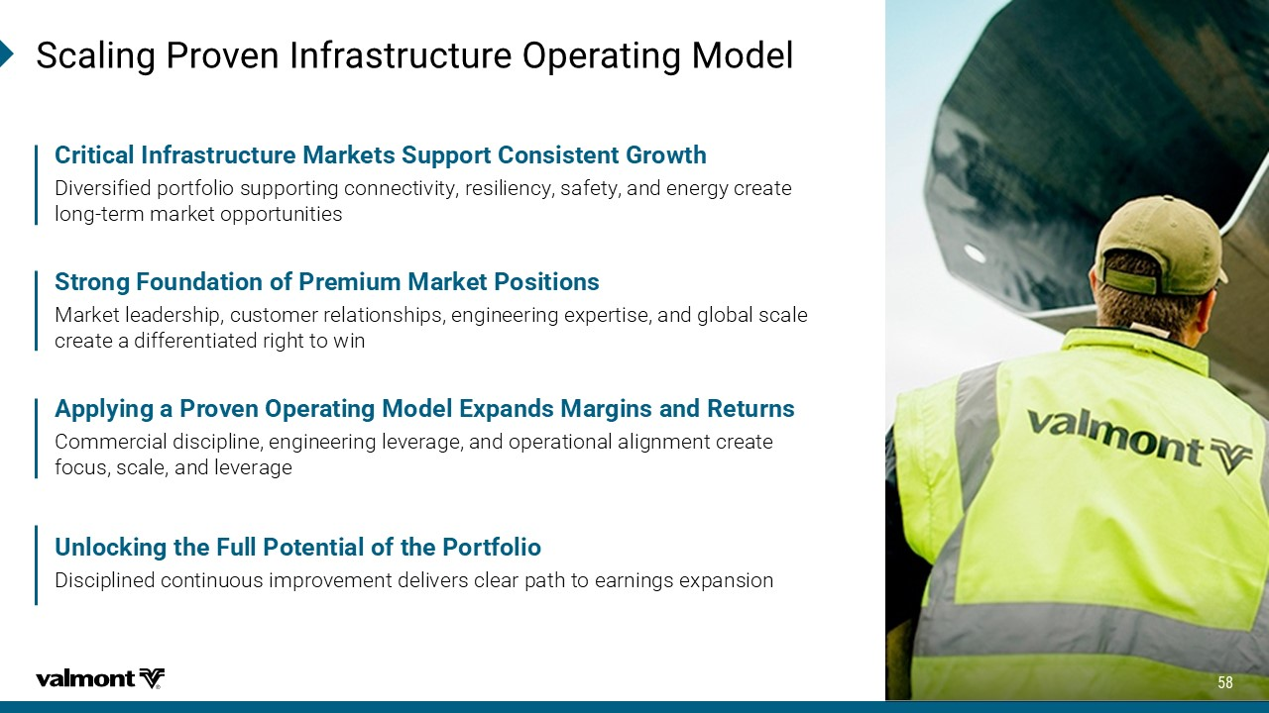
7GEPMRK4VSZIR-RJVEWXVYGXYVI3TIVEXMRK1SHIP 7XVSRK*SYRHEXMSRSJ4VIQMYQ1EVOIX4SWMXMSRW Market leadership, customer relationships, engineering expertise, and global scale create a differentiated right to win ​ %TTP]MRKE4VSZIR3TIVEXMRK1SHIP)\TERHW1EVKMRWERH6IXYVRW Commercial discipline, engineering leverage, and operational alignment create focus, scale, and leverage​ 'VMXMGEP-RJVEWXVYGXYVI1EVOIXW7YTTSVX'SRWMWXIRX+VS[XL Diversified portfolio supporting connectivity, resiliency, safety, and energy create long - term market opportunities 9RPSGOMRKXLI*YPP4SXIRXMEPSJXLI4SVXJSPMS Disciplined continuous improvement delivers clear path to earnings expansion

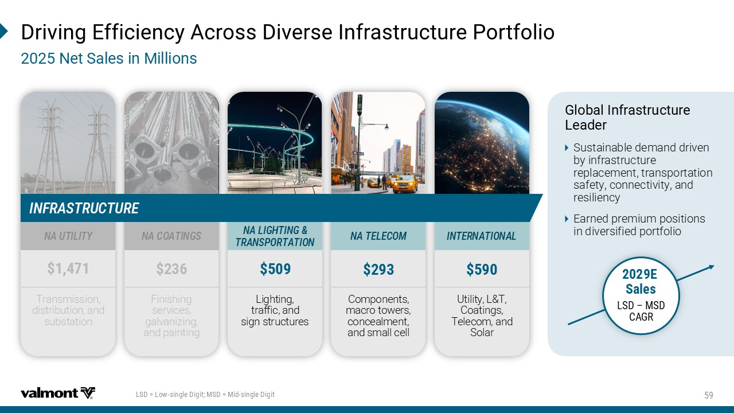
(VMZMRK)JJMGMIRG]%GVSWW(MZIVWI-RJVEWXVYGXYVI4SVXJSPMS 2IX7EPIWMR1MPPMSRW 07(!0S[ WMRKPI(MKMX17(!1MH WMRKPI(MKMX +PSFEP-RJVEWXVYGXYVI 0IEHIV Sustainable demand driven by infrastructure replacement, transportation safety, connectivity, and resiliency Earned premium positions in diversified portfolio Lighting, traffic, and sign structures Finishing services, galvanizing, and painting Components, macro towers, concealment, and small cell Utility, L&T, Coatings, Telecom, and Solar Transmission, distribution, and substation 2%0-+,8-2+ 86%274368%8-32 2%'3%8-2+7 2%8)0)'31 -28)62%8-32%0 2%98-0-8= -2*6%7869'896) ) 7EPIW 07( Ɓ 17( '%+6

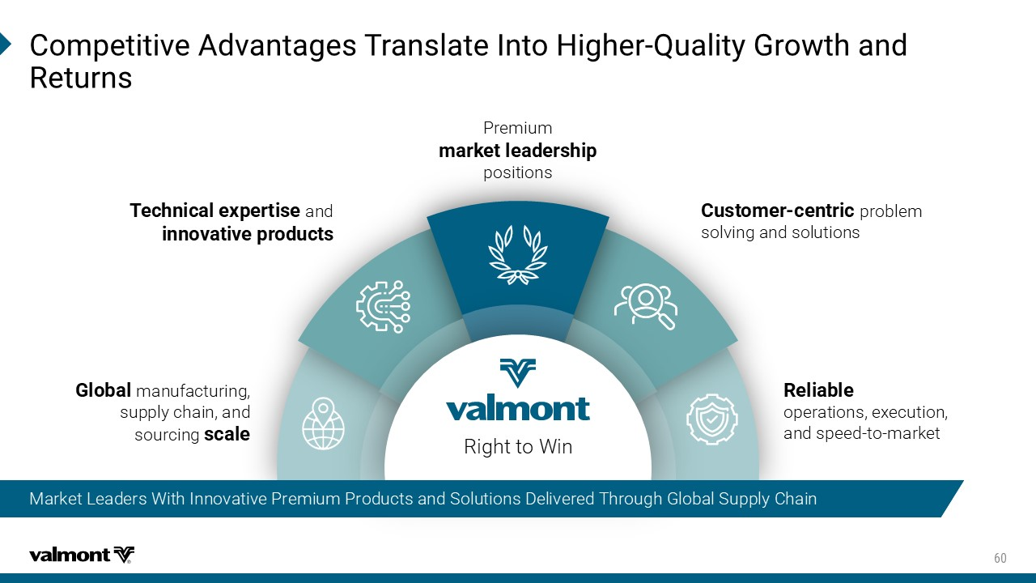
'SQTIXMXMZI%HZERXEKIW8VERWPEXI-RXS,MKLIV 5YEPMX]+VS[XLERH 6IXYVRW Premium QEVOIXPIEHIVWLMT positions 8IGLRMGEPI\TIVXMWI and MRRSZEXMZITVSHYGXW 'YWXSQIV GIRXVMG problem solving and solutions 6IPMEFPI operations, execution, and speed - to - market +PSFEP manufacturing, supply chain, and sourcing WGEPI Right to Win Market Leaders With Innovative Premium Products and Solutions Delivered Through Global Supply Chain

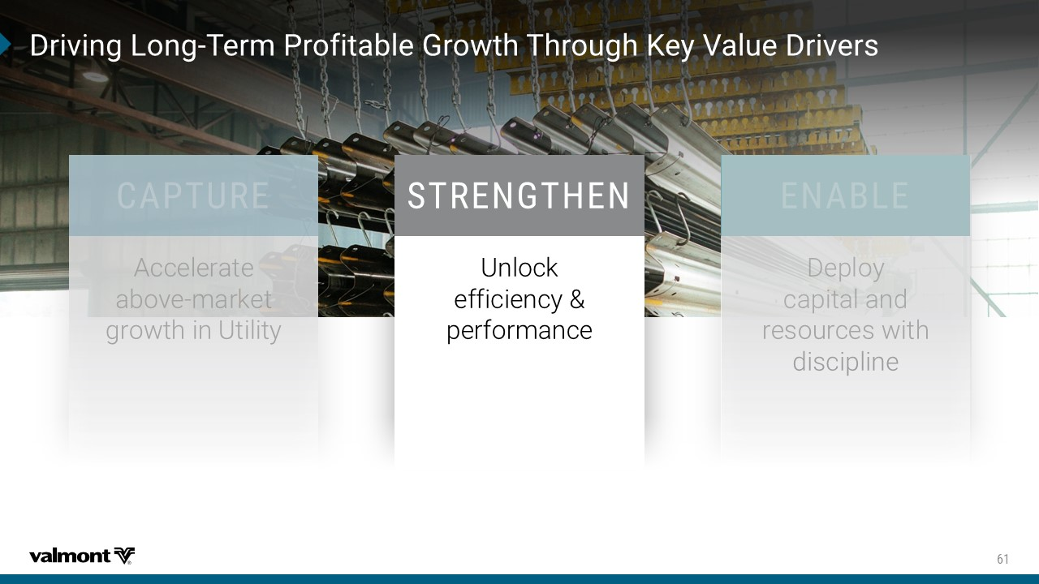
(VMZMRK0SRK 8IVQ4VSJMXEFPI+VS[XL8LVSYKL/I]:EPYI(VMZIVW 786)2+8,)2 Unlock efficiency & performance

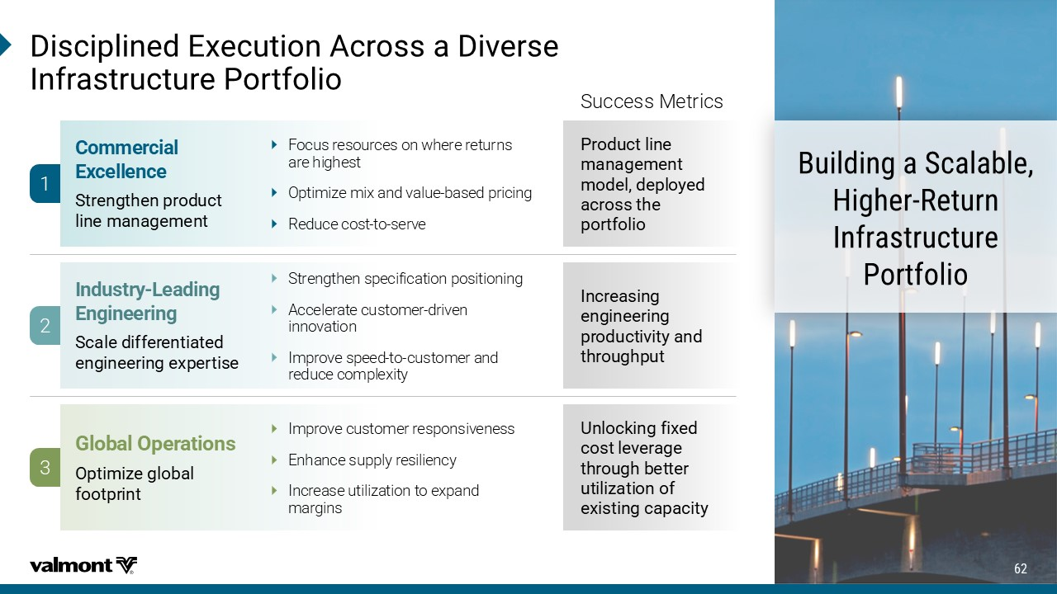
1 2 3 Focus resources on where returns are highest Optimize mix and value - based pricing Reduce cost - to - serve &YMPHMRKE7GEPEFPI ,MKLIV 6IXYVR -RJVEWXVYGXYVI 4SVXJSPMS Strengthen specification positioning Accelerate customer - driven innovation Improve speed - to - customer and reduce complexity Improve customer responsiveness Enhance supply resiliency Increase utilization to expand margins 'SQQIVGMEP )\GIPPIRGI 8YWJSLYMJSUWTIZHY QNSJRFSFLJRJSY -RHYWXV] 0IEHMRK )RKMRIIVMRK 8HFQJINKKJWJSYNFYJI JSLNSJJWNSLJ]UJWYNXJ +PSFEP3TIVEXMSRW 4UYNRN_JLQTGFQ KTTYUWNSY (MWGMTPMRIH)\IGYXMSR%GVSWWE(MZIVWI -RJVEWXVYGXYVI4SVXJSPMS 5WTIZHYQNSJ RFSFLJRJSY RTIJQIJUQT^JI FHWTXXYMJ UTWYKTQNT .SHWJFXNSL JSLNSJJWNSL UWTIZHYN[NY^FSI YMWTZLMUZY :SQTHPNSLKN]JI HTXYQJ[JWFLJ YMWTZLMGJYYJW ZYNQN_FYNTSTK J]NXYNSLHFUFHNY^ Success Metrics

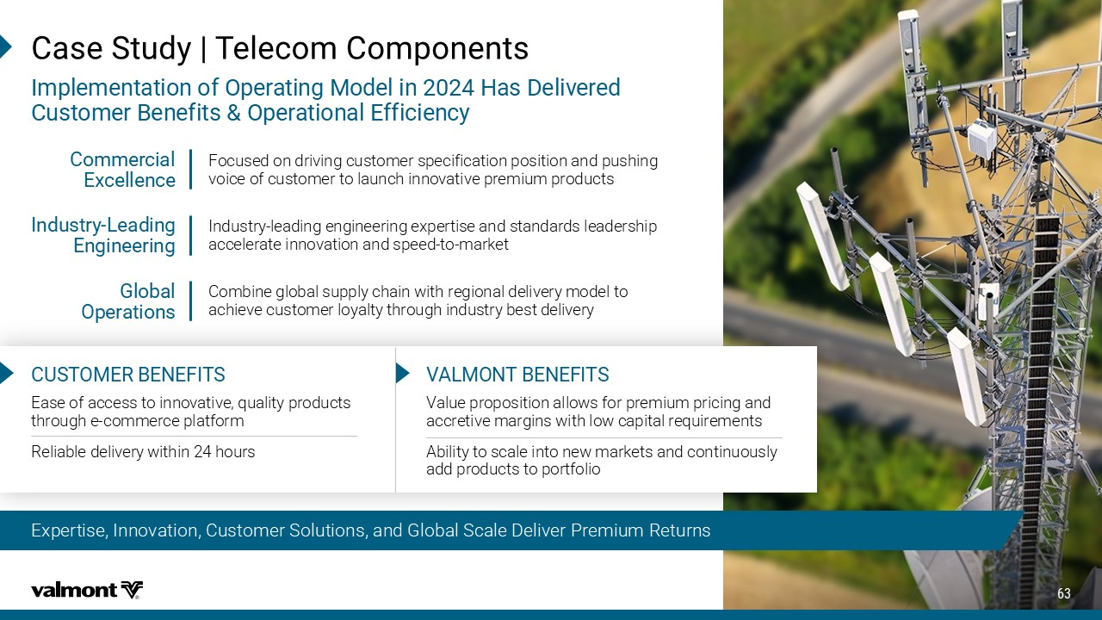
Expertise, Innovation, Customer Solutions, and Global Scale Deliver Premium Returns 'EWI7XYH]`8IPIGSQ'SQTSRIRXW -QTPIQIRXEXMSRSJ3TIVEXMRK1SHIPMR,EW(IPMZIVIH 'YWXSQIV&IRIJMXW3TIVEXMSREP)JJMGMIRG] '97831)6&)2)*-87 Ease of access to innovative, quality products through e - commerce platform Reliable delivery within 24 hours Value proposition allows for premium pricing and accretive margins with low capital requirements Ability to scale into new markets and continuously add products to portfolio :%01328&)2)*-87 'SQQIVGMEP )\GIPPIRGI -RHYWXV] 0IEHMRK )RKMRIIVMRK +PSFEP 3TIVEXMSRW Focused on driving customer specification position and pushing voice of customer to launch innovative premium products Industry - leading engineering expertise and standards leadership accelerate innovation and speed - to - market Combine global supply chain with regional delivery model to achieve customer loyalty through industry best delivery

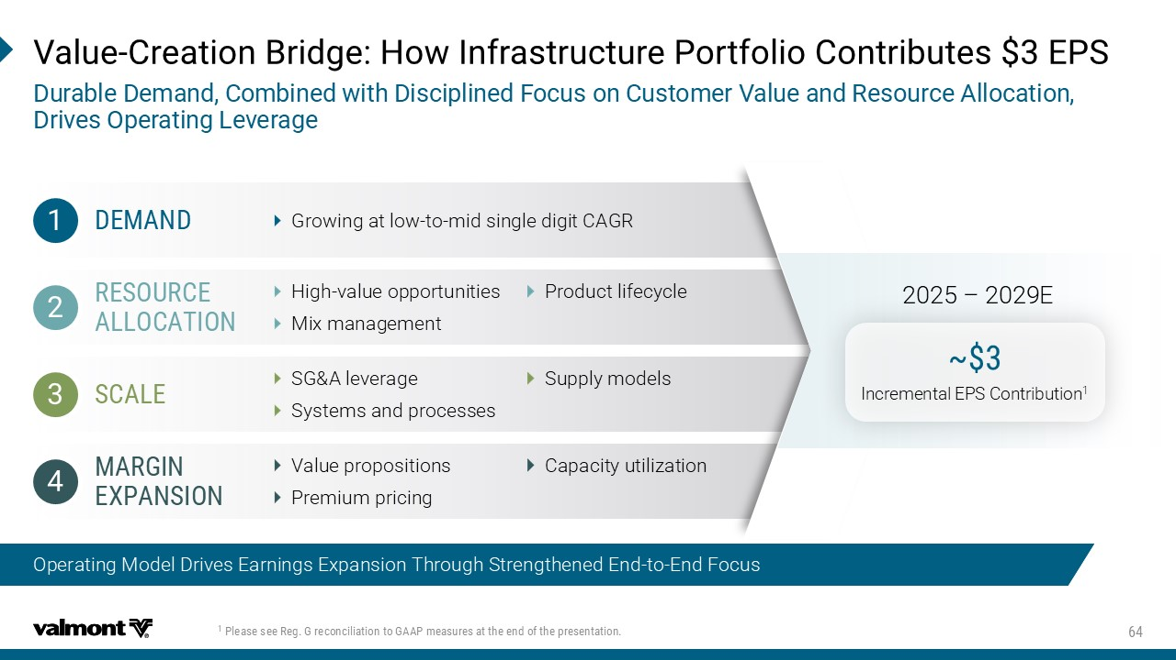
Growing at low - to - mid single digit CAGR High - value opportunities Mix management SG&A leverage Systems and processes Value propositions Premium pricing Operating Model Drives Earnings Expansion Through Strengthened End - to - End Focus :EPYI 'VIEXMSR&VMHKI,S[-RJVEWXVYGXYVI4SVXJSPMS'SRXVMFYXIW)47 (YVEFPI(IQERH'SQFMRIH[MXL(MWGMTPMRIH*SGYWSR'YWXSQIV:EPYIERH6IWSYVGI%PPSGEXMSR (VMZIW3TIVEXMRK0IZIVEKI Product lifecycle Supply models Capacity utilization b Incremental EPS Contribution 1 2025 – 2029E 4PIEWIWII6IK+VIGSRGMPMEXMSRXS+%%4QIEWYVIWEXXLIIRHSJXLITVIWIRXEXMSR ()1%2( 6)7396') %003'%8-32 7'%0) 1%6+-2 )<4%27-32

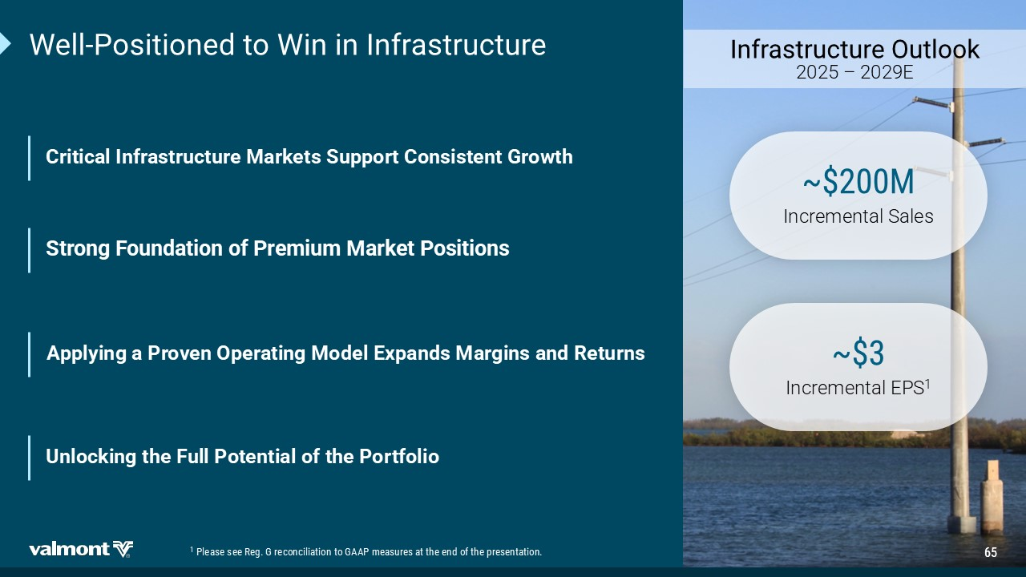
;IPP 4SWMXMSRIHXS;MRMR-RJVEWXVYGXYVI -RJVEWXVYGXYVI3YXPSSO 2025 – 2029E 'VMXMGEP-RJVEWXVYGXYVI1EVOIXW7YTTSVX'SRWMWXIRX+VS[XL 7XVSRK*SYRHEXMSRSJ4VIQMYQ1EVOIX4SWMXMSRW %TTP]MRKE4VSZIR3TIVEXMRK1SHIP)\TERHW1EVKMRWERH6IXYVRW b1 Incremental Sales b Incremental EPS 1 9RPSGOMRKXLI*YPP4SXIRXMEPSJXLI4SVXJSPMS 4PIEWIWII6IK+VIGSRGMPMEXMSRXS+%%4QIEWYVIWEXXLIIRHSJXLITVIWIRXEXMSR


5%


&VIEO

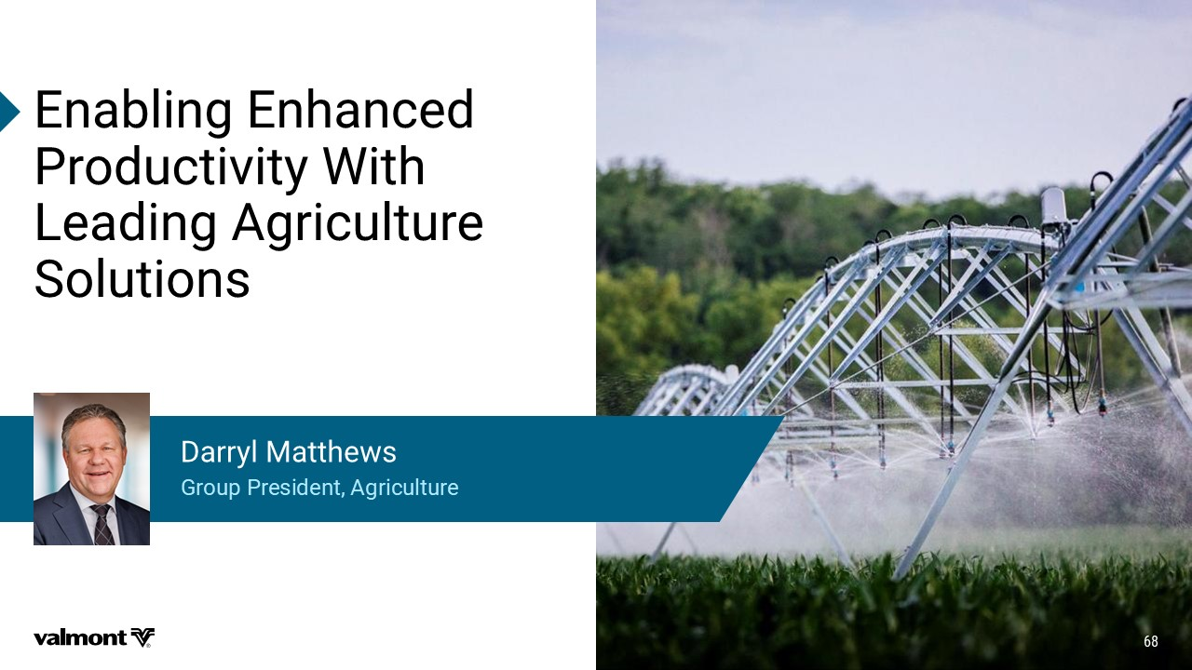
)REFPMRK)RLERGIH 4VSHYGXMZMX];MXL 0IEHMRK%KVMGYPXYVI 7SPYXMSRW +VSYT4VIWMHIRX%KVMGYPXYVI (EVV]P1EXXLI[W

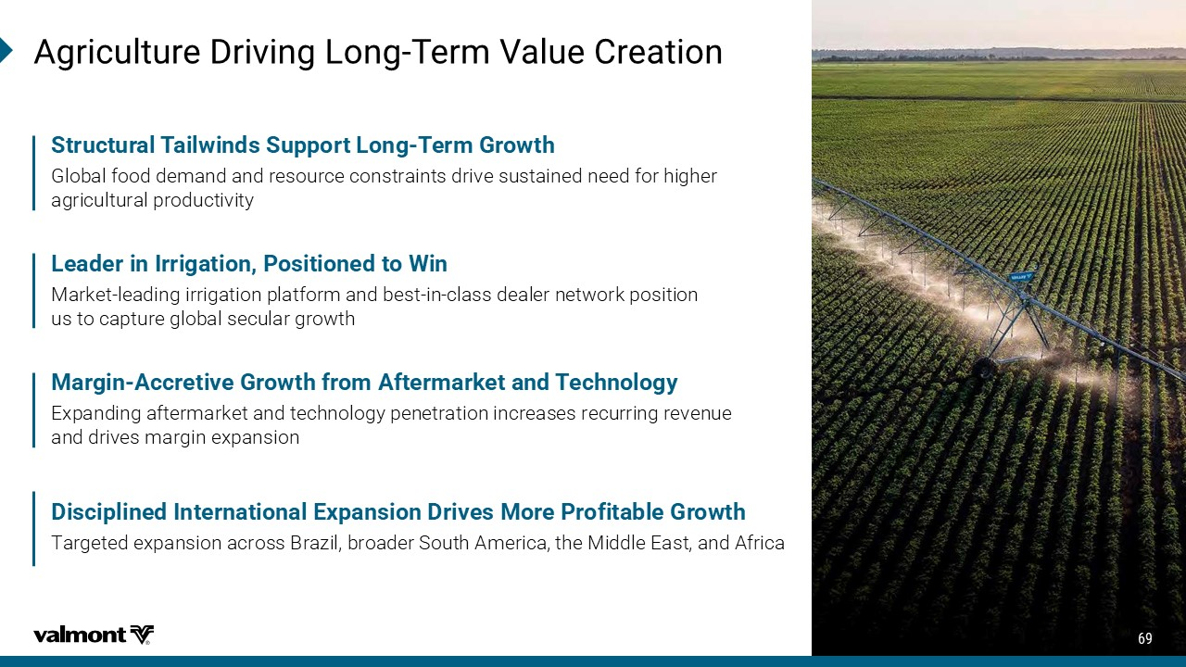
%KVMGYPXYVI(VMZMRK0SRK 8IVQ:EPYI'VIEXMSR 0IEHIVMR-VVMKEXMSR4SWMXMSRIHXS;MR Market - leading irrigation platform and best - in - class dealer network position us to capture global secular growth 1EVKMR %GGVIXMZI+VS[XLJVSQ%JXIVQEVOIXERH8IGLRSPSK] Expanding aftermarket and technology penetration increases recurring revenue and drives margin expansion 7XVYGXYVEP8EMP[MRHW7YTTSVX0SRK 8IVQ+VS[XL Global food demand and resource constraints drive sustained need for higher agricultural productivity (MWGMTPMRIH-RXIVREXMSREP)\TERWMSR(VMZIW1SVI4VSJMXEFPI+VS[XL Targeted expansion across Brazil, broader South America, the Middle East, and Africa

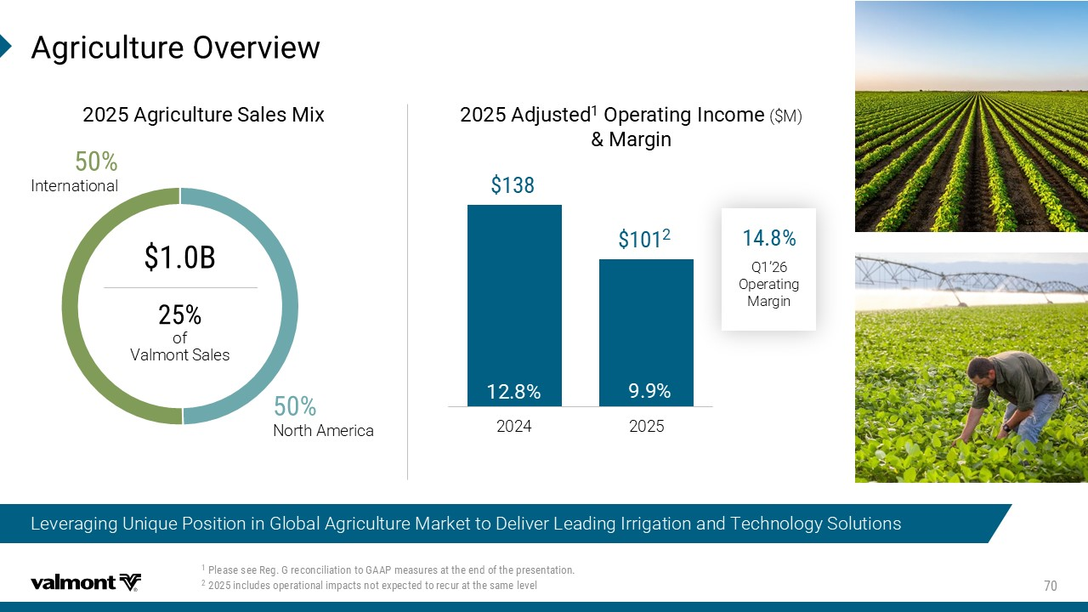
%KVMGYPXYVI3ZIVZMI[ Leveraging Unique Position in Global Agriculture Market to Deliver Leading Irrigation and Technology Solutions %KVMGYPXYVI 7EPIW 1M\ North America International 2024 2025 %HNYWXIH 3TIVEXMRK -RGSQI ($M) 1EVKMR & of Valmont Sales Q1’26 Operating Margin 4PIEWIWII6IK+VIGSRGMPMEXMSRXS+%%4QIEWYVIWEXXLIIRHSJXLITVIWIRXEXMSR MRGPYHIWSTIVEXMSREPMQTEGXWRSXI\TIGXIHXSVIGYVEXXLIWEQIPIZIP

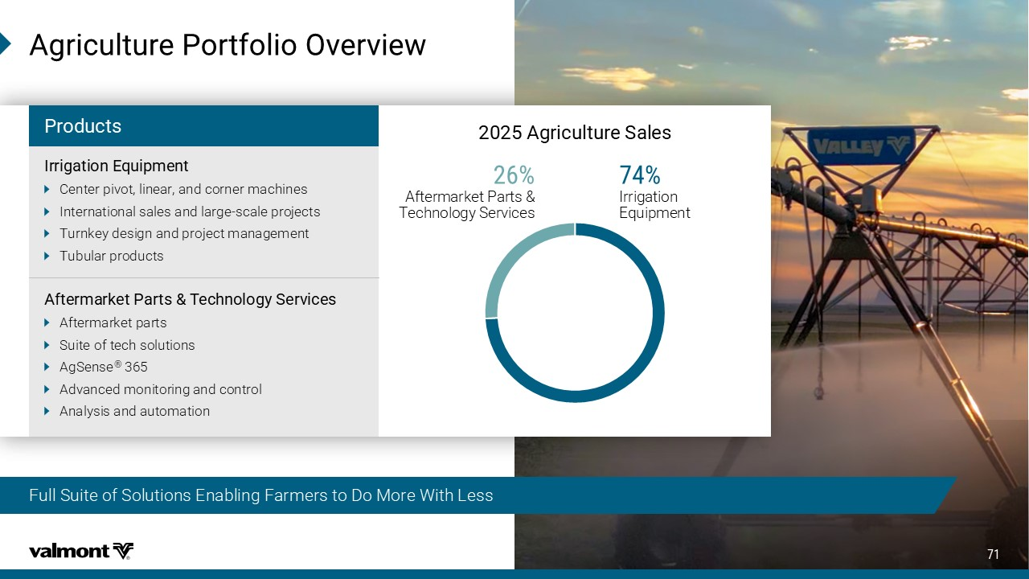
%KVMGYPXYVI7EPIW Aftermarket Parts & Technology Services Irrigation Equipment Full Suite of Solutions Enabling Farmers to Do More With Less %KVMGYPXYVI4SVXJSPMS3ZIVZMI[ 4VSHYGXW -VVMKEXMSR)UYMTQIRX Center pivot, linear, and corner machines International sales and large - scale projects Turnkey design and project management Tubular products %JXIVQEVOIX4EVXW8IGLRSPSK] 7IVZMGIW Aftermarket parts Suite of tech solutions AgSense ® 365 Advanced monitoring and control Analysis and automation

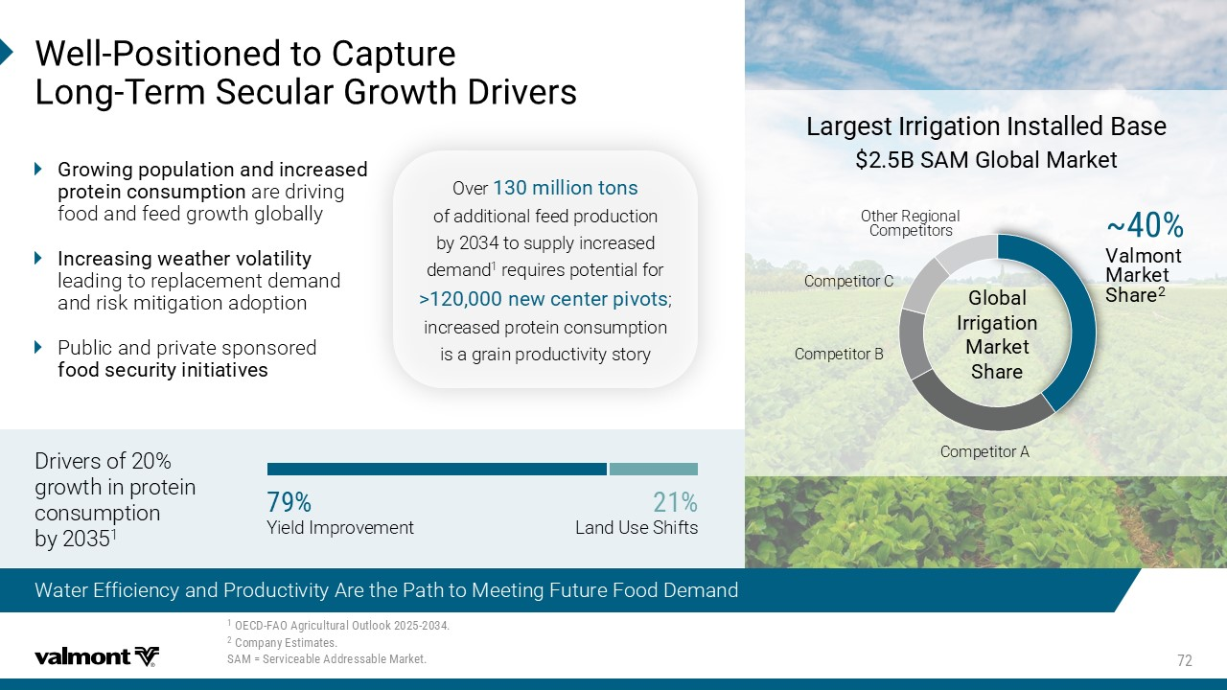
;IPP 4SWMXMSRIHXS'ETXYVI 0SRK 8IVQ7IGYPEV+VS[XL(VMZIVW Water Efficiency and Productivity Are the Path to Meeting Future Food Demand 3)'( *%3%KVMGYPXYVEP3YXPSSO 'SQTER])WXMQEXIW 7%1!7IVZMGIEFPI%HHVIWWEFPI1EVOIX +VS[MRKTSTYPEXMSRERHMRGVIEWIH TVSXIMRGSRWYQTXMSR are driving food and feed growth globally -RGVIEWMRK[IEXLIVZSPEXMPMX] leading to replacement demand and risk mitigation adoption Public and private sponsored JSSHWIGYVMX]MRMXMEXMZIW 0EVKIWX-VVMKEXMSR-RWXEPPIH&EWI &7%1+PSFEP1EVOIX +PSFEP -VVMKEXMSR 1EVOIX 7LEVI b Valmont Market Share 2 Competitor B Competitor C Other Regional Competitors Competitor A Drivers of 20% growth in protein consumption by 2035 1 Yield Improvement Land Use Shifts Over QMPPMSRXSRW of additional feed production by 2034 to supply increased demand 1 requires potential for "RI[GIRXIVTMZSXW ; increased protein consumption is a grain productivity story

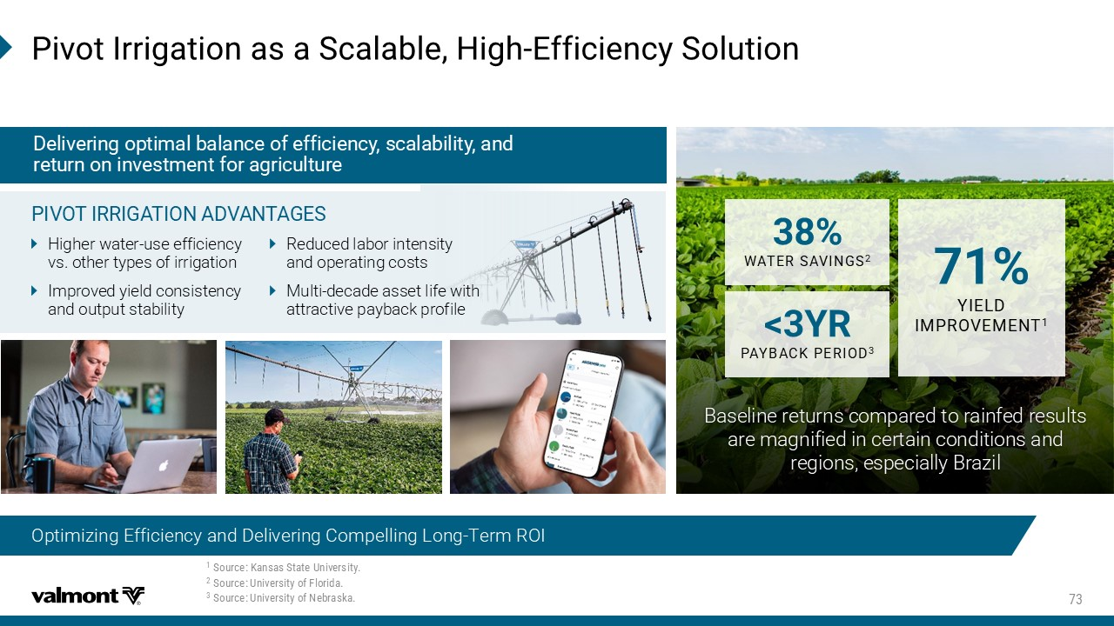
4MZSX-VVMKEXMSREWE7GEPEFPI,MKL )JJMGMIRG]7SPYXMSR Optimizing Efficiency and Delivering Compelling Long - Term ROI (IPMZIVMRKSTXMQEPFEPERGISJIJJMGMIRG]WGEPEFMPMX]ERH VIXYVRSRMRZIWXQIRXJSVEKVMGYPXYVI Higher water - use efficiency vs. other types of irrigation Improved yield consistency and output stability 4-:38-66-+%8-32%(:%28%+)7 Reduced labor intensity and operating costs Multi - decade asset life with attractive payback profile 7SYVGI/ERWEW7XEXI9RMZIVWMX] 7SYVGI 9RMZIVWMX]SJ*PSVMHE 7SYVGI 9RMZIVWMX]SJ2IFVEWOE Baseline returns compared to rainfed results are magnified in certain conditions and regions, especially Brazil ;%8)67%:-2+7 =-)0( -1463:)1)28 =6 4%=&%'/4)6-3(

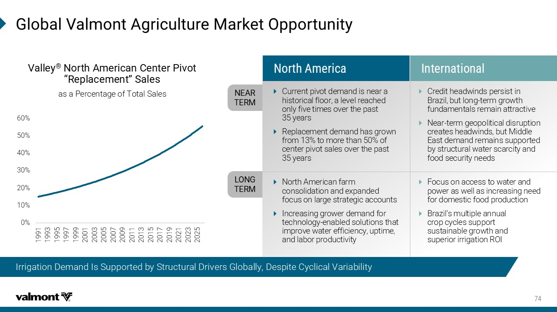
+PSFEP:EPQSRX%KVMGYPXYVI1EVOIX3TTSVXYRMX] Irrigation Demand Is Supported by Structural Drivers Globally, Despite Cyclical Variability 0% 10% 20% 30% 40% 50% 60% 1991 1993 1995 1997 1999 2001 2003 2005 2007 2009 2011 2013 2015 2017 2019 2021 2023 2025 :EPPI] o 2SVXL%QIVMGER'IRXIV4MZSX Ɖ6ITPEGIQIRXƊ7EPIW as a Percentage of Total Sales 2)%6 8)61 032+ 8)61 2SVXL%QIVMGE -RXIVREXMSREP ​ Current pivot demand is near a historical floor, a level reached only five times over the past 35 years Replacement demand has grown from 13% to more than 50% of center pivot sales over the past 35 years Credit headwinds persist in Brazil, but long - term growth fundamentals remain attractive Near - term geopolitical disruption creates headwinds, but Middle East demand remains supported by structural water scarcity and food security needs North American farm consolidation and expanded focus on large strategic accounts Increasing grower demand for technology - enabled solutions that improve water efficiency, uptime, and labor productivity Focus on access to water and power as well as increasing need for domestic food production Brazil’s multiple annual crop cycles support sustainable growth and superior irrigation ROI

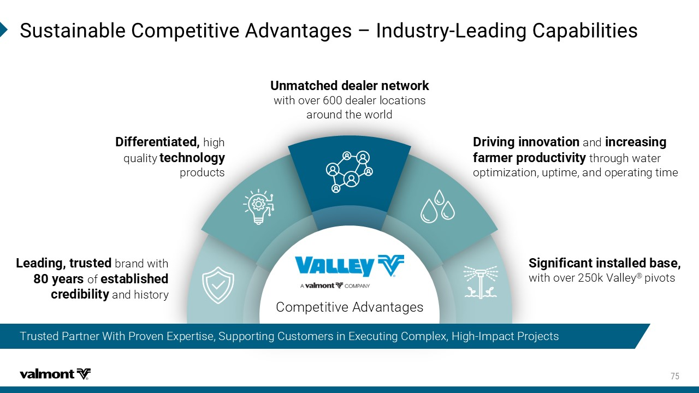
7YWXEMREFPI'SQTIXMXMZI%HZERXEKIW Ƃ -RHYWXV] 0IEHMRK'ETEFMPMXMIW 9RQEXGLIHHIEPIVRIX[SVO with over 600 dealer locations around the world (MJJIVIRXMEXIH high quality XIGLRSPSK] products (VMZMRKMRRSZEXMSR and MRGVIEWMRK JEVQIVTVSHYGXMZMX] through water optimization, uptime, and operating time 7MKRMJMGERXMRWXEPPIHFEWI with over 250k Valley ® pivots 0IEHMRKXVYWXIH brand with ]IEVW of IWXEFPMWLIH GVIHMFMPMX] and history Competitive Advantages Trusted Partner With Proven Expertise, Supporting Customers in Executing Complex, High - Impact Projects

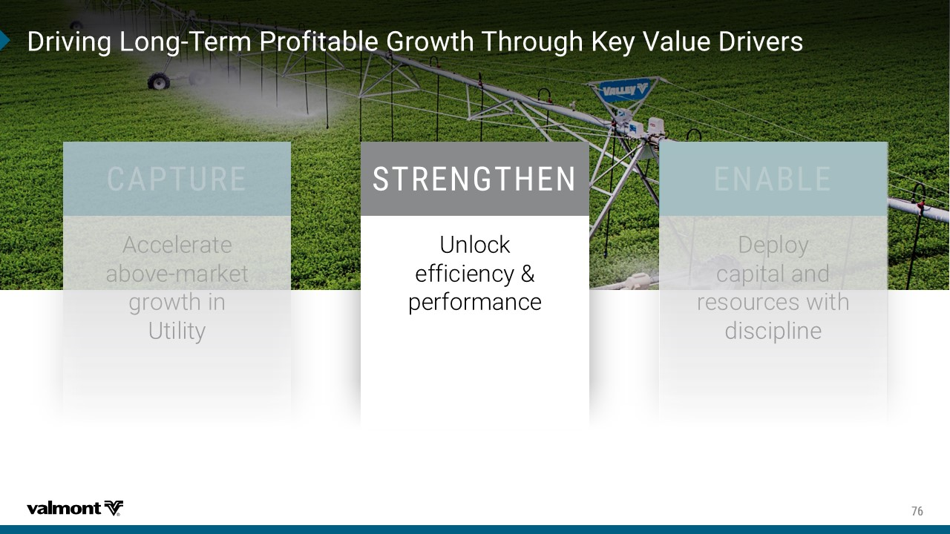
(VMZMRK0SRK 8IVQ4VSJMXEFPI+VS[XL8LVSYKL/I]:EPYI(VMZIVW 786)2+8,)2 Unlock efficiency & performance

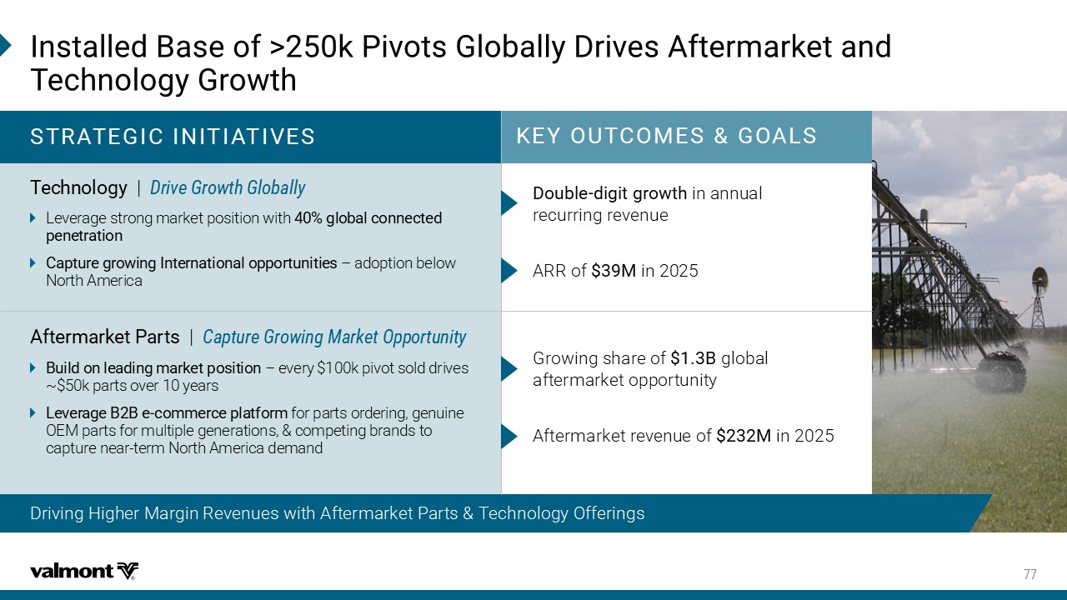
-RWXEPPIH&EWISJ"O4MZSXW+PSFEPP](VMZIW%JXIVQEVOIXERH 8IGLRSPSK]+VS[XL Driving Higher Margin Revenues with Aftermarket Parts & Technology Offerings /)=398'31)7+3%07 786%8)+-'-2-8-%8-:)7 ARR of 1 in 2025 (SYFPI HMKMXKVS[XL in annual recurring revenue %JXIVQEVOIX4EVXW | 'ETXYVI+VS[MRK1EVOIX3TTSVXYRMX] 8IGLRSPSK] | (VMZI+VS[XL+PSFEPP] Leverage strong market position with KPSFEPGSRRIGXIH TIRIXVEXMSR 'ETXYVIKVS[MRK-RXIVREXMSREPSTTSVXYRMXMIW ў adoption below North America &YMPHSRPIEHMRKQEVOIXTSWMXMSR – every $100k pivot sold drives ~$50k parts over 10 years 0IZIVEKI&&I GSQQIVGITPEXJSVQ for parts ordering, genuine OEM parts for multiple generations, & competing brands to capture near - term North America demand Aftermarket revenue of 1 in 2025 Growing share of & global aftermarket opportunity

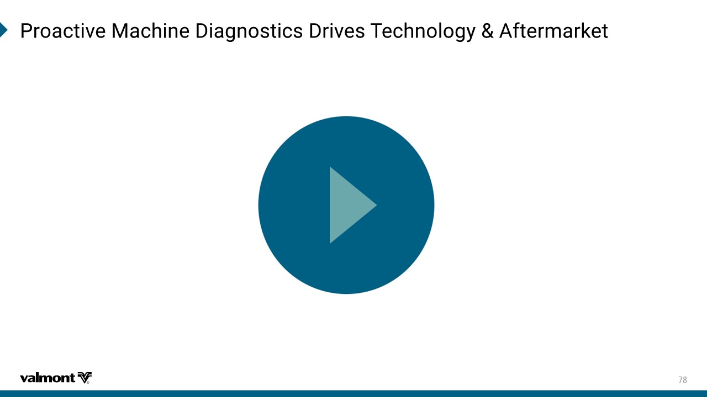
4VSEGXMZI1EGLMRI(MEKRSWXMGW(VMZIW8IGLRSPSK]%JXIVQEVOIX

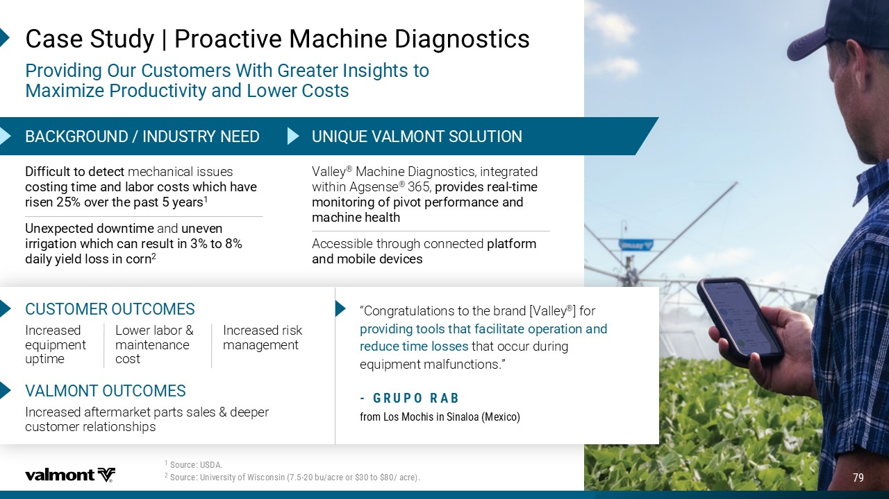
Valley ® Machine Diagnostics, integrated within Agsense ® 365, TVSZMHIWVIEP XMQI QSRMXSVMRKSJTMZSXTIVJSVQERGIERH QEGLMRILIEPXL Accessible through connected TPEXJSVQ ERHQSFMPIHIZMGIW (MJJMGYPXXSHIXIGX mechanical issues GSWXMRKXMQIERHPEFSVGSWXW[LMGLLEZI VMWIR SZIVXLITEWX]IEVW 9RI\TIGXIHHS[RXMQI and YRIZIR MVVMKEXMSR[LMGLGERVIWYPXMR XS HEMP]]MIPHPSWWMRGSVR 'EWI7XYH]`4VSEGXMZI1EGLMRI(MEKRSWXMGW 4VSZMHMRK3YV'YWXSQIVW;MXL+VIEXIV-RWMKLXWXS 1E\MQM^I4VSHYGXMZMX]ERH0S[IV'SWXW 7SYVGI97(% 7SYVGI9RMZIVWMX]SJ;MWGSRWMR FY EGVISVXSEGVI WIP: Update content as needed &%'/+6392(-2(9786=2))( 92-59):%0132873098-32 Increased equipment uptime '97831)6398'31)7 Lower labor & maintenance cost Increased risk management Increased aftermarket parts sales & deeper customer relationships :%01328398'31)7 “Congratulations to the brand [ Valley ® ] for TVSZMHMRKXSSPWXLEXJEGMPMXEXISTIVEXMSRERH VIHYGIXMQIPSWWIW that occur during equipment malfunctions.” +69436%& JVSQ0SW1SGLMWMR7MREPSE1I\MGS

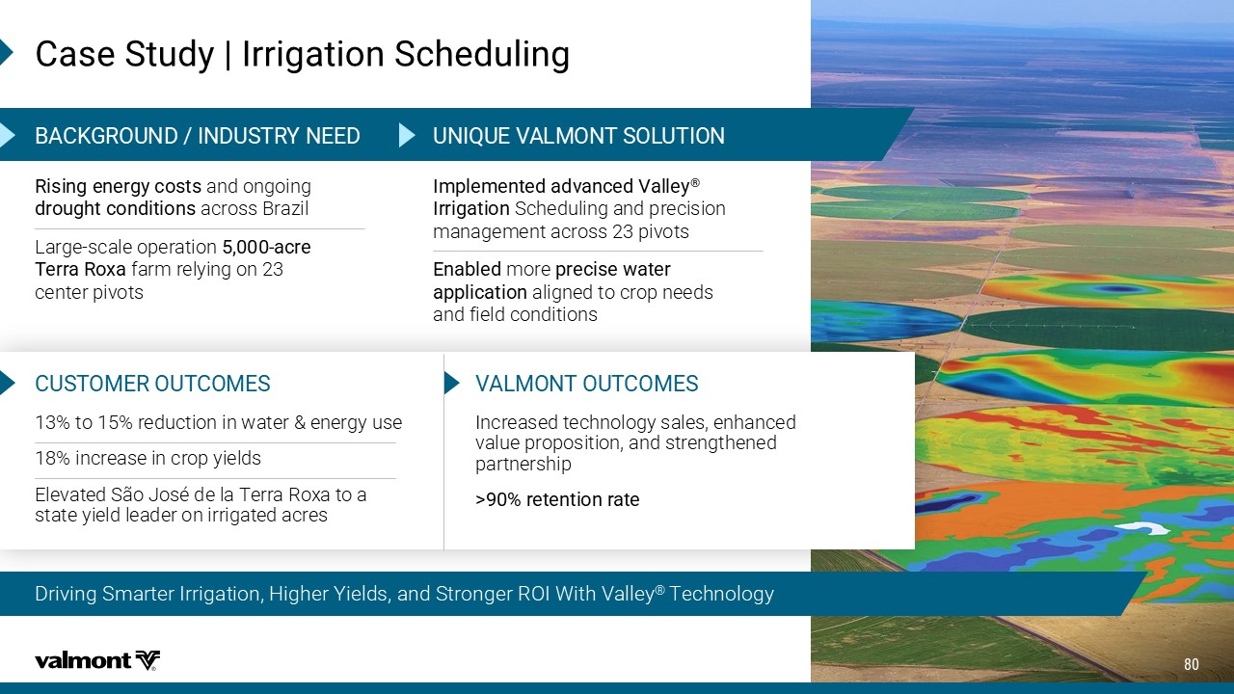
Driving Smarter Irrigation, Higher Yields, and Stronger ROI With Valley ® Technology 'EWI7XYH]`-VVMKEXMSR7GLIHYPMRK -QTPIQIRXIHEHZERGIH:EPPI] o -VVMKEXMSR Scheduling and precision management across 23 pivots )REFPIH more TVIGMWI[EXIV ETTPMGEXMSR aligned to crop needs and field conditions 6MWMRKIRIVK]GSWXW and ongoing HVSYKLXGSRHMXMSRW across Brazil Large - scale operation EGVI 8IVVE6S\E farm relying on 23 center pivots &%'/+6392(-2(9786=2))( 92-59):%0132873098-32 '97831)6398'31)7 Increased technology sales, enhanced value proposition, and strengthened partnership " VIXIRXMSRVEXI :%01328398'31)7 13% to 15% reduction in water & energy use 18% increase in crop yields Elevated São José de la Terra Roxa to a state yield leader on irrigated acres

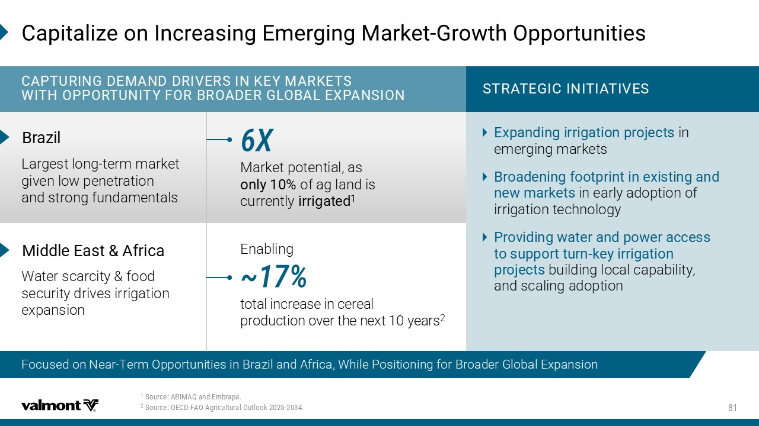
7SYVGI%&-1%5ERH)QFVETE 7SYVGI3)'( *%3%KVMGYPXYVEP3YXPSSO 'ETMXEPM^ISR-RGVIEWMRK)QIVKMRK1EVOIX +VS[XL3TTSVXYRMXMIW '%4896-2+ ()1%2((6-:)67-2/)=1%6/)87 ;-8, 34436892-8=*36&63%()6+03&%0)<4%27-32 &VE^MP Largest long - term market given low penetration and strong fundamentals 786%8)+-'-2-8-%8-:)7 )\TERHMRKMVVMKEXMSRTVSNIGXW in emerging markets &VSEHIRMRKJSSXTVMRXMRI\MWXMRKERH RI[QEVOIXW in early adoption of irrigation technology 4VSZMHMRK[EXIVERHTS[IVEGGIWW XSWYTTSVXXYVR OI]MVVMKEXMSR TVSNIGXW building local capability, and scaling adoption < Market potential, as SRP] of ag land is currently MVVMKEXIH 1MHHPI)EWX %JVMGE Water scarcity & food security drives irrigation expansion Enabling b total increase in cereal production over the next 10 years 2 Focused on Near - Term Opportunities in Brazil and Africa, While Positioning for Broader Global Expansion

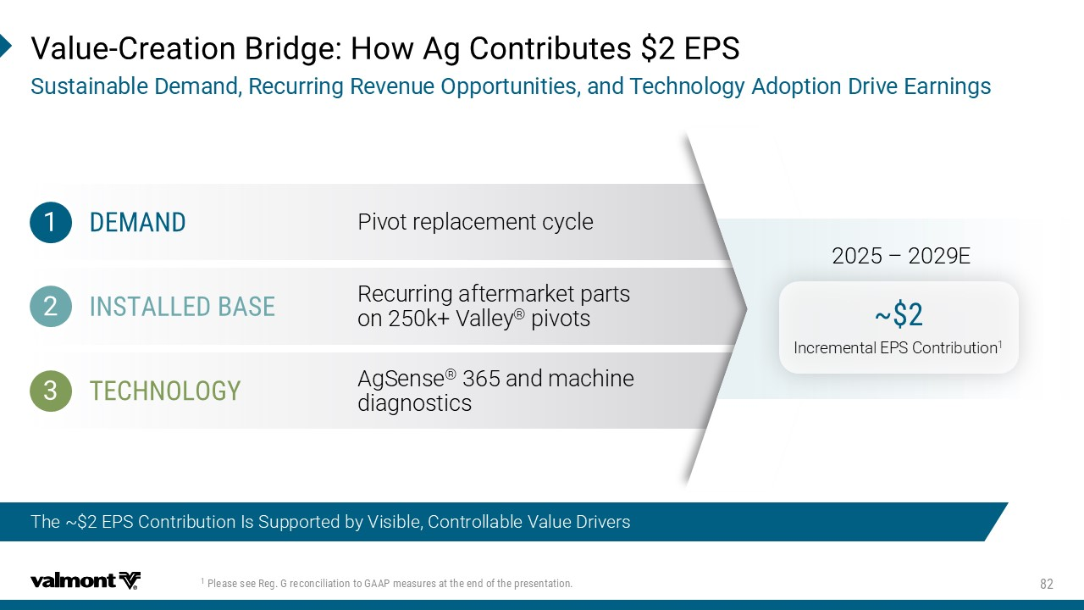
The ~$2 EPS Contribution Is Supported by Visible, Controllable Value Drivers 4PIEWIWII6IK+VIGSRGMPMEXMSRXS+%%4QIEWYVIWEXXLIIRHSJXLITVIWIRXEXMSR :EPYI 'VIEXMSR&VMHKI,S[%K'SRXVMFYXIW)47 7YWXEMREFPI(IQERH6IGYVVMRK6IZIRYI3TTSVXYRMXMIWERH8IGLRSPSK]%HSTXMSR(VMZI)EVRMRKW ()1%2( -278%00)(&%7) 8)',2303+= Pivot replacement cycle Recurring aftermarket parts on 250k + Valley ® pivots AgSense ® 365 and machine diagnostics b Incremental EPS Contribution 1 2025 – 2029E

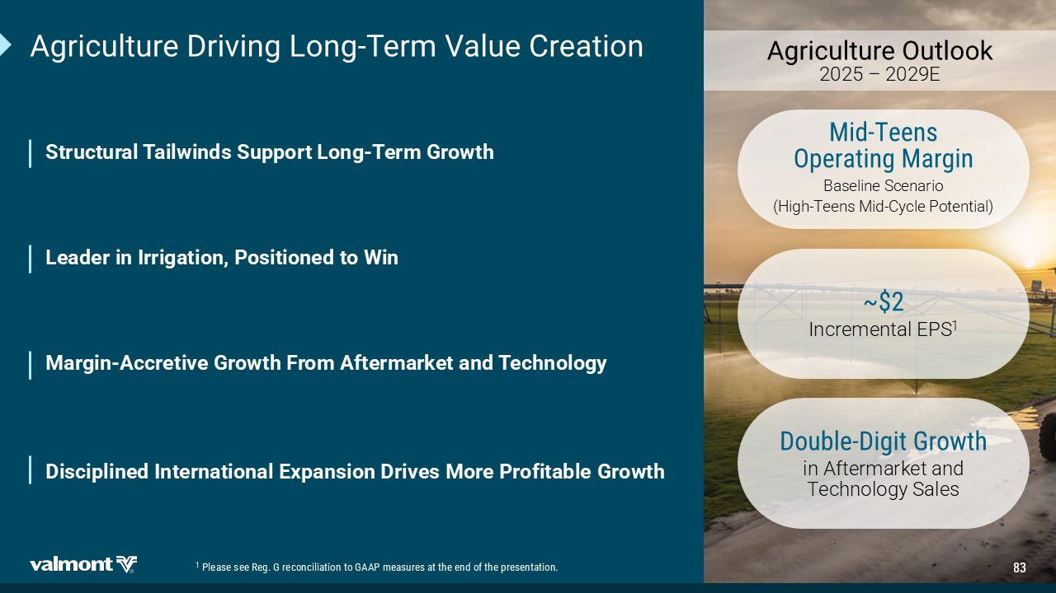
%KVMGYPXYVI(VMZMRK0SRK 8IVQ:EPYI'VIEXMSR 0IEHIVMR-VVMKEXMSR4SWMXMSRIHXS;MR 1EVKMR %GGVIXMZI+VS[XL *VSQ %JXIVQEVOIXERH8IGLRSPSK] 7XVYGXYVEP8EMP[MRHW7YTTSVX0SRK 8IVQ+VS[XL (MWGMTPMRIH-RXIVREXMSREP)\TERWMSR(VMZIW1SVI 4VSJMXEFPI +VS[XL %KVMGYPXYVI3YXPSSO 2025 – 2029E 1MH 8IIRW 3TIVEXMRK1EVKMR Baseline Scenario (High - Teens Mid - Cycle Potential) b Incremental EPS 1 (SYFPI (MKMX+VS[XL i n Aftermarket and Technology Sales 4PIEWIWII6IK+VIGSRGMPMEXMSRXS+%%4QIEWYVIWEXXLIIRHSJXLITVIWIRXEXMSR


+IRIVEXMRK0EWXMRK 7LEVILSPHIV:EPYI 'LMIJ*MRERGMEP3JJMGIV .SLR7GL[MIX^

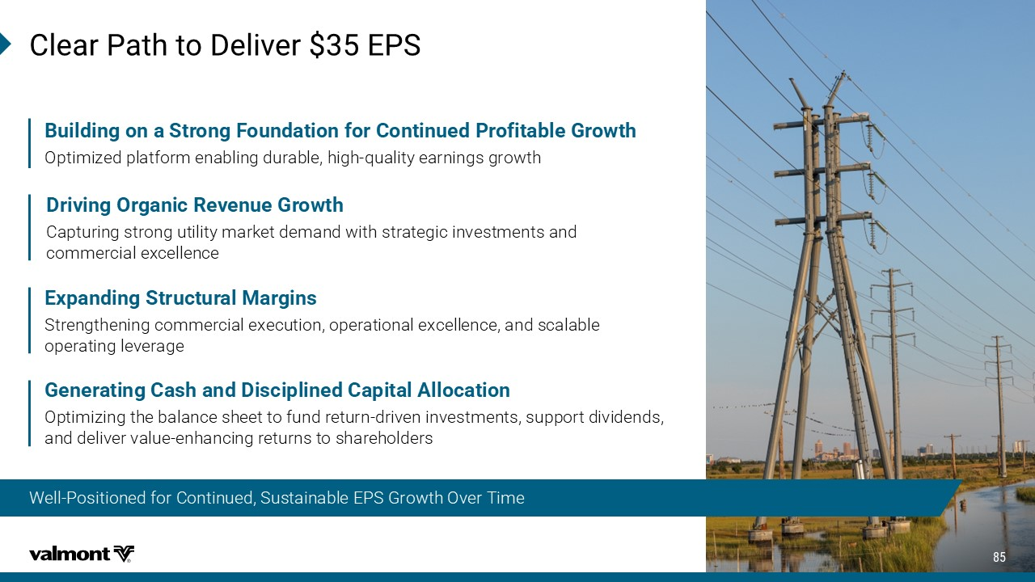
Well - Positioned for Continued, Sustainable EPS Growth Over Time 'PIEV4EXLXS(IPMZIV)47 )\TERHMRK7XVYGXYVEP1EVKMRW Strengthening commercial execution, operational excellence, and scalable operating leverage (VMZMRK3VKERMG6IZIRYI+VS[XL Capturing strong utility market demand with strategic investments and commercial excellence​ &YMPHMRKSRE7XVSRK*SYRHEXMSRJSV'SRXMRYIH4VSJMXEFPI+VS[XL O ptimized platform enabling durable, high - quality earnings growth​ +IRIVEXMRK'EWLERH(MWGMTPMRIH'ETMXEP%PPSGEXMSR Optimizing the balance sheet to fund return - driven investments, support dividends, and deliver value - enhancing returns to shareholders

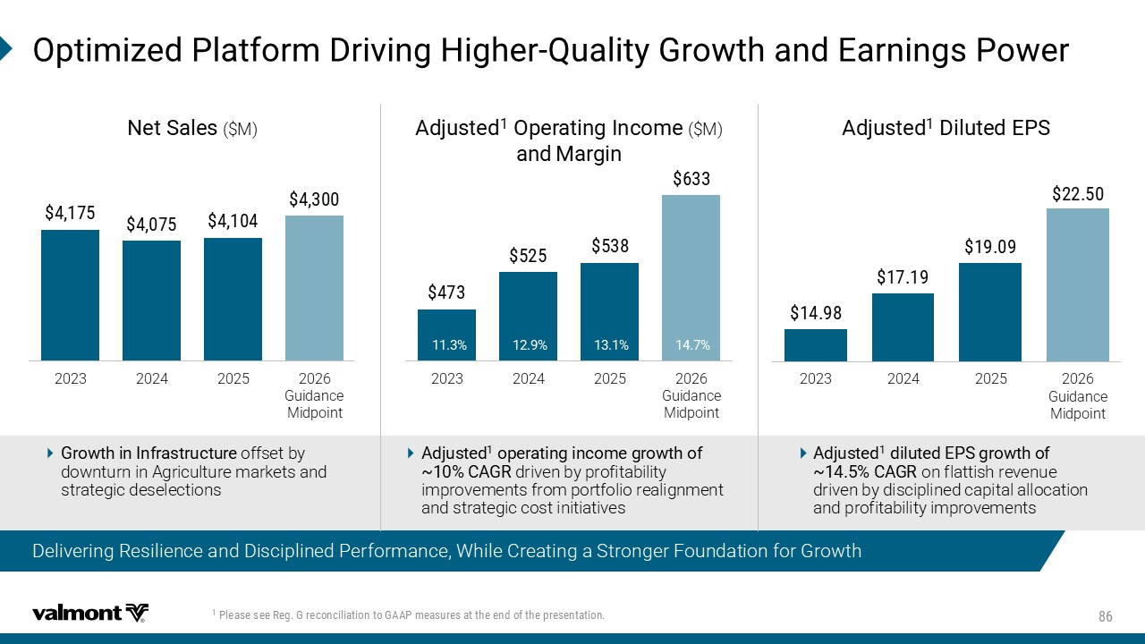
3TXMQM^IH4PEXJSVQ(VMZMRK,MKLIV 5YEPMX]+VS[XLERH)EVRMRKW4S[IV Delivering Resilience and Disciplined Performance, While Creating a Stronger Foundation for Growth 4PIEWIWII6IK+VIGSRGMPMEXMSRXS+%%4QIEWYVIWEXXLIIRHSJXLITVIWIRXEXMSR 2023 2024 2025 2026 Guidance Midpoint 2IX7EPIW ($M) %HNYWXIH (MPYXIH )47 2023 2024 2025 2026 Guidance Midpoint +VS[XLMR-RJVEWXVYGXYVI offset by downturn in Agriculture markets and strategic deselections 2023 2024 2025 2026 Guidance Midpoint %HNYWXIH 3TIVEXMRK-RGSQI ($M) ERH 1EVKMR %HNYWXIH STIVEXMRKMRGSQIKVS[XLSJ b '%+6 driven by profitability improvements from portfolio realignment and strategic cost initiatives %HNYWXIH HMPYXIH)47KVS[XLSJ b '%+6 on flattish revenue driven by disciplined capital allocation and profitability improvements

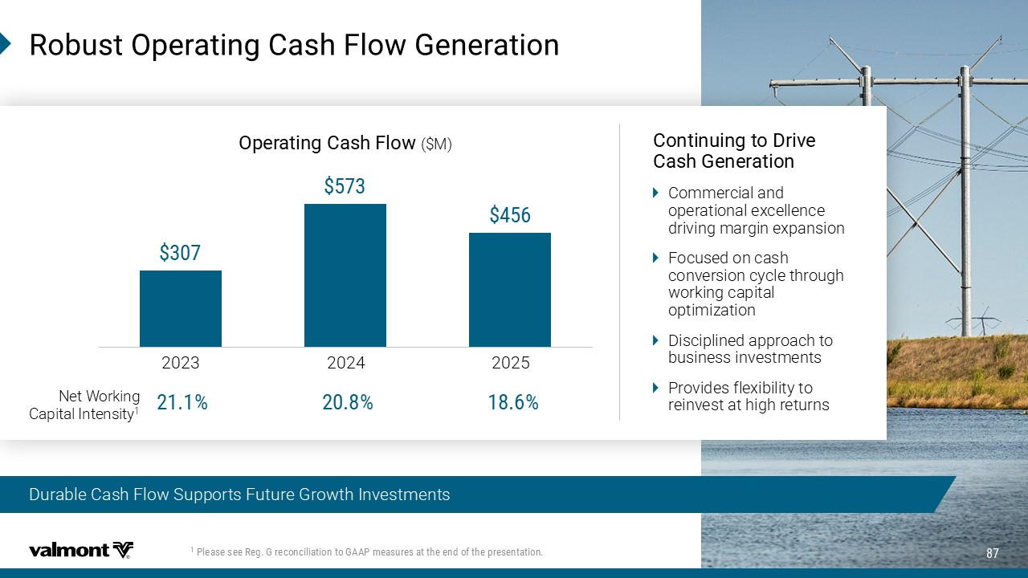
'SRXMRYMRKXS(VMZI 'EWL+IRIVEXMSR Commercial and operational excellence driving margin expansion Focused on cash conversion cycle through working capital optimization Disciplined approach to business investments Provides flexibility to reinvest at high returns Durable Cash Flow Supports Future Growth Investments 6SFYWX3TIVEXMRK'EWL*PS[+IRIVEXMSR $- $100 $200 $300 $400 $500 $600 $700 2023 2024 2025 3TIVEXMRK'EWL*PS[ ($M) Net Working Capital Intensity 1 4PIEWIWII6IK+VIGSRGMPMEXMSRXS+%%4QIEWYVIWEXXLIIRHSJXLITVIWIRXEXMSR

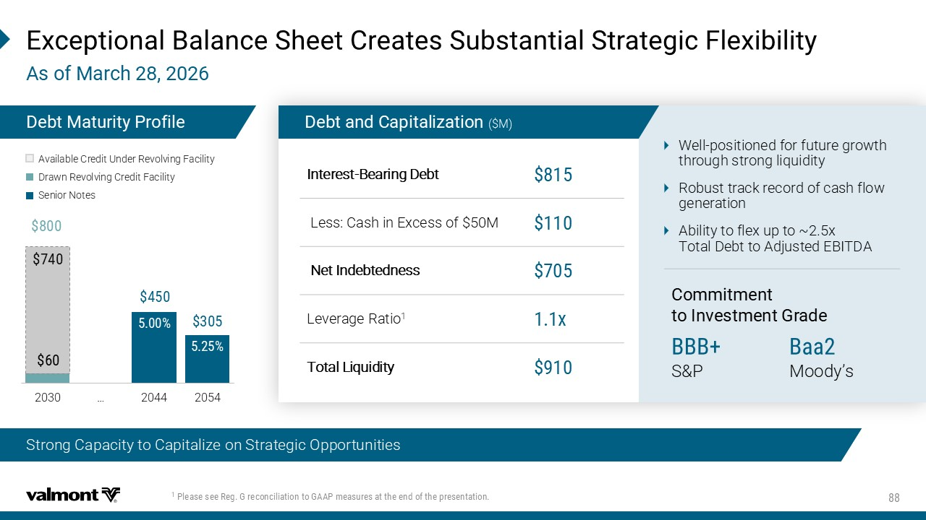
4PIEWIWII6IK+VIGSRGMPMEXMSRXS+%%4QIEWYVIWEXXLIIRHSJXLITVIWIRXEXMSR )\GITXMSREP&EPERGI7LIIX'VIEXIW7YFWXERXMEP7XVEXIKMG*PI\MFMPMX] %WSJ1EVGL (IFX1EXYVMX]4VSJMPI Well - positioned for future growth through strong liquidity ​ Robust track record of cash flow generation​ Ability to flex up to ~2.5x Total Debt to Adjusted EBITDA​ 'SQQMXQIRX XS-RZIWXQIRX+VEHI &EE Moody’s &&& S&P Interest - Bearing Debt Less: Cash in Excess of $50M Net Indebtedness \ Leverage Ratio 1 Total Liquidity (IFXERH'ETMXEPM^EXMSR ($M) 2030 … 2044 2054 Available Credit Under Revolving Facility Drawn Revolving Credit Facility Senior Notes Strong Capacity to Capitalize on Strategic Opportunities

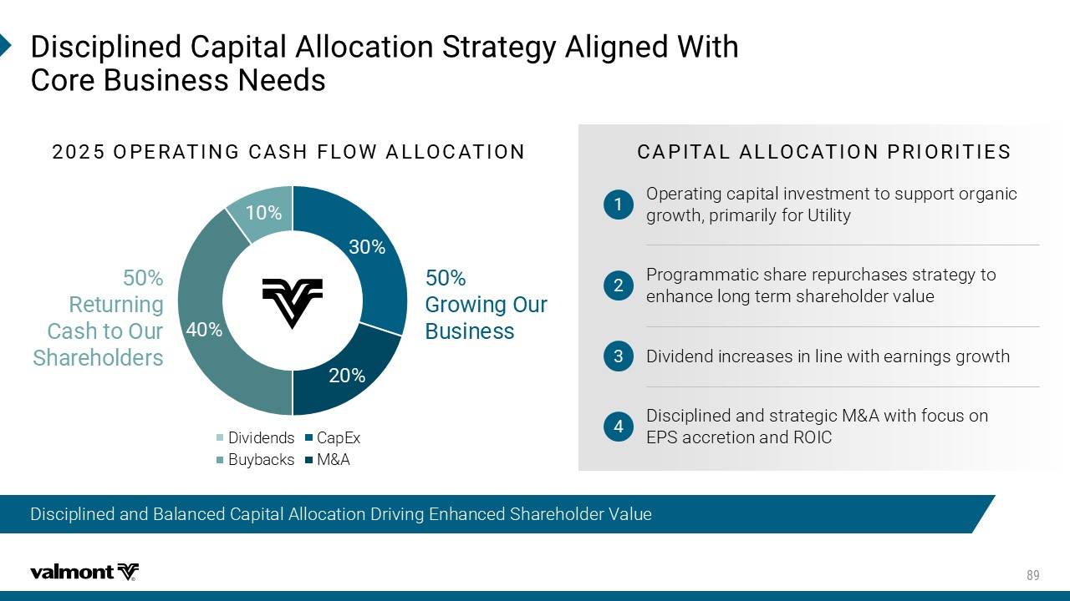
z 6IXYVRMRK 'EWLXS3YV 7LEVILSPHIVW +VS[MRK3YV &YWMRIWW (MWGMTPMRIH'ETMXEP%PPSGEXMSR7XVEXIK]%PMKRIH;MXL 'SVI&YWMRIWW2IIHW '%4-8%0%003'%8-3246-36-8-)7 Operating capital investment to support organic growth, primarily for Utility 1 Programmatic share repurchases strategy to enhance long term shareholder value 2 Dividend increases in line with earnings growth 3 Disciplined and strategic M&A with focus on EPS accretion and ROIC 4 34)6%8-2+'%7,*03;%003'%8-32 CapEx M&A Dividends Buybacks Disciplined and Balanced Capital Allocation Driving Enhanced Shareholder Value

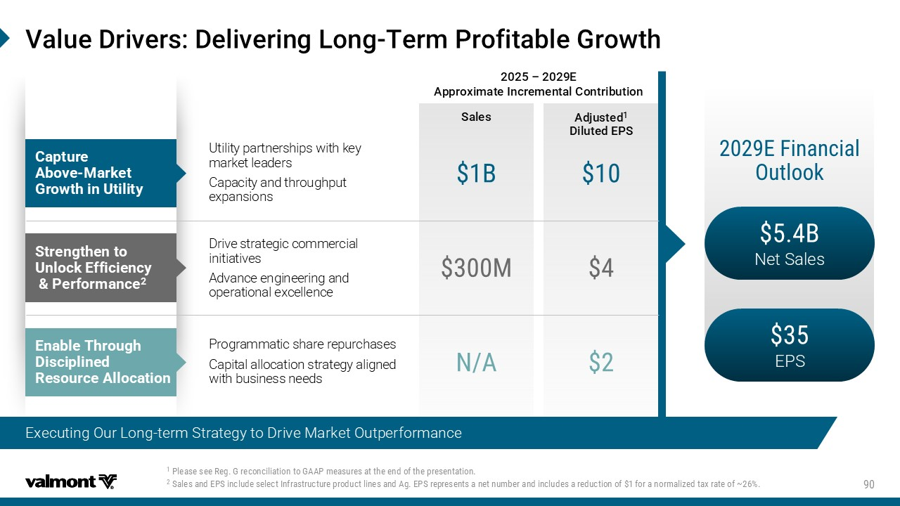
D 7EPIW %HNYWXIH (MPYXIH)47 4PIEWIWII6IK+VIGSRGMPMEXMSRXS+%%4QIEWYVIWEXXLIIRHSJXLITVIWIRXEXMSR 7EPIWERH)47MRGPYHIWIPIGX-RJVEWXVYGXYVITVSHYGXPMRIWERH%K)47VITVIWIRXWERIXRYQFIVERHMRGPYHIWEVIHYGXMSRSJ JS VERSVQEPM^IHXE\VEXISJb :EPYI(VMZIVW(IPMZIVMRK0SRK 8IVQ4VSJMXEFPI+VS[XL & Net Sales EPS )*MRERGMEP 3YXPSSO 'ETXYVI %FSZI 1EVOIX +VS[XLMR9XMPMX] Utility partnerships with key market leaders Capacity and throughput expansions & 7XVIRKXLIRXS 9RPSGO )JJMGMIRG] 4IVJSVQERGI 1 Programmatic share repurchases Capital allocation strategy aligned with business needs 2% )REFPI 8LVSYKL (MWGMTPMRIH 6IWSYVGI%PPSGEXMSR Ƃ ) %TTVS\MQEXI-RGVIQIRXEP'SRXVMFYXMSR Drive strategic commercial initiatives Advance engineering and operational excellence Executing Our Long - term Strategy to Drive Market Outperformance

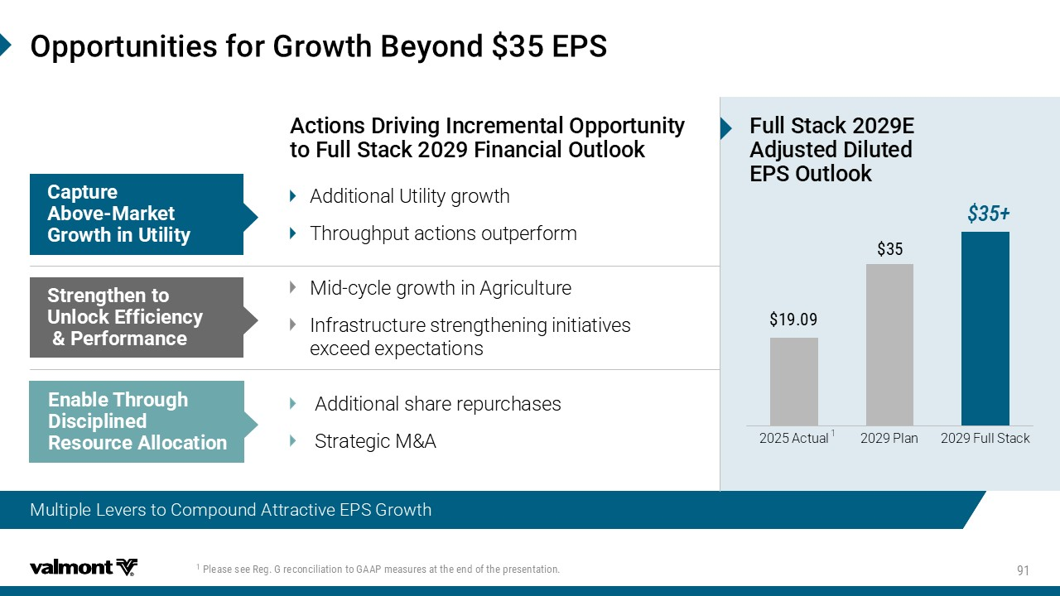
4PIEWIWII6IK+VIGSRGMPMEXMSRXS+%%4QIEWYVIWEXXLIIRHSJXLITVIWIRXEXMSR Expect Long - Term Strategy to Drive Profitable Growth 3TTSVXYRMXMIWJSV+VS[XL&I]SRH)47 Multiple Levers to Compound Attractive EPS Growth %GXMSRW(VMZMRK-RGVIQIRXEP3TTSVXYRMX]XS *YPP7XEGO*MRERGMEP3YXPSSO Mid - cycle growth in Agriculture Infrastructure strengthening initiatives exceed expectations 7XVIRKXLIRXS 9RPSGO )JJMGMIRG] 4IVJSVQERGI Additional Utility growth Throughput actions outperform 'ETXYVI %FSZI 1EVOIX +VS[XLMR9XMPMX] Additional share repurchases Strategic M&A )REFPI 8LVSYKL (MWGMTPMRIH 6IWSYVGI%PPSGEXMSR *YPP7XEGO) %HNYWXIH(MPYXIH )473YXPSSO 2025 Actual 2029 Plan 2029 Full Stack 1

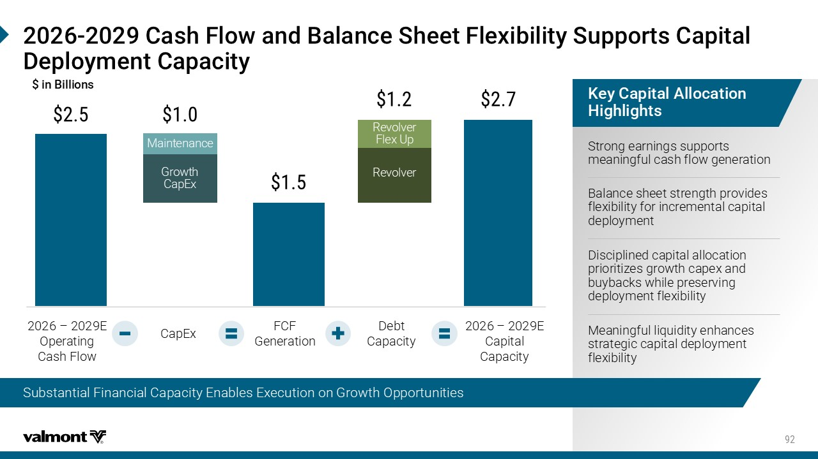
'EWL*PS[ERH&EPERGI7LIIX*PI\MFMPMX]7YTTSVXW'ETMXEP (ITPS]QIRX'ETEGMX] 2026 – 2029E Operating Cash Flow CapEx FCF Generation Debt Capacity 2026 – 2029E Capital Capacity /I]'ETMXEP%PPSGEXMSR ,MKLPMKLXW Strong earnings supports meaningful cash flow generation Balance sheet strength provides flexibility for incremental capital deployment Disciplined capital allocation prioritizes growth capex and buybacks while preserving deployment flexibility Meaningful liquidity enhances strategic capital deployment flexibility Growth CapEx Revolver Revolver Flex Up Maintenance Substantial Financial Capacity Enables Execution on Growth Opportunities MR&MPPMSRW

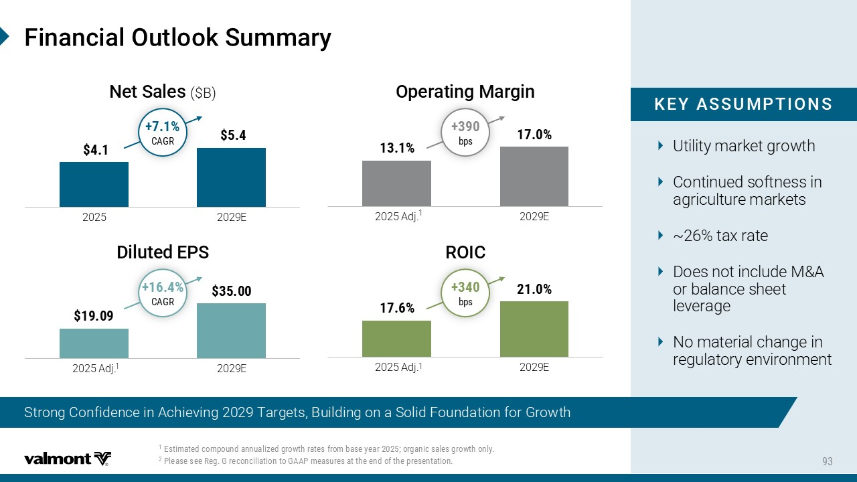
2025 2029E Utility market growth Continued softness in agriculture markets ~26% tax rate Does not include M&A or balance sheet leverage No material change in regulatory environment /)=%779148-327 *MRERGMEP3YXPSSO7YQQEV] Strong Confidence in Achieving 2029 Targets, Building on a Solid Foundation for Growth )WXMQEXIHGSQTSYRHERRYEPM^IHKVS[XLVEXIWJVSQFEWI]IEVSVKERMGWEPIWKVS[XLSRP] 4PIEWIWII6IK+VIGSRGMPMEXMSRXS+%%4QIEWYVIWEXXLIIRHSJXLITVIWIRXEXMSR 2025 Adj. 2029E '%+6 '%+6 2025 Adj. 2029E 2025 Adj. 2029E FTW FTW 2IX7EPIW ($B) (MPYXIH )47 3TIVEXMRK 1EVKMR 63-'

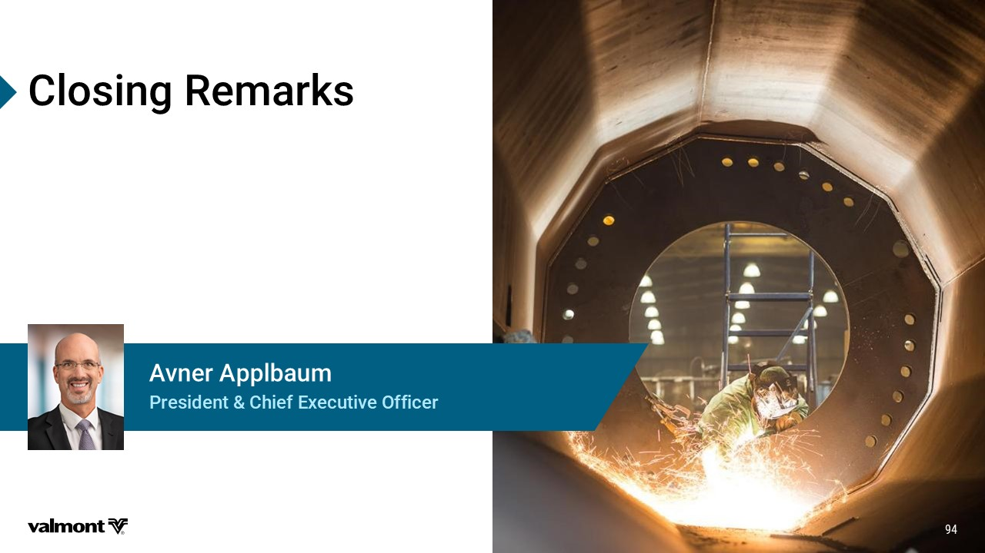
'PSWMRK6IQEVOW 4VIWMHIRX'LMIJ)\IGYXMZI3JJMGIV %ZRIV%TTPFEYQ

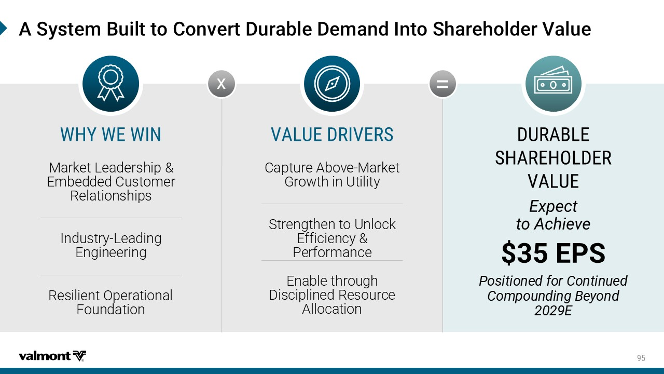
%7]WXIQ&YMPXXS'SRZIVX(YVEFPI(IQERH-RXS7LEVILSPHIV:EPYI (96%&0) 7,%6),30()6 :%09) )\TIGX XS%GLMIZI )47 4SWMXMSRIHJSV'SRXMRYIH 'SQTSYRHMRK&I]SRH ) ;,=;);-2 :%09)(6-:)67 = x 2FWPJY1JFIJWXMNU *RGJIIJI(ZXYTRJW 7JQFYNTSXMNUX .SIZXYW^ 1JFINSL *SLNSJJWNSL 7JXNQNJSY4UJWFYNTSFQ +TZSIFYNTS (FUYZWJ&GT[J 2FWPJY ,WT\YMNS:YNQNY^ 8YWJSLYMJSYT:SQTHP *KKNHNJSH^5JWKTWRFSHJ *SFGQJYMWTZLM )NXHNUQNSJI7JXTZWHJ &QQTHFYNTS




5%


%TTIRHM\

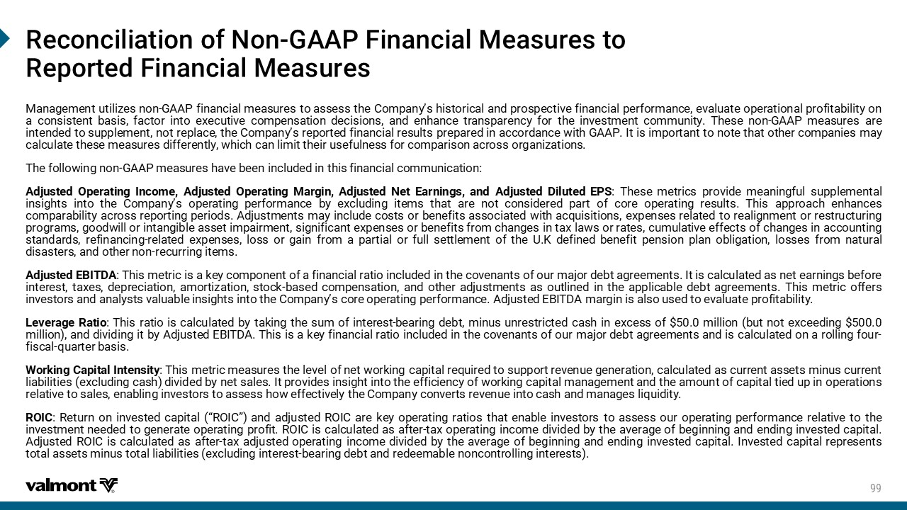
6IGSRGMPMEXMSRSJ2SR +%%4*MRERGMEP1IEWYVIWXS 6ITSVXIH*MRERGMEP1IEWYVIW 2FSFLJRJSY ZYNQN_JX STS ,&&5 KNSFSHNFQ RJFXZWJX YT FXXJXX YMJ (TRUFS^ѣX MNXYTWNHFQ FSI UWTXUJHYN[J KNSFSHNFQ UJWKTWRFSHJ J[FQZFYJ TUJWFYNTSFQ UWTKNYFGNQNY^ TS F HTSXNXYJSY GFXNX KFHYTW NSYT J]JHZYN[J HTRUJSXFYNTS IJHNXNTSX FSI JSMFSHJ YWFSXUFWJSH^ KTW YMJ NS[JXYRJSY HTRRZSNY^ 9MJXJ STS ,&&5 RJFXZWJX FWJ NSYJSIJI YT XZUUQJRJSY STY WJUQFHJ YMJ (TRUFS^ѣX WJUTWYJI KNSFSHNFQ WJXZQYX UWJUFWJI NS FHHTWIFSHJ \NYM ,&&5 .Y NX NRUTWYFSY YT STYJ YMFY TYMJW HTRUFSNJX RF^ HFQHZQFYJ YMJXJ RJFXZWJX INKKJWJSYQ^ \MNHM HFS QNRNY YMJNW ZXJKZQSJXX KTW HTRUFWNXTS FHWTXX TWLFSN_FYNTSX 9MJ KTQQT\NSL STS ,&&5 RJFXZWJX MF[J GJJS NSHQZIJI NS YMNX KNSFSHNFQ HTRRZSNHFYNTS &IOZXYJI 4UJWFYNSL .SHTRJ &IOZXYJI 4UJWFYNSL 2FWLNS &IOZXYJI 3JY *FWSNSLX FSI &IOZXYJI )NQZYJI *58 9MJXJ RJYWNHX UWT[NIJ RJFSNSLKZQ XZUUQJRJSYFQ NSXNLMYX NSYT YMJ (TRUFS^ѣX TUJWFYNSL UJWKTWRFSHJ G^ J]HQZINSL NYJRX YMFY FWJ STY HTSXNIJWJI UFWY TK HTWJ TUJWFYNSL WJXZQYX 9MNX FUUWTFHM JSMFSHJX HTRUFWFGNQNY^ FHWTXX WJUTWYNSL UJWNTIX &IOZXYRJSYX RF^ NSHQZIJ HTXYX TW GJSJKNYX FXXTHNFYJI \NYM FHVZNXNYNTSX J]UJSXJX WJQFYJI YT WJFQNLSRJSY TW WJXYWZHYZWNSL UWTLWFRX LTTI\NQQ TW NSYFSLNGQJ FXXJY NRUFNWRJSY XNLSNKNHFSY J]UJSXJX TW GJSJKNYX KWTR HMFSLJX NS YF] QF\X TW WFYJX HZRZQFYN[J JKKJHYX TK HMFSLJX NS FHHTZSYNSL XYFSIFWIX WJKNSFSHNSL WJQFYJI J]UJSXJX QTXX TW LFNS KWTR F UFWYNFQ TW KZQQ XJYYQJRJSY TK YMJ : 0 IJKNSJI GJSJKNY UJSXNTS UQFS TGQNLFYNTS QTXXJX KWTR SFYZWFQ INXFXYJWX FSI TYMJW STS WJHZWWNSL NYJRX &IOZXYJI *'.9)& 9MNX RJYWNH NX F PJ^ HTRUTSJSY TK F KNSFSHNFQ WFYNT NSHQZIJI NS YMJ HT[JSFSYX TK TZW RFOTW IJGY FLWJJRJSYX .Y NX HFQHZQFYJI FX SJY JFWSNSLX GJKTWJ NSYJWJXY YF]JX IJUWJHNFYNTS FRTWYN_FYNTS XYTHP GFXJI HTRUJSXFYNTS FSI TYMJW FIOZXYRJSYX FX TZYQNSJI NS YMJ FUUQNHFGQJ IJGY FLWJJRJSYX 9MNX RJYWNH TKKJWX NS[JXYTWX FSI FSFQ^XYX [FQZFGQJ NSXNLMYX NSYT YMJ (TRUFS^ѣX HTWJ TUJWFYNSL UJWKTWRFSHJ &IOZXYJI *'.9)& RFWLNS NX FQXT ZXJI YT J[FQZFYJ UWTKNYFGNQNY^ 1J[JWFLJ 7FYNT 9MNX WFYNT NX HFQHZQFYJI G^ YFPNSL YMJ XZR TK NSYJWJXY GJFWNSL IJGY RNSZX ZSWJXYWNHYJI HFXM NS J]HJXX TK RNQQNTS GZY STY J]HJJINSL RNQQNTS FSI IN[NINSL NY G^ &IOZXYJI *'.9)& 9MNX NX F PJ^ KNSFSHNFQ WFYNT NSHQZIJI NS YMJ HT[JSFSYX TK TZW RFOTW IJGY FLWJJRJSYX FSI NX HFQHZQFYJI TS F WTQQNSL KTZW KNXHFQ VZFWYJW GFXNX <TWPNSL (FUNYFQ .SYJSXNY^ 9MNX RJYWNH RJFXZWJX YMJ QJ[JQ TK SJY \TWPNSL HFUNYFQ WJVZNWJI YT XZUUTWY WJ[JSZJ LJSJWFYNTS HFQHZQFYJI FX HZWWJSY FXXJYX RNSZX HZWWJSY QNFGNQNYNJX J]HQZINSL HFXM IN[NIJI G^ SJY XFQJX .Y UWT[NIJX NSXNLMY NSYT YMJ JKKNHNJSH^ TK \TWPNSL HFUNYFQ RFSFLJRJSY FSI YMJ FRTZSY TK HFUNYFQ YNJI ZU NS TUJWFYNTSX WJQFYN[J YT XFQJX JSFGQNSL NS[JXYTWX YT FXXJXX MT\ JKKJHYN[JQ^ YMJ (TRUFS^ HTS[JWYX WJ[JSZJ NSYT HFXM FSI RFSFLJX QNVZNINY^ 74.( 7JYZWS TS NS[JXYJI HFUNYFQ Ѧ74.(ѧ FSI FIOZXYJI 74.( FWJ PJ^ TUJWFYNSL WFYNTX YMFY JSFGQJ NS[JXYTWX YT FXXJXX TZW TUJWFYNSL UJWKTWRFSHJ WJQFYN[J YT YMJ NS[JXYRJSY SJJIJI YT LJSJWFYJ TUJWFYNSL UWTKNY 74.( NX HFQHZQFYJI FX FKYJW YF] TUJWFYNSL NSHTRJ IN[NIJI G^ YMJ F[JWFLJ TK GJLNSSNSL FSI JSINSL NS[JXYJI HFUNYFQ &IOZXYJI 74.( NX HFQHZQFYJI FX FKYJW YF] FIOZXYJI TUJWFYNSL NSHTRJ IN[NIJI G^ YMJ F[JWFLJ TK GJLNSSNSL FSI JSINSL NS[JXYJI HFUNYFQ .S[JXYJI HFUNYFQ WJUWJXJSYX YTYFQ FXXJYX RNSZX YTYFQ QNFGNQNYNJX J]HQZINSL NSYJWJXY GJFWNSL IJGY FSI WJIJJRFGQJ STSHTSYWTQQNSL NSYJWJXYX

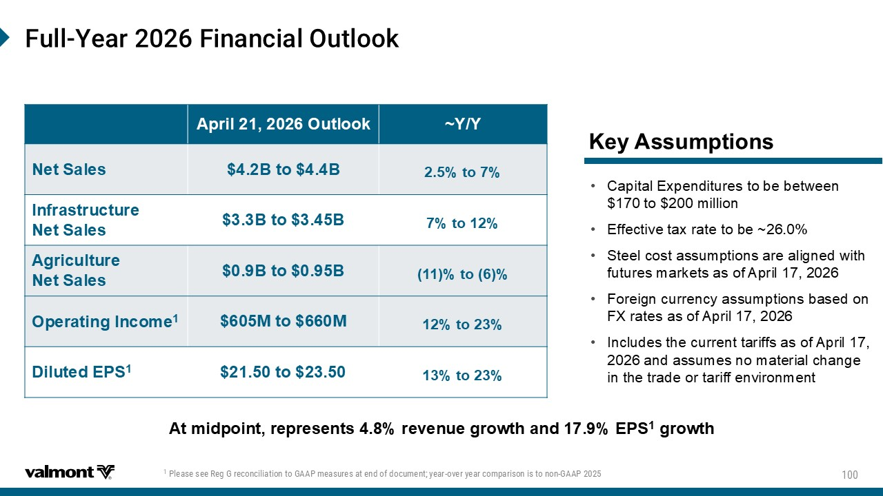
*YPP =IEV*MRERGMEP3YXPSSO Key Assumptions • Capital Expenditures to be between $170 to $200 million • Effective tax rate to be ~26.0% • Steel cost assumptions are aligned with futures markets as of April 17, 2026 • Foreign currency assumptions based on FX rates as of April 17, 2026 • Includes the current tariffs as of April 17, 2026 and assumes no material change in the trade or tariff environment At midpoint, represents 4.8% revenue growth and 17.9% EPS 1 growth ~Y/Y​ April 21, 2026 Outlook​ ​ 2.5% to 7% ​ $4.2B to $4.4B Net Sales ​ 7% to 12% ​ $3.3B to $3.45B ​ Infrastructure ​ Net Sales ​ (11)% to (6)% ​ $0.9B to $0.95B ​ Agriculture ​ Net Sales ​ 12% to 23% ​ $605M to $660M Operating Income 1 13% to 23% ​ $21.50 to $23.50 ​ Diluted EPS 1 4PIEWIWII6IK+VIGSRGMPMEXMSRXS+%%4QIEWYVIWEXIRHSJHSGYQIRX ]IEV SZIV]IEVGSQTEVMWSRMWXSRSR +%%4

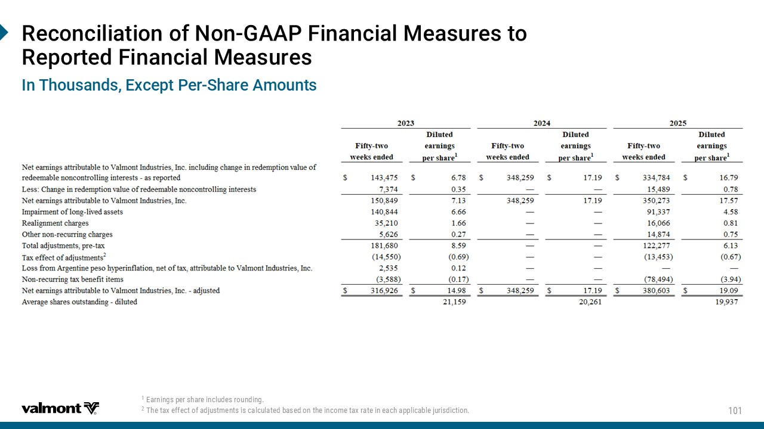
6IGSRGMPMEXMSRSJ2SR +%%4*MRERGMEP1IEWYVIWXS 6ITSVXIH*MRERGMEP1IEWYVIW )EVRMRKWTIVWLEVIMRGPYHIWVSYRHMRK 8LIXE\IJJIGXSJEHNYWXQIRXWMWGEPGYPEXIHFEWIHSRXLIMRGSQIXE\VEXIMRIEGLETTPMGEFPINYVMWHMGXMSR -R8LSYWERHW)\GITX4IV 7LEVI%QSYRXW

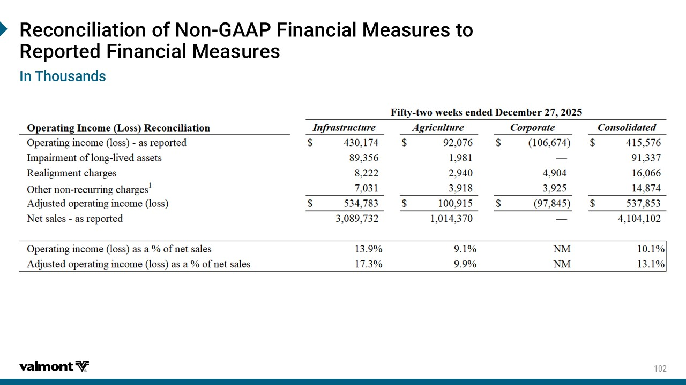
6IGSRGMPMEXMSRSJ2SR +%%4*MRERGMEP1IEWYVIWXS 6ITSVXIH*MRERGMEP1IEWYVIW -R8LSYWERHW

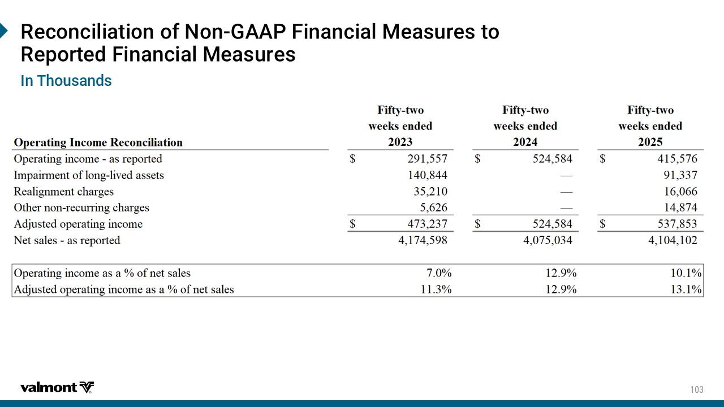
6IGSRGMPMEXMSRSJ2SR +%%4*MRERGMEP1IEWYVIWXS 6ITSVXIH*MRERGMEP1IEWYVIW -R8LSYWERHW

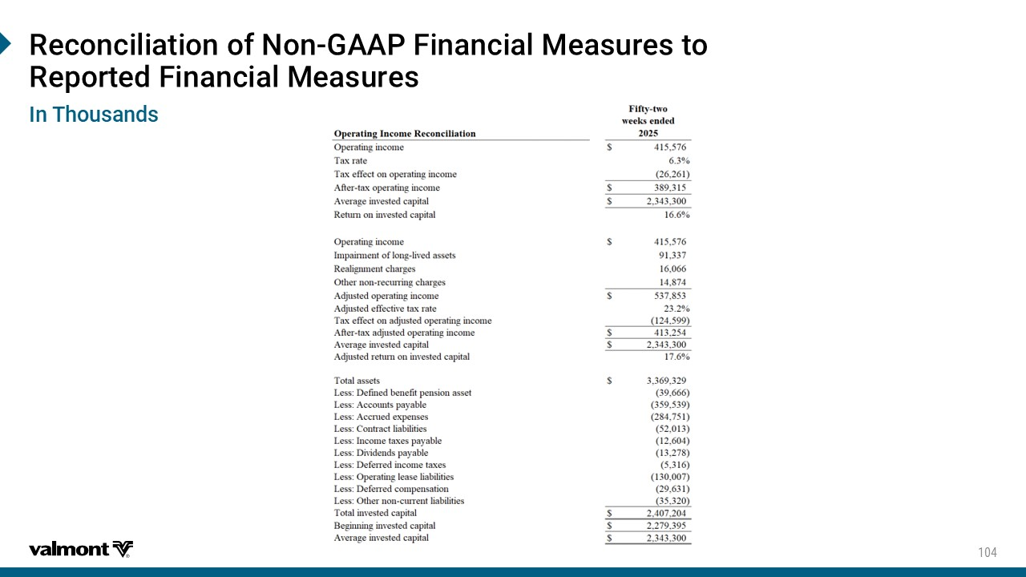
6IGSRGMPMEXMSRSJ2SR +%%4*MRERGMEP1IEWYVIWXS 6ITSVXIH*MRERGMEP1IEWYVIW -R8LSYWERHW

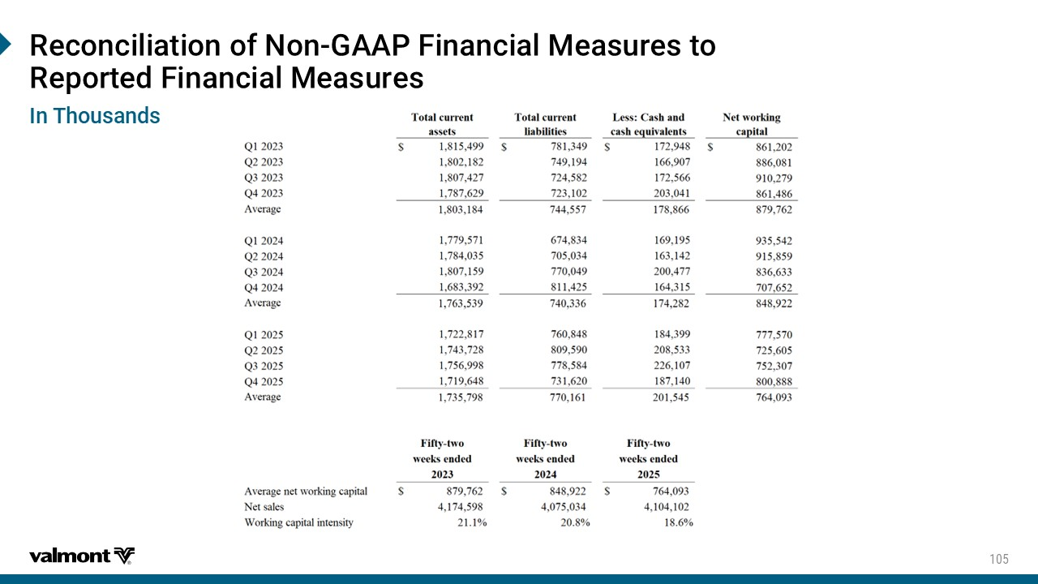
6IGSRGMPMEXMSRSJ2SR +%%4*MRERGMEP1IEWYVIWXS 6ITSVXIH*MRERGMEP1IEWYVIW -R8LSYWERHW

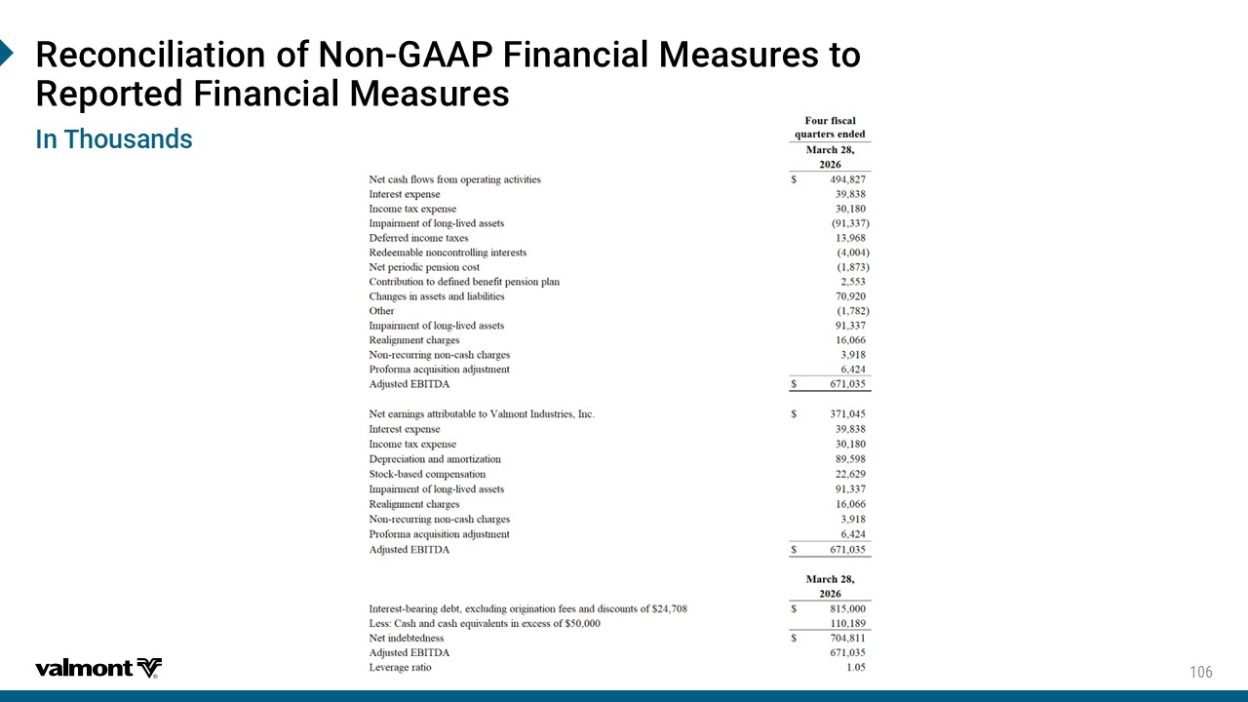
6IGSRGMPMEXMSRSJ2SR +%%4*MRERGMEP1IEWYVIWXS 6ITSVXIH*MRERGMEP1IEWYVIW -R8LSYWERHW


0IEHIVWLMT&MSW

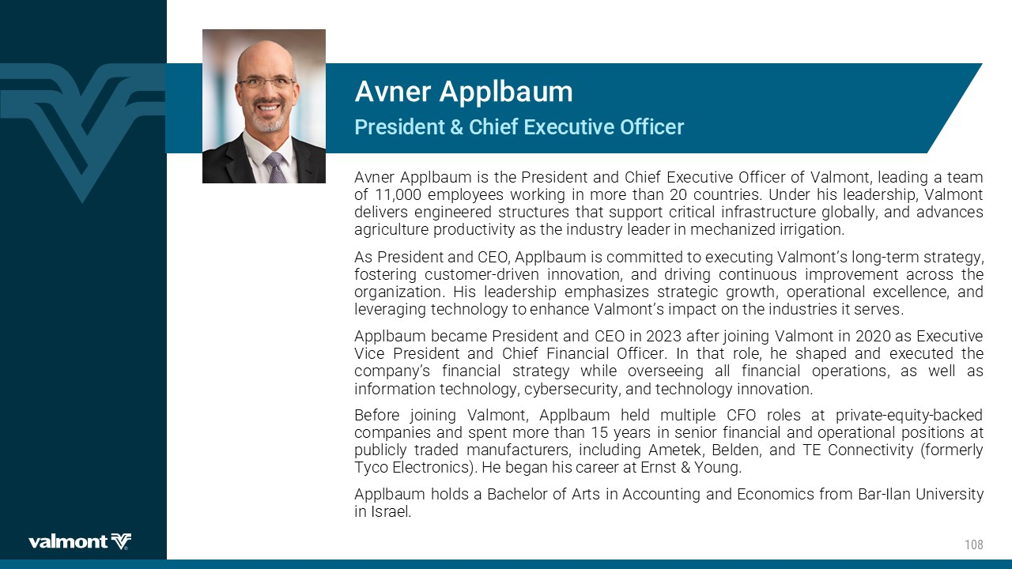
4VIWMHIRX'LMIJ)\IGYXMZI3JJMGIV %ZRIV %TTPFEYQ Avner Applbaum is the President and Chief Executive Officer of Valmont, leading a team of 11 , 000 employees working in more than 20 countries . Under his leadership, Valmont delivers engineered structures that support critical infrastructure globally, and advances agriculture productivity as the industry leader in mechanized irrigation . As President and CEO, Applbaum is committed to executing Valmont’s long - term strategy, fostering customer - driven innovation, and driving continuous improvement across the organization . His leadership emphasizes strategic growth, operational excellence, and leveraging technology to enhance Valmont’s impact on the industries it serves . Applbaum became President and CEO in 2023 after joining Valmont in 2020 as Executive Vice President and Chief Financial Officer . In that role, he shaped and executed the company’s financial strategy while overseeing all financial operations, as well as information technology, cybersecurity, and technology innovation . Before joining Valmont, Applbaum held multiple CFO roles at private - equity - backed companies and spent more than 15 years in senior financial and operational positions at publicly traded manufacturers, including Ametek , Belden, and TE Connectivity (formerly Tyco Electronics) . He began his career at Ernst & Young . Applbaum holds a Bachelor of Arts in Accounting and Economics from Bar - Ilan University in Israel .

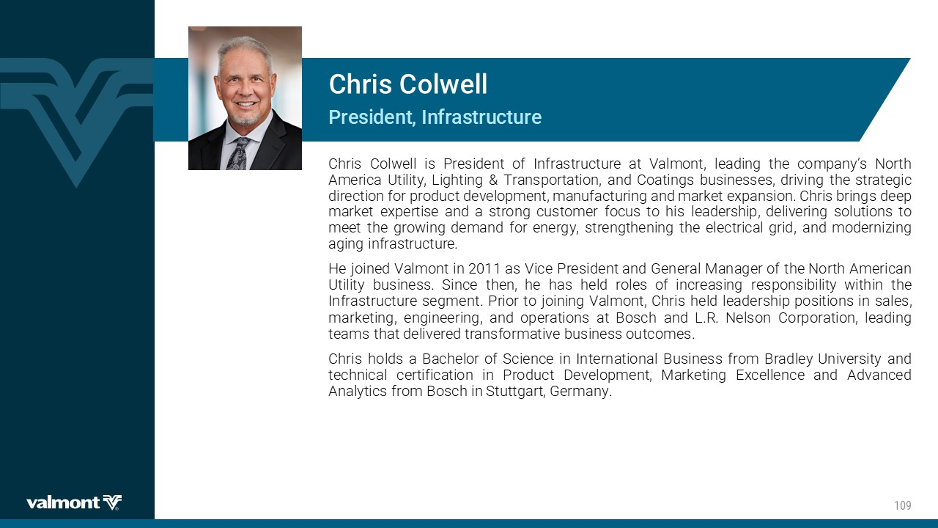
4VIWMHIRX-RJVEWXVYGXYVI 'LVMW'SP[IPP Chris Colwell is President of Infrastructure at Valmont, leading the company’s North America Utility, Lighting & Transportation, and Coatings businesses, driving the strategic direction for product development, manufacturing and market expansion . Chris brings deep market expertise and a strong customer focus to his leadership, delivering solutions to meet the growing demand for energy, strengthening the electrical grid, and modernizing aging infrastructure . He joined Valmont in 2011 as Vice President and General Manager of the North American Utility business . Since then, he has held roles of increasing responsibility within the Infrastructure segment . Prior to joining Valmont, Chris held leadership positions in sales, marketing, engineering, and operations at Bosch and L . R . Nelson Corporation, leading teams that delivered transformative business outcomes . Chris holds a Bachelor of Science in International Business from Bradley University and technical certification in Product Development, Marketing Excellence and Advanced Analytics from Bosch in Stuttgart, Germany .

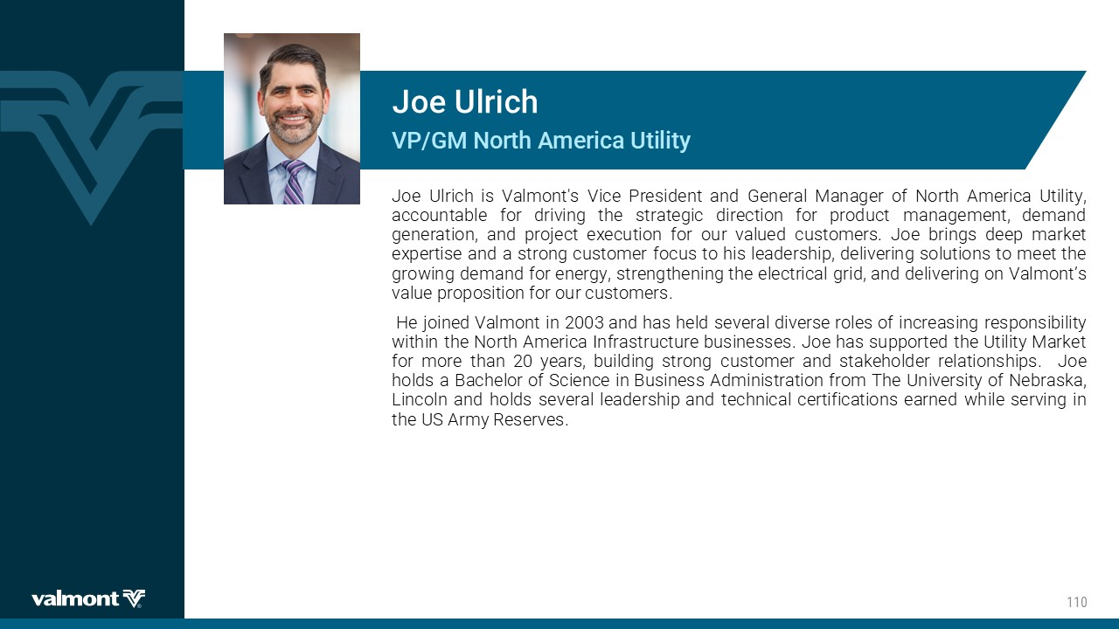
:4+12SVXL%QIVMGE9XMPMX] .SI9PVMGL Joe Ulrich is Valmont's Vice President and General Manager of North America Utility, accountable for driving the strategic direction for product management, demand generation, and project execution for our valued customers . Joe brings deep market expertise and a strong customer focus to his leadership, delivering solutions to meet the growing demand for energy, strengthening the electrical grid, and delivering on Valmont’s value proposition for our customers . ​ He joined Valmont in 2003 ​and has held several diverse roles of increasing responsibility within the North America Infrastructure businesses . Joe has supported the Utility Market for more than 20 years, building strong customer and stakeholder relationships . Joe holds a Bachelor of Science in Business Administration from The University of Nebraska, Lincoln and holds several leadership and technical certifications earned while serving in the US Army Reserves .

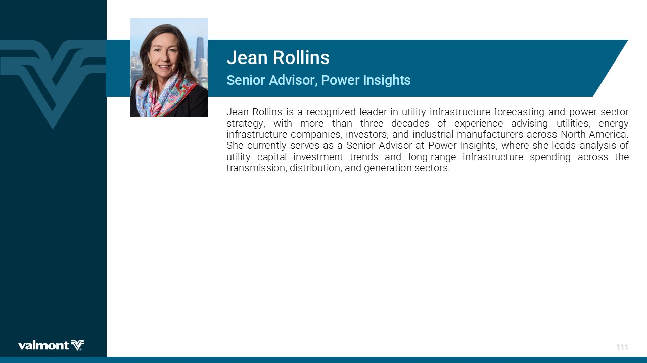
7IRMSV%HZMWSV4S[IV-RWMKLXW .IER6SPPMRW Jean Rollins is a recognized leader in utility infrastructure forecasting and power sector strategy, with more than three decades of experience advising utilities, energy infrastructure companies, investors, and industrial manufacturers across North America . She currently serves as a Senior Advisor at Power Insights, where she leads analysis of utility capital investment trends and long - range infrastructure spending across the transmission, distribution, and generation sectors .

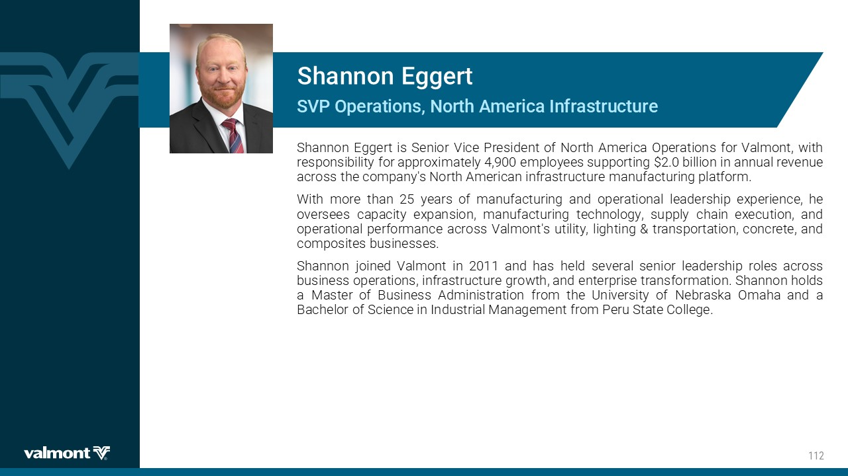
7:4 3TIVEXMSRW2SVXL%QIVMGE-RJVEWXVYGXYVI 7LERRSR)KKIVX Shannon Eggert is Senior Vice President of North America Operations for Valmont, with responsibility for approximately 4 , 900 employees supporting $ 2 . 0 billion in annual revenue across the company's North American infrastructure manufacturing platform . With more than 25 years of manufacturing and operational leadership experience, he oversees capacity expansion, manufacturing technology, supply chain execution, and operational performance across Valmont's utility, lighting & transportation, concrete, and composites businesses . Shannon joined Valmont in 2011 and has held several senior leadership roles across business operations, infrastructure growth, and enterprise transformation . Shannon holds a Master of Business Administration from the University of Nebraska Omaha and a Bachelor of Science in Industrial Management from Peru State College .

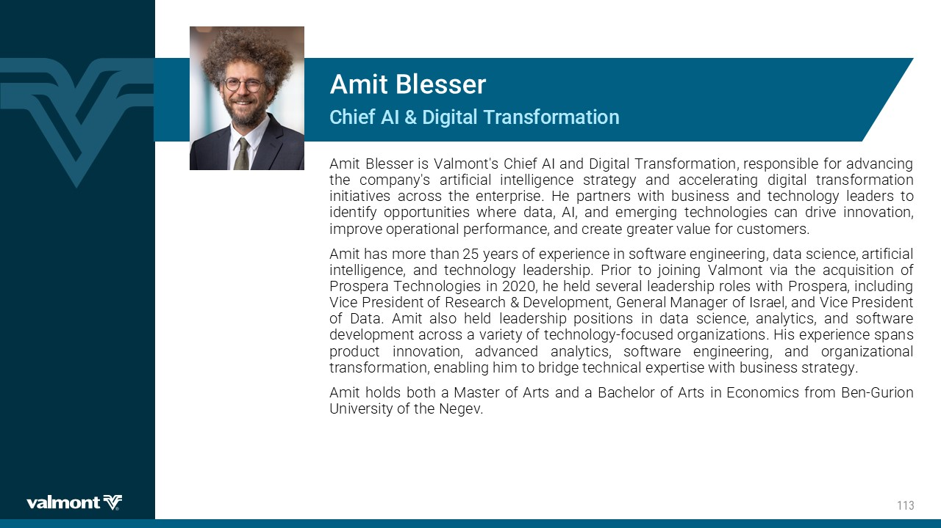
'LMIJ %-(MKMXEP8VERWJSVQEXMSR %QMX&PIWWIV Amit Blesser is Valmont's Chief AI and Digital Transformation, responsible for advancing the company's artificial intelligence strategy and accelerating digital transformation initiatives across the enterprise . He partners with business and technology leaders to identify opportunities where data, AI, and emerging technologies can drive innovation, improve operational performance, and create greater value for customers . Amit has more than 25 years of experience in software engineering, data science, artificial intelligence, and technology leadership . Prior to joining Valmont via the acquisition of Prospera Technologies in 2020 , he held several leadership roles with Prospera, including Vice President of Research & Development, General Manager of Israel, and Vice President of Data . Amit also held leadership positions in data science, analytics, and software development across a variety of technology - focused organizations . His experience spans product innovation, advanced analytics, software engineering, and organizational transformation, enabling him to bridge technical expertise with business strategy . Amit holds both a Master of Arts and a Bachelor of Arts in Economics from Ben - Gurion University of the Negev .

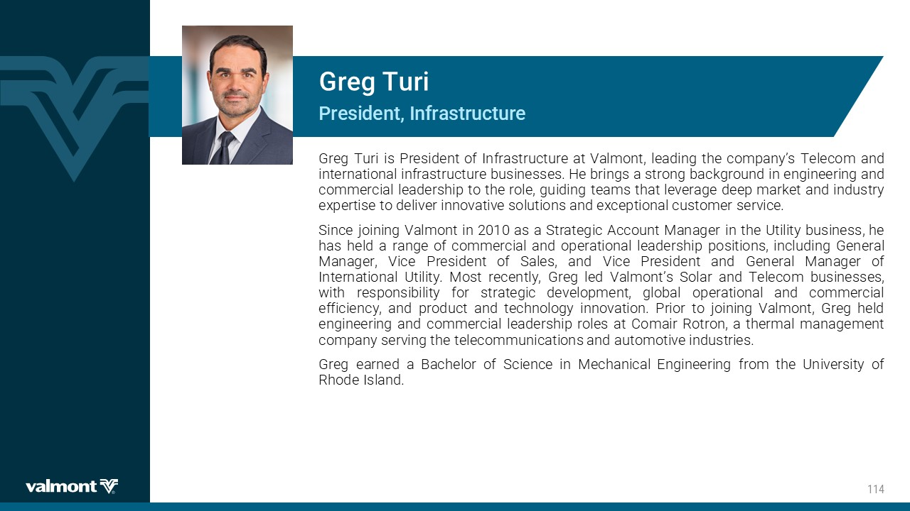
4VIWMHIRX -RJVEWXVYGXYVI +VIK8YVM Greg Turi is President of Infrastructure at Valmont, leading the company’s Telecom and international infrastructure businesses . He brings a strong background in engineering and commercial leadership to the role, guiding teams that leverage deep market and industry expertise to deliver innovative solutions and exceptional customer service . Since joining Valmont in 2010 as a Strategic Account Manager in the Utility business, he has held a range of commercial and operational leadership positions, including General Manager, Vice President of Sales, and Vice President and General Manager of International Utility . Most recently, Greg led Valmont’s Solar and Telecom businesses, with responsibility for strategic development, global operational and commercial efficiency, and product and technology innovation . Prior to joining Valmont, Greg held engineering and commercial leadership roles at Comair Rotron , a thermal management company serving the telecommunications and automotive industries . Greg earned a Bachelor of Science in Mechanical Engineering from the University of Rhode Island .

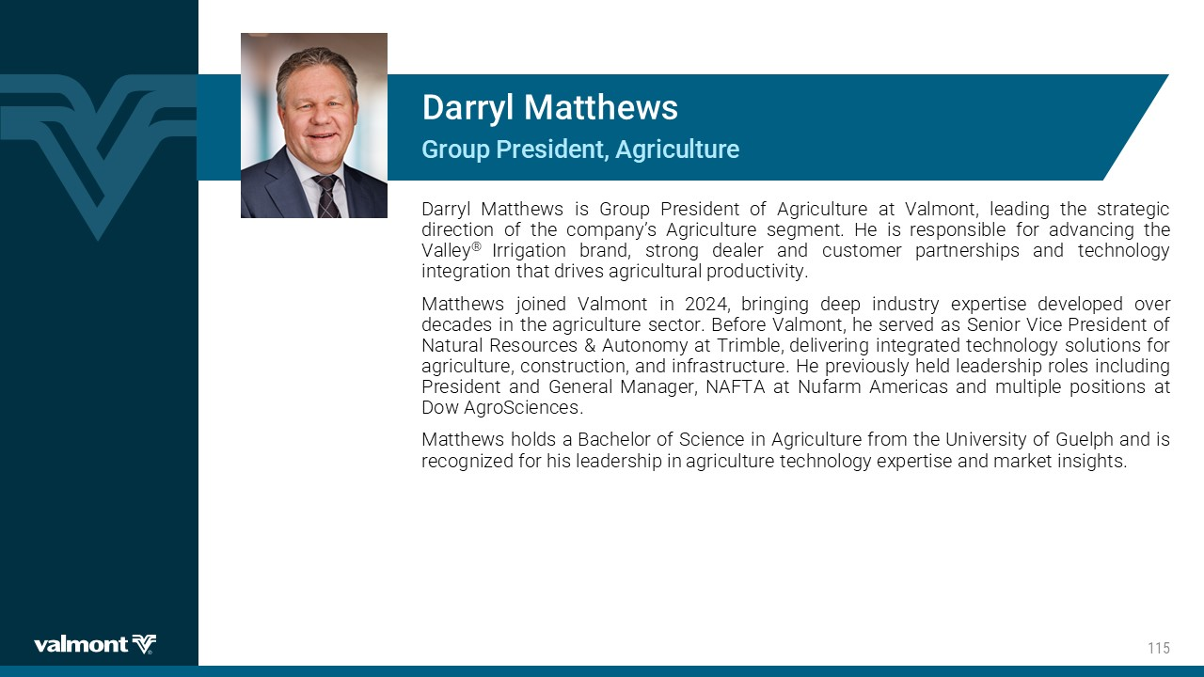
+VSYT4VIWMHIRX%KVMGYPXYVI (EVV]P1EXXLI[W Darryl Matthews is Group President of Agriculture at Valmont, leading the strategic direction of the company’s Agriculture segment . He is responsible for advancing the Valley ® Irrigation brand, strong dealer and customer partnerships and technology integration that drives agricultural productivity . Matthews joined Valmont in 2024 , bringing deep industry expertise developed over decades in the agriculture sector . Before Valmont, he served as Senior Vice President of Natural Resources & Autonomy at Trimble, delivering integrated technology solutions for agriculture, construction, and infrastructure . He previously held leadership roles including President and General Manager, NAFTA at Nufarm Americas and multiple positions at Dow AgroSciences . Matthews holds a Bachelor of Science in Agriculture from the University of Guelph and is recognized for his leadership in agriculture technology expertise and market insights .

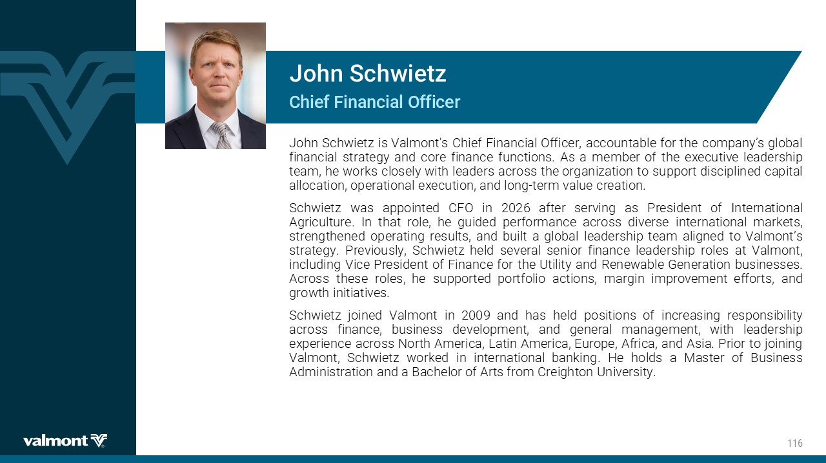
'LMIJ*MRERGMEP3JJMGIV .SLR7GL[MIX^ John Schwietz is Valmont's Chief Financial Officer, accountable for the company’s global financial strategy and core finance functions . As a member of the executive leadership team, he works closely with leaders across the organization to support disciplined capital allocation, operational execution, and long - term value creation . Schwietz was appointed CFO in 2026 after serving as President of International Agriculture . In that role, he guided performance across diverse international markets, strengthened operating results, and built a global leadership team aligned to Valmont’s strategy . Previously, Schwietz held several senior finance leadership roles at Valmont, including Vice President of Finance for the Utility and Renewable Generation businesses . Across these roles, he supported portfolio actions, margin improvement efforts, and growth initiatives . Schwietz joined Valmont in 2009 and has held positions of increasing responsibility across finance, business development, and general management, with leadership experience across North America, Latin America, Europe, Africa, and Asia . Prior to joining Valmont, Schwietz worked in international banking . He holds a Master of Business Administration and a Bachelor of Arts from Creighton University .

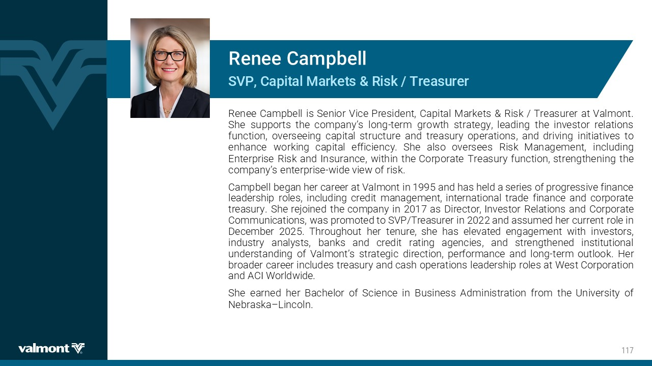
7:4'ETMXEP1EVOIXW6MWO8VIEWYVIV 6IRII'EQTFIPP Renee Campbell is Senior Vice President, Capital Markets & Risk / Treasurer at Valmont . She supports the company’s long - term growth strategy, leading the investor relations function, overseeing capital structure and treasury operations, and driving initiatives to enhance working capital efficiency . She also oversees Risk Management, including Enterprise Risk and Insurance, within the Corporate Treasury function, strengthening the company’s enterprise - wide view of risk . Campbell began her career at Valmont in 1995 and has held a series of progressive finance leadership roles, including credit management, international trade finance and corporate treasury . She rejoined the company in 2017 as Director, Investor Relations and Corporate Communications, was promoted to SVP/Treasurer in 2022 and assumed her current role in December 2025 . Throughout her tenure, she has elevated engagement with investors, industry analysts, banks and credit rating agencies, and strengthened institutional understanding of Valmont’s strategic direction, performance and long - term outlook . Her broader career includes treasury and cash operations leadership roles at West Corporation and ACI Worldwide . She earned her Bachelor of Science in Business Administration from the University of Nebraska – Lincoln .

